# Azure Cosmos DB Workshop

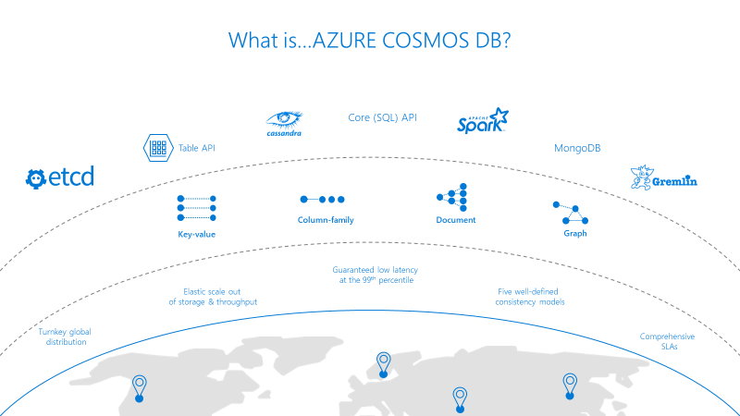

# Problem statement:

Consume and Analyze meter and weather data.

# Architecture:

For this workshop we have created an event hub which will be used as a source for both the meter data and the weather data.

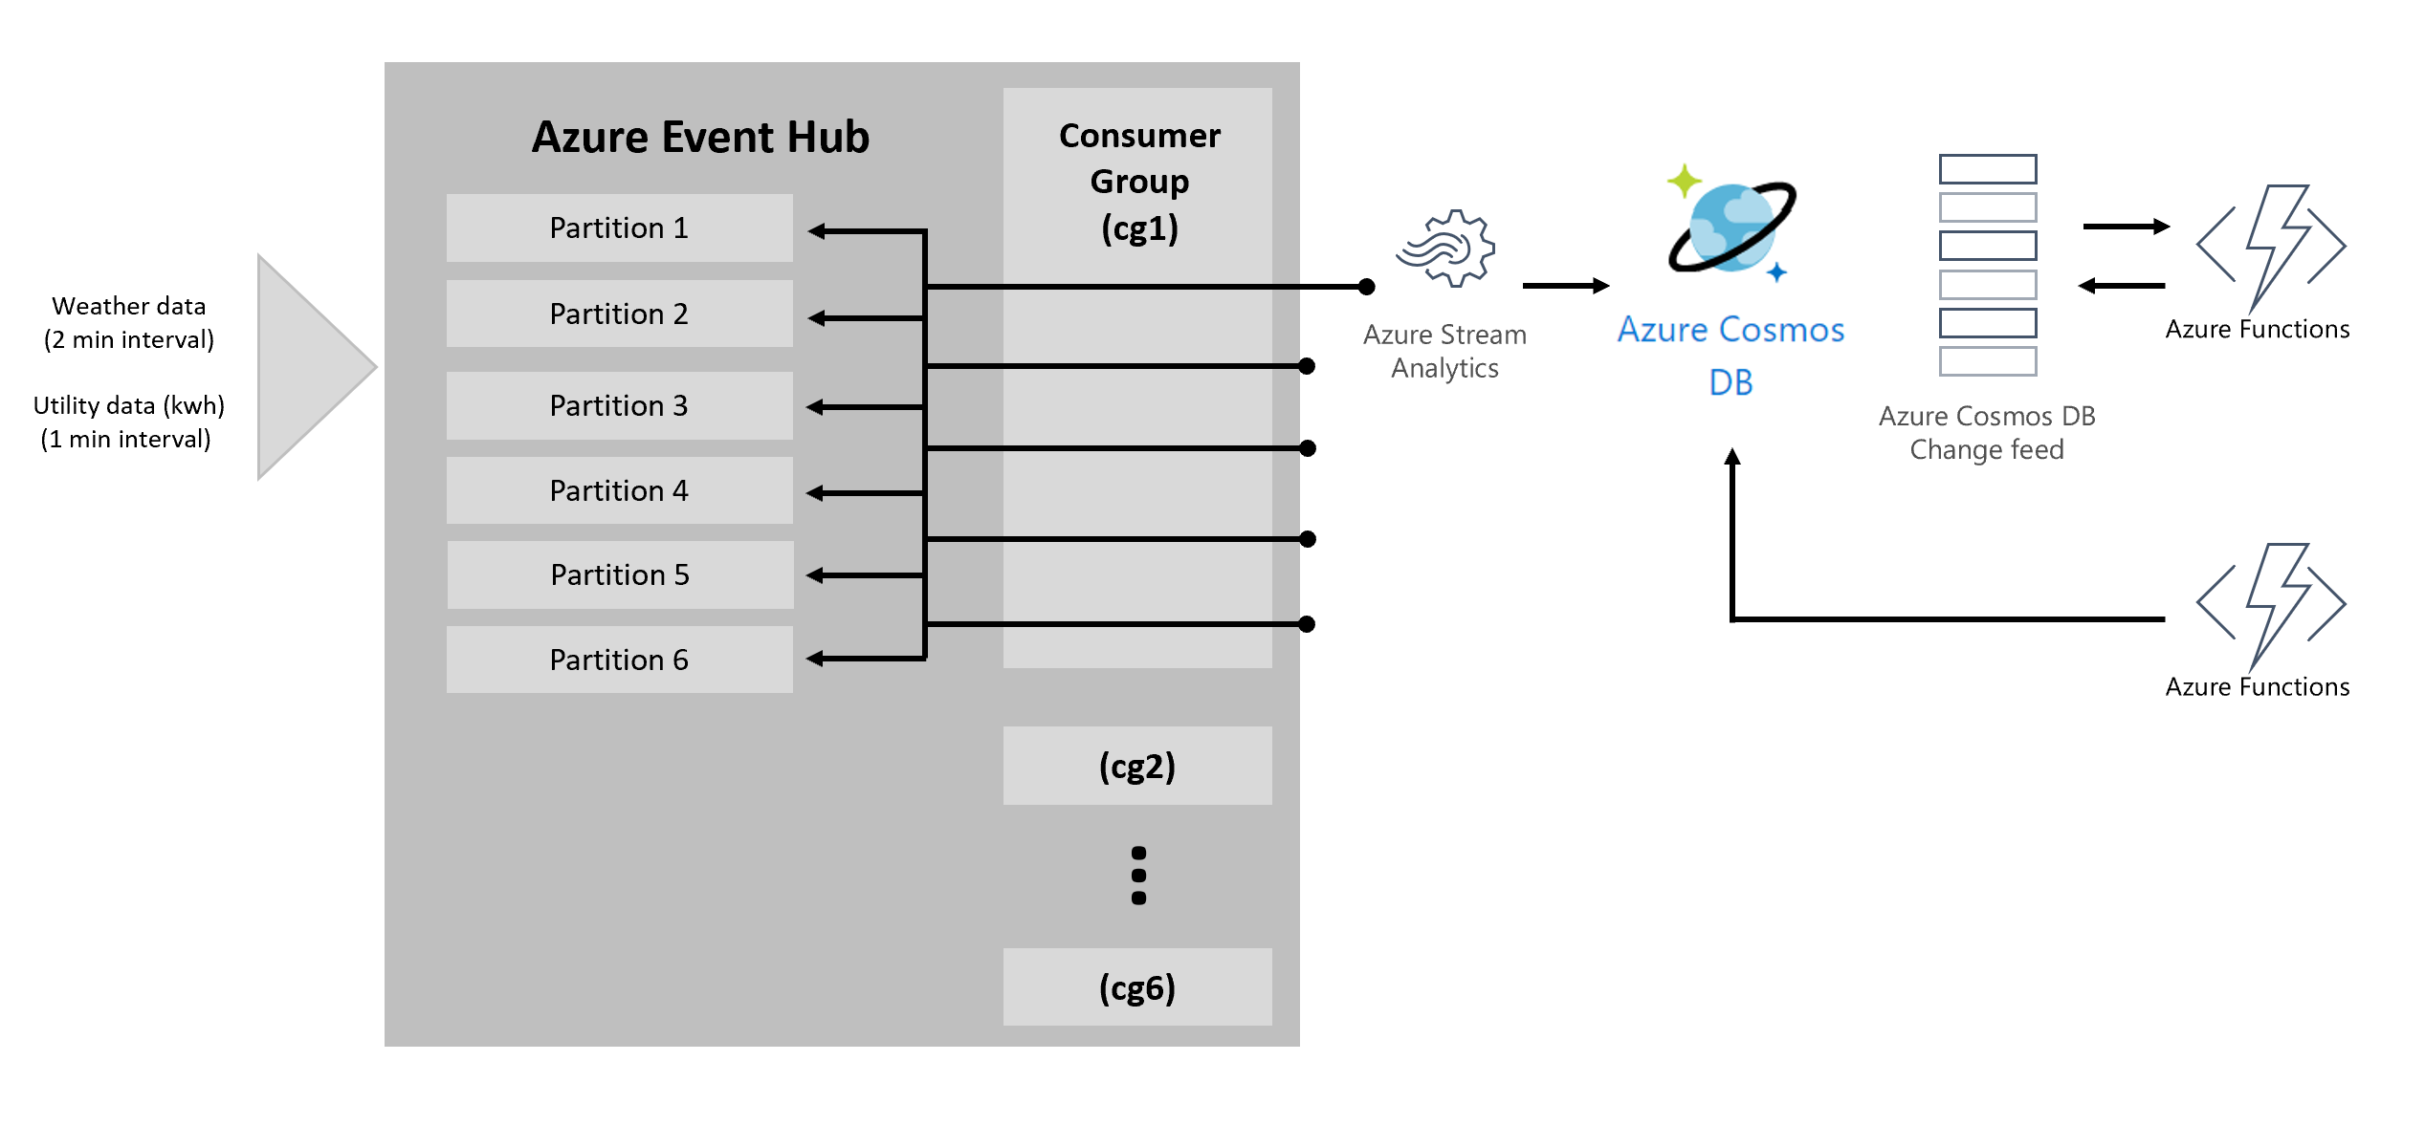

# Hands on Start:

# Step1: Create Cosmos DB Account under new resource Group

1. Go to Azure portal

<https://ms.portal.azure.com>

1. Click on Create a Resource

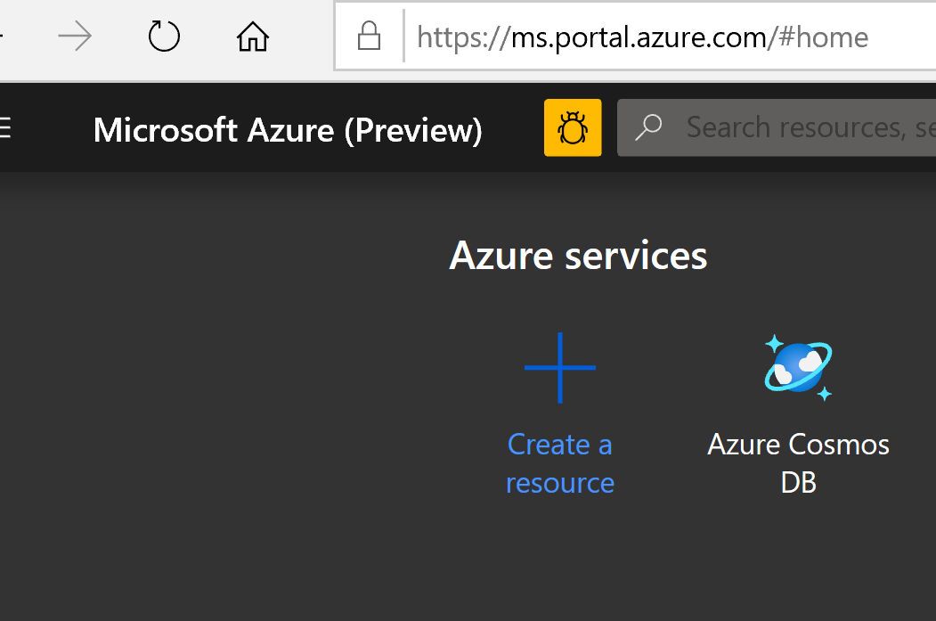

1. 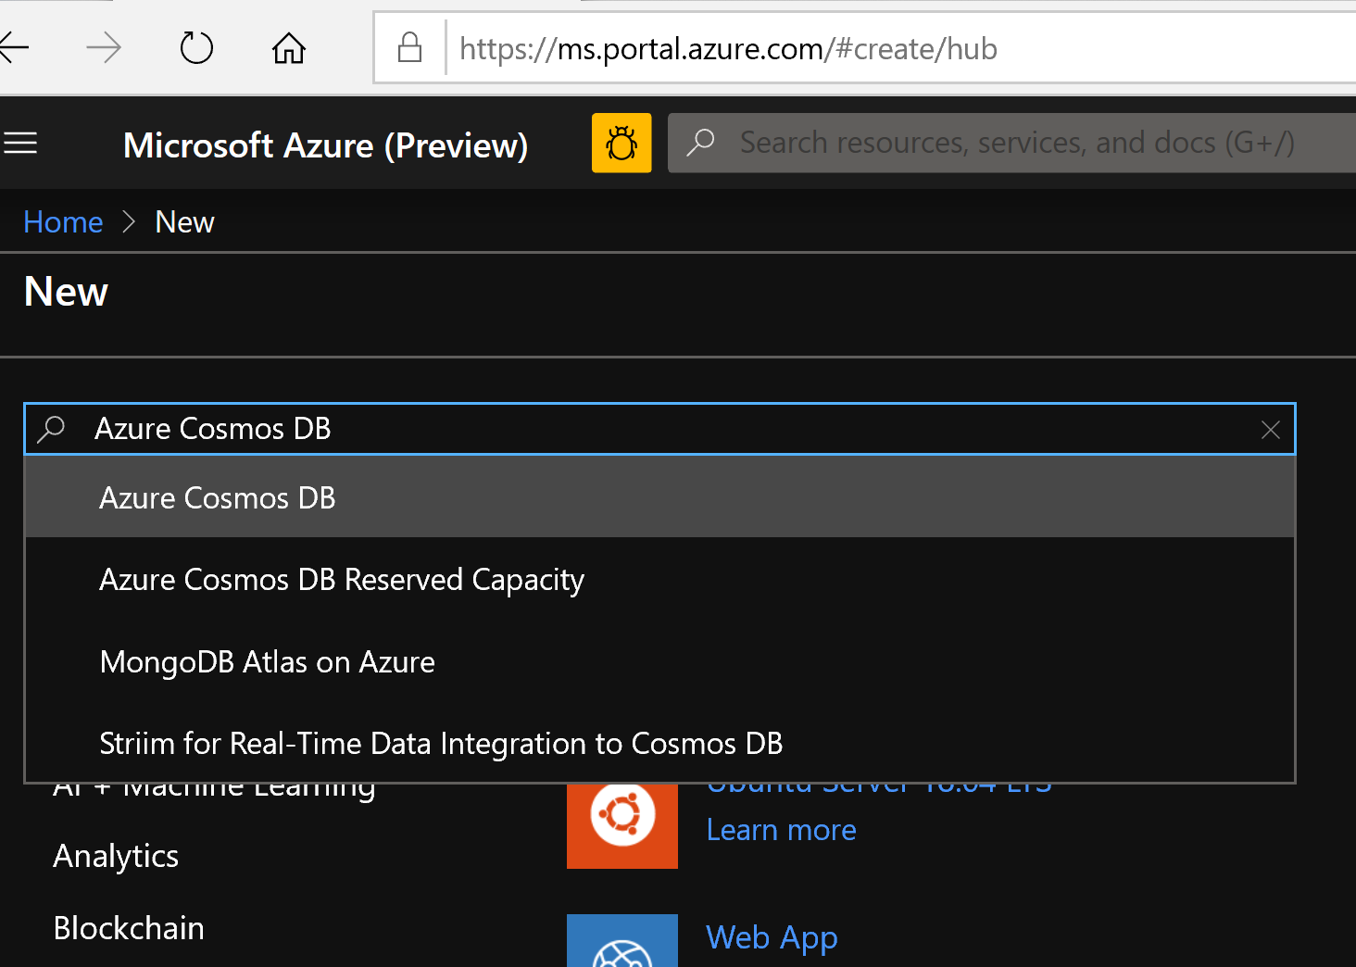
2. 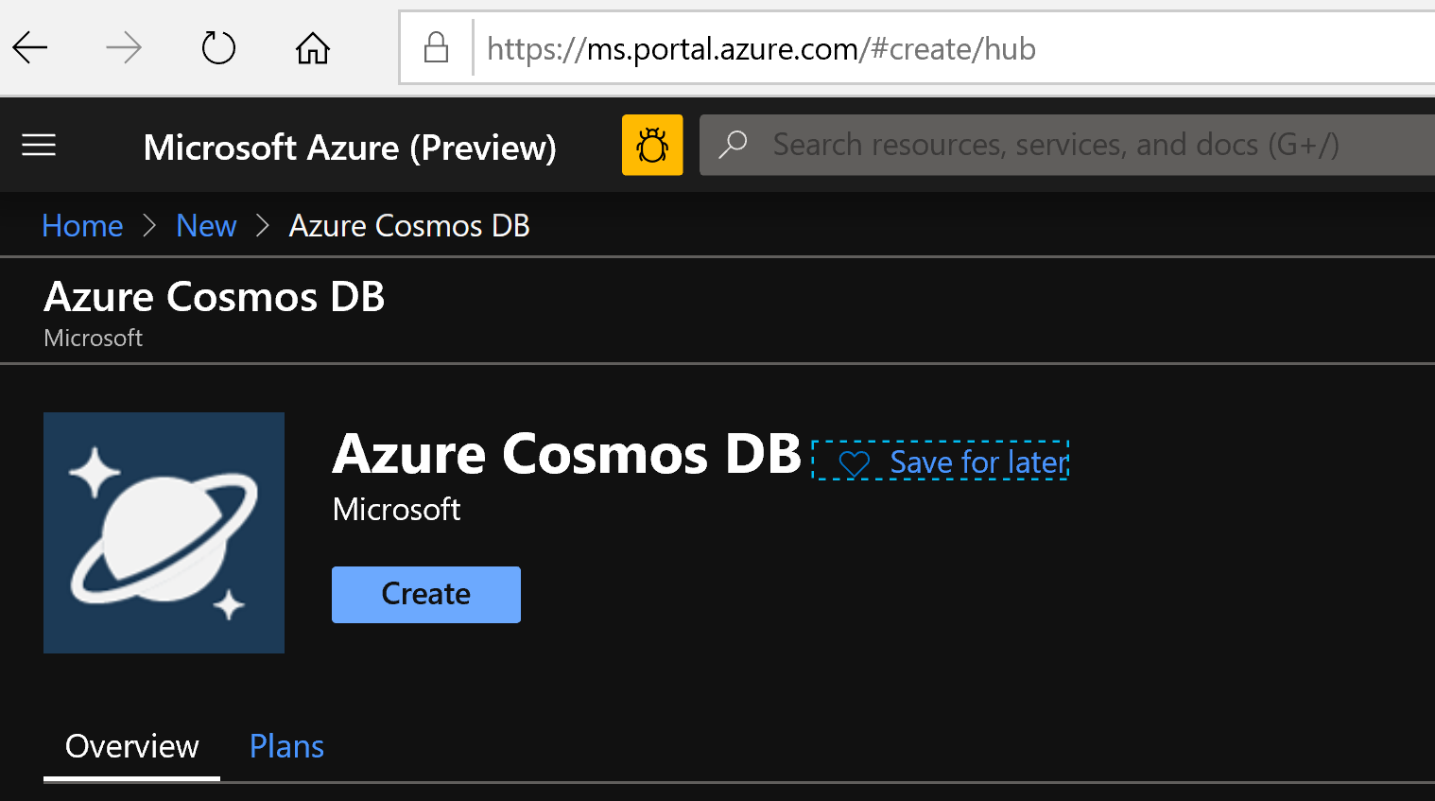
3. Create new resource group rg_cosmos_db_workshop_<alias>

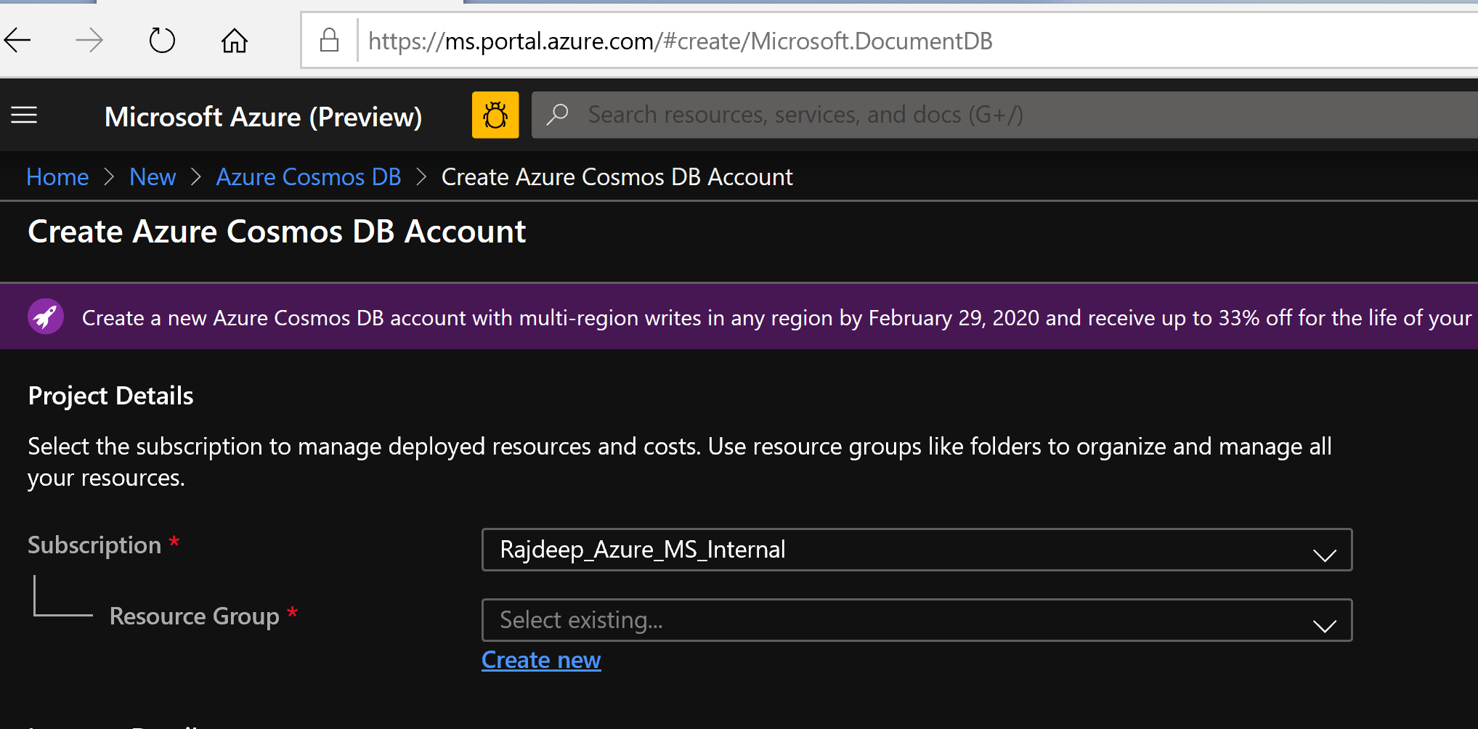

1. Create a new cosmos db account ac-cosmos-workshop-<alias>
2. Choose API as Core SQL

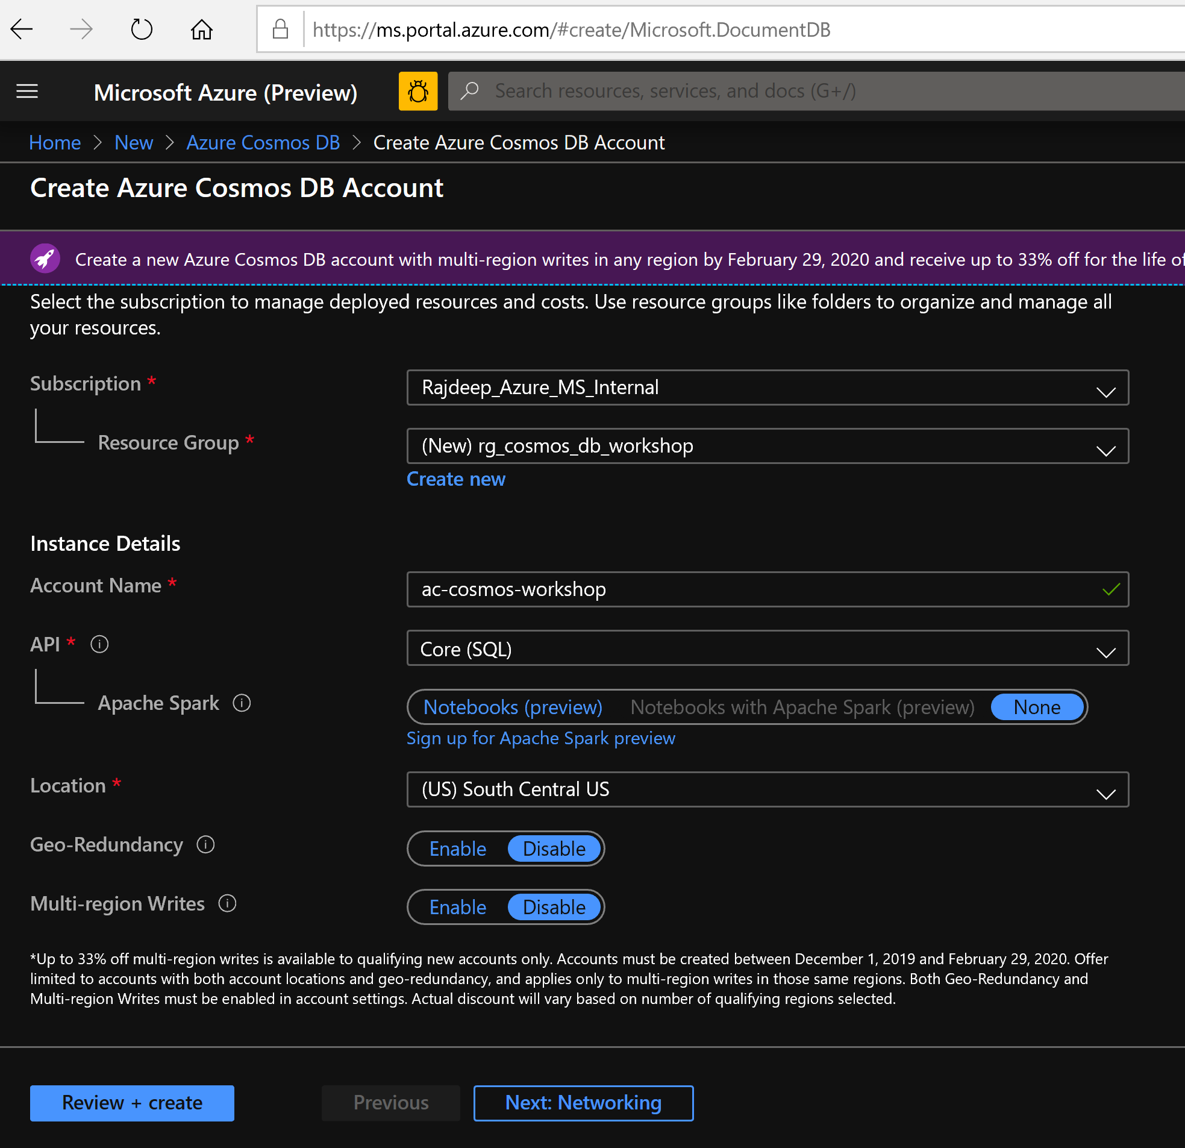

1. Review and Create

# Step2: Create Stream Analytics service under newly created resource Group

1. 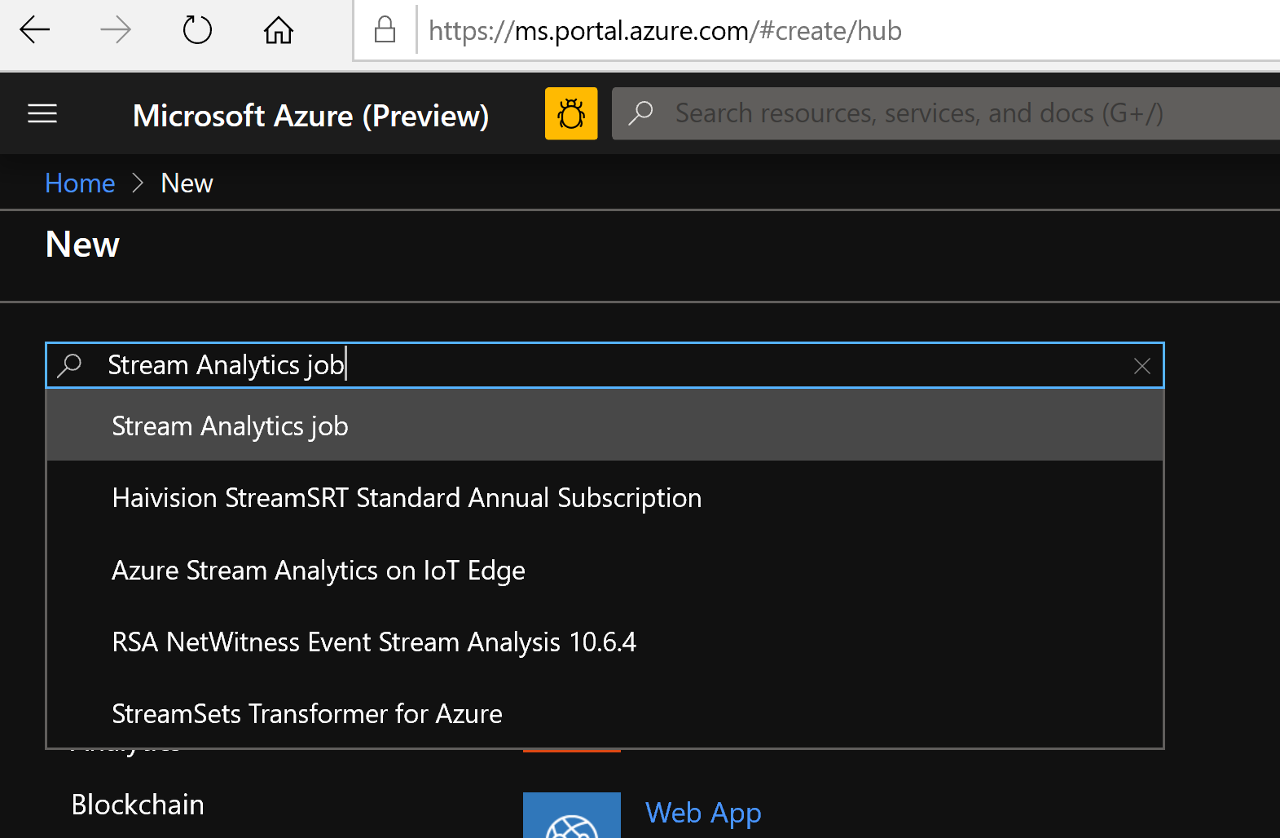
2. 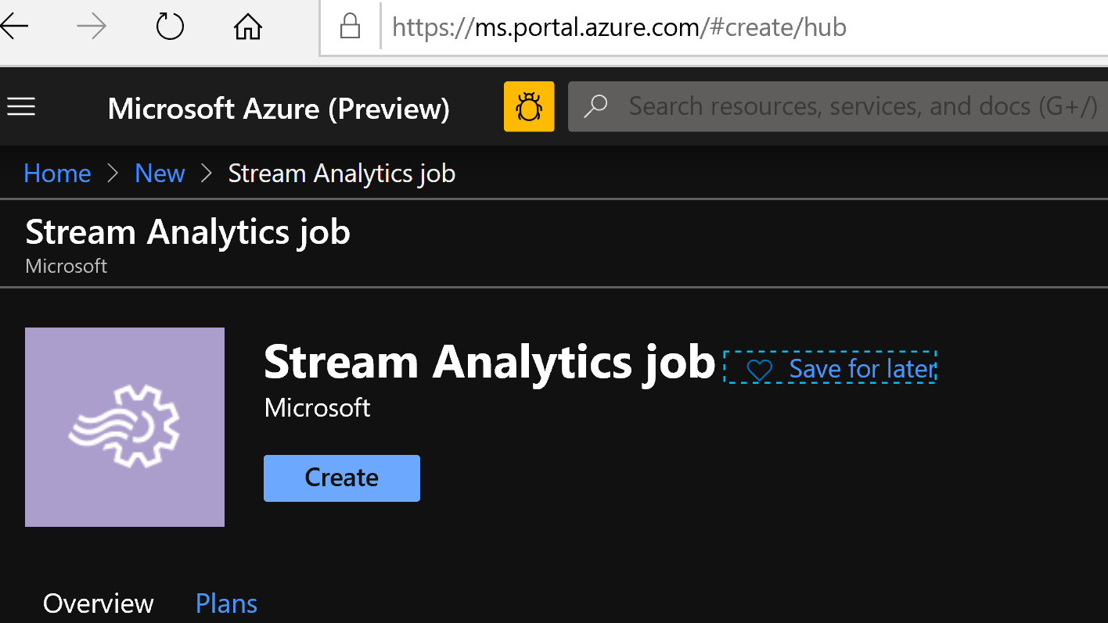
3. Create job name as sa_cosmos_db_ws_<alias>
4. Hit create

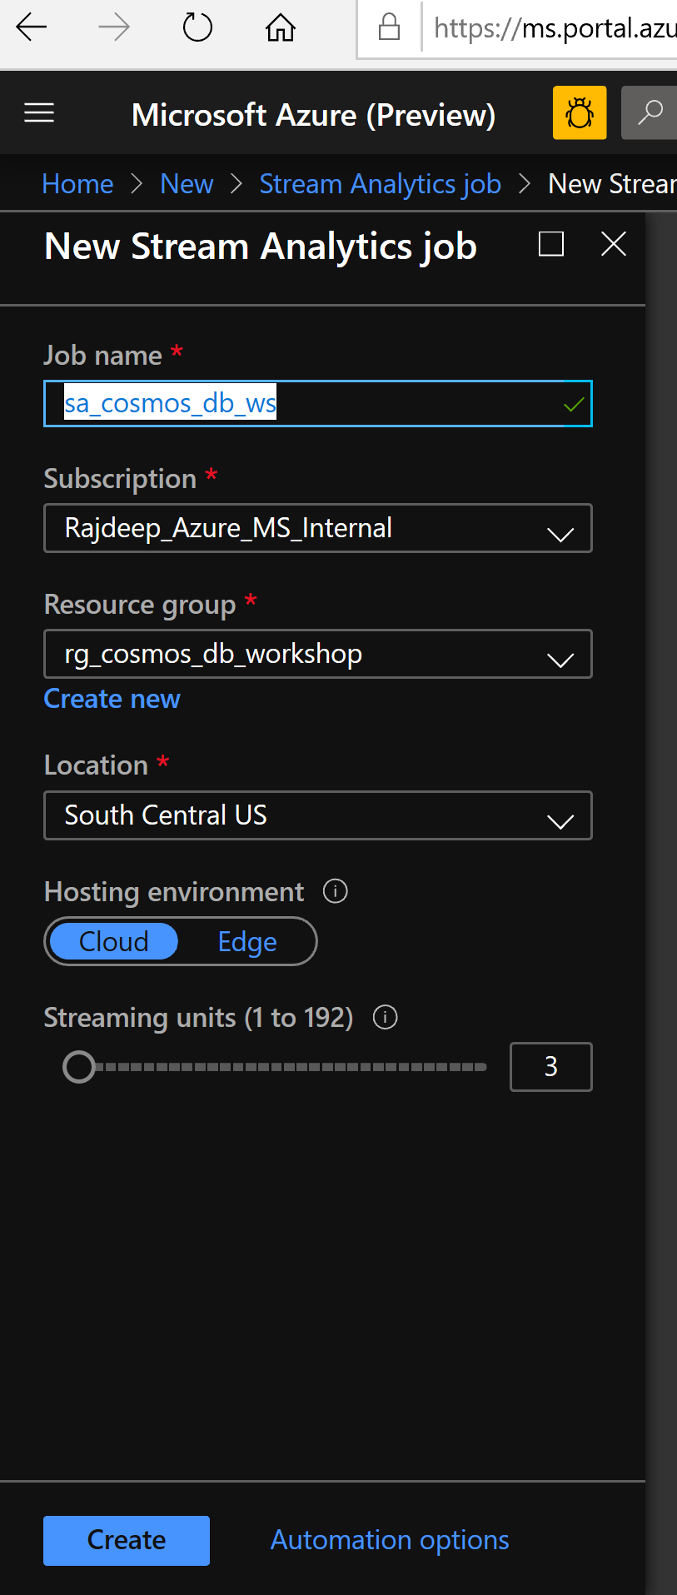

# Step3: Create Cosmos DB Database and collection

1. Search for resource group and go to the one you just created.

Go to the resource group and click on the cosmos db account

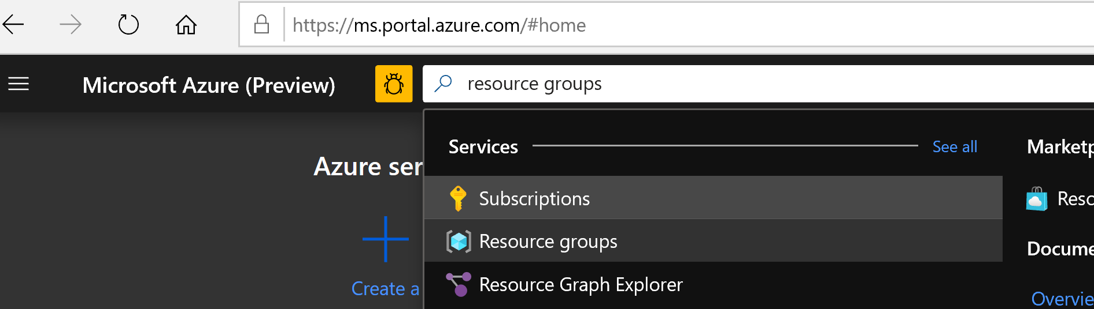

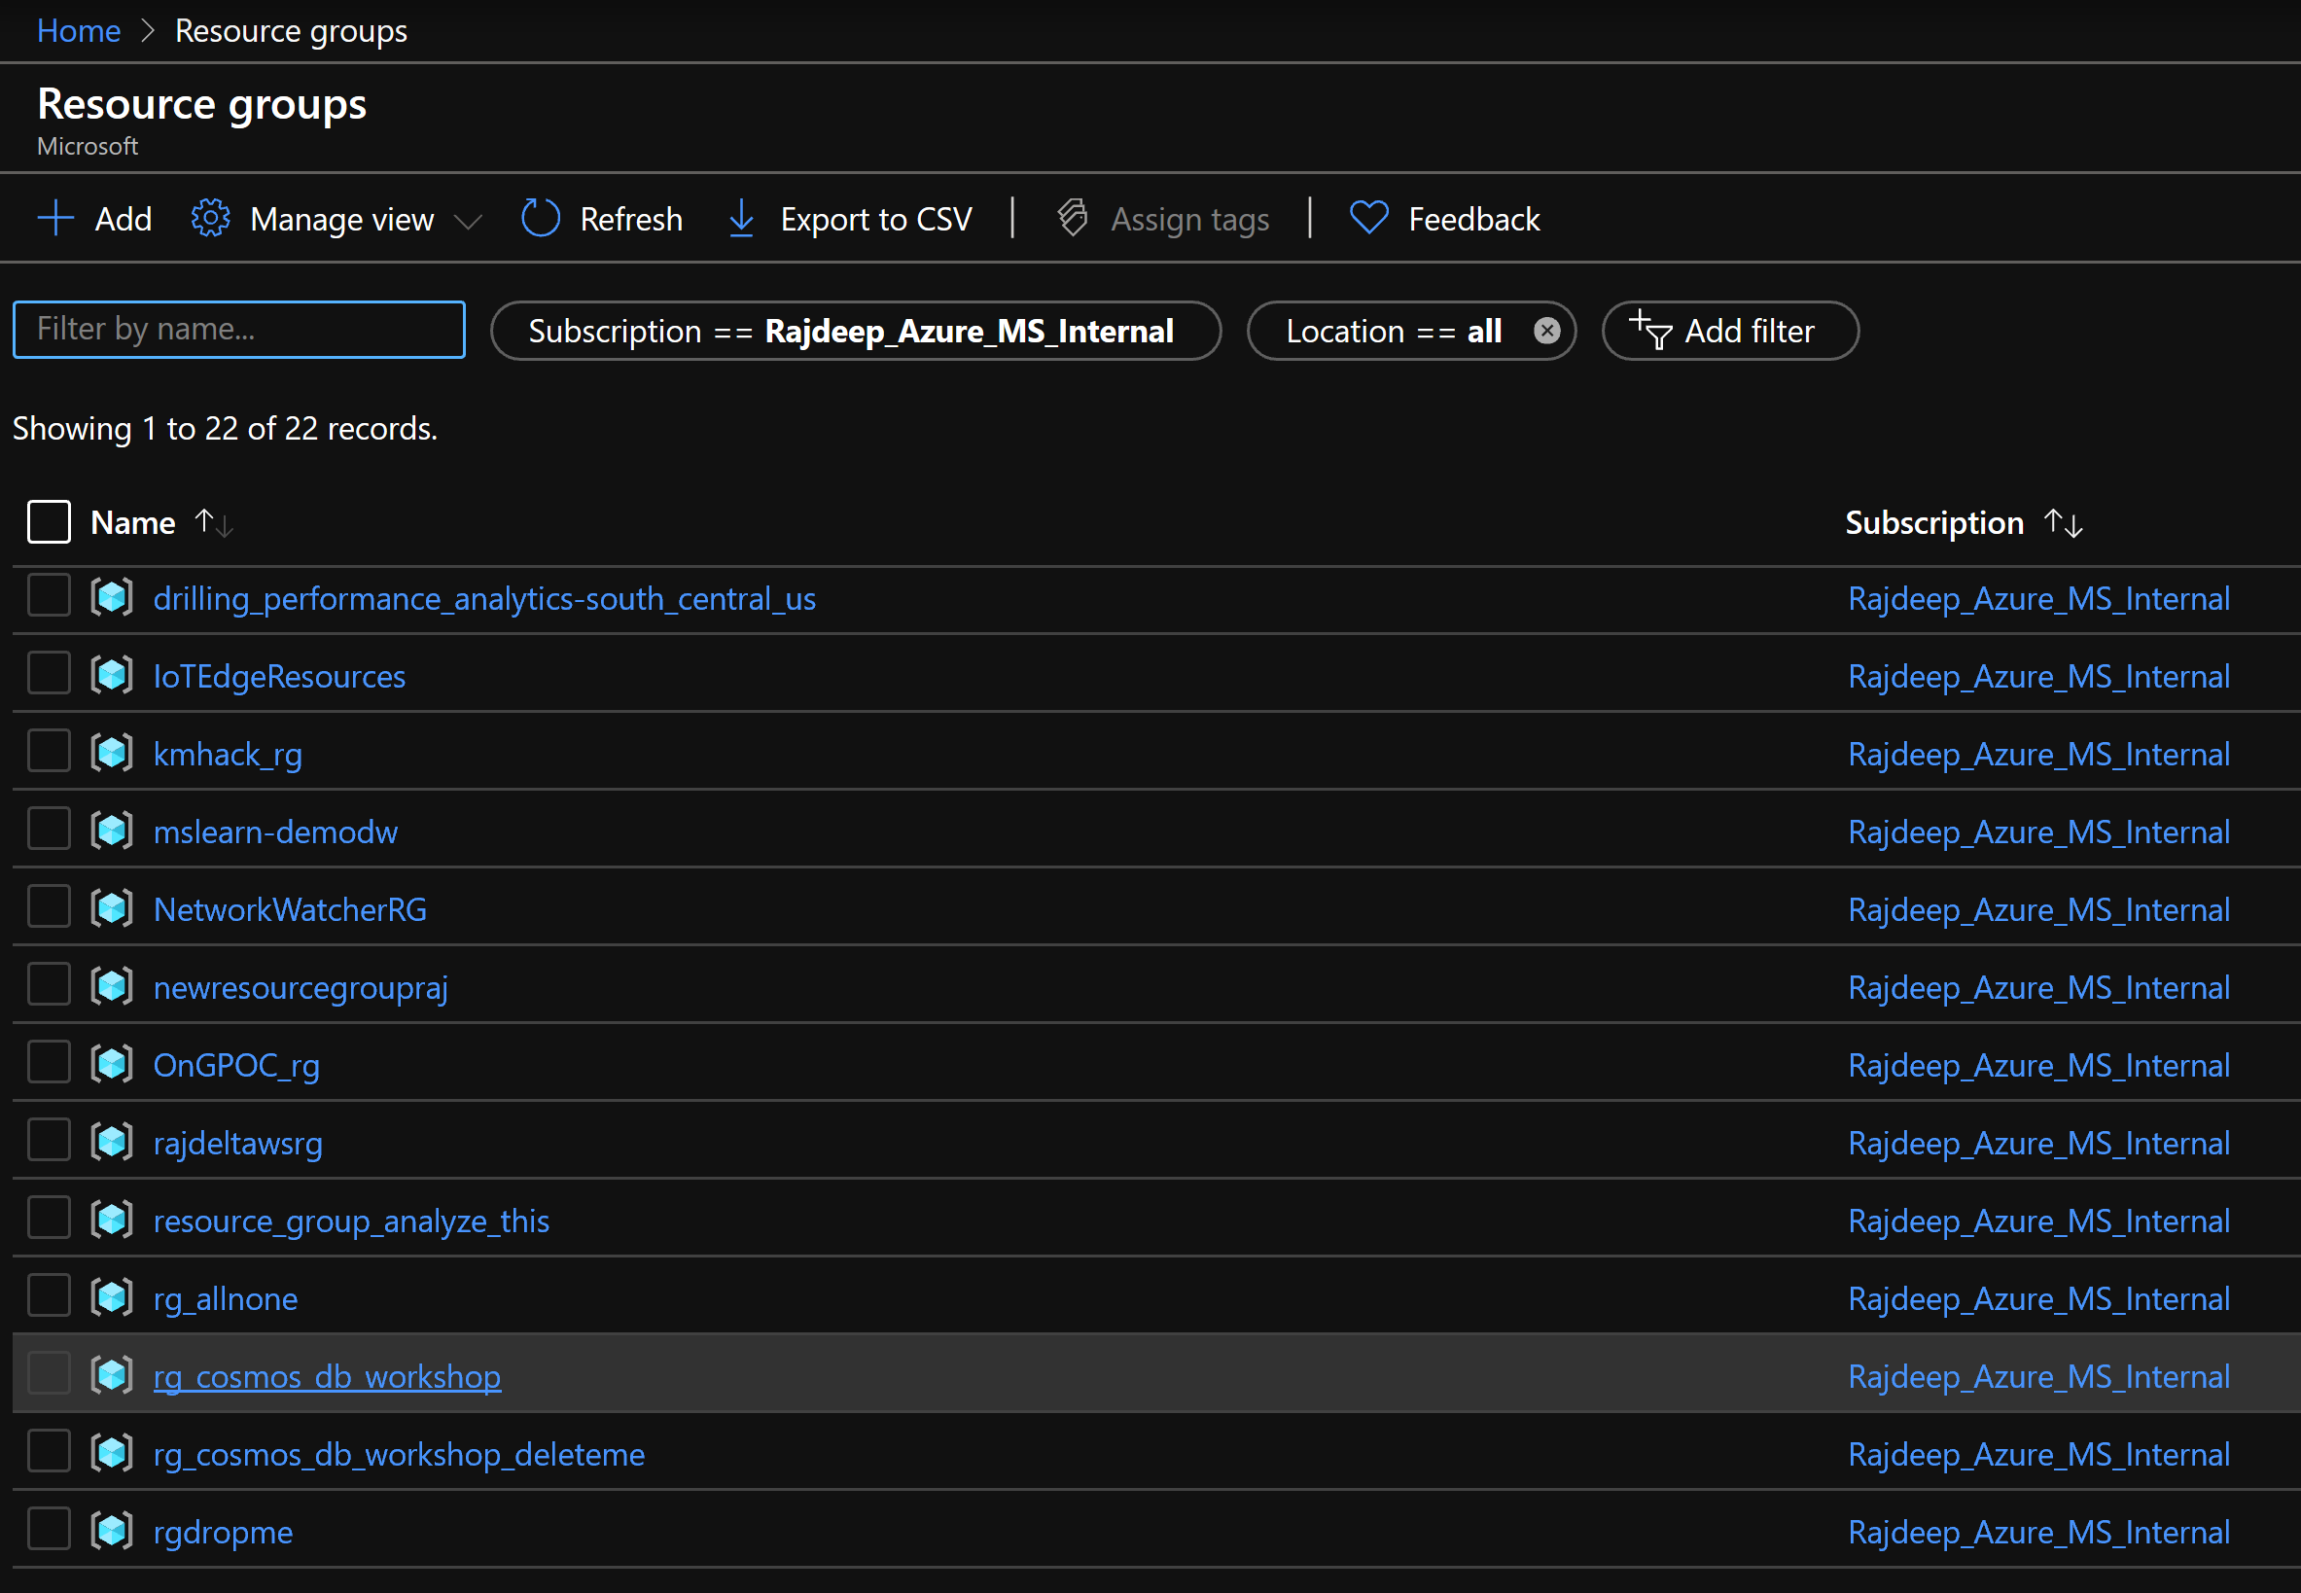

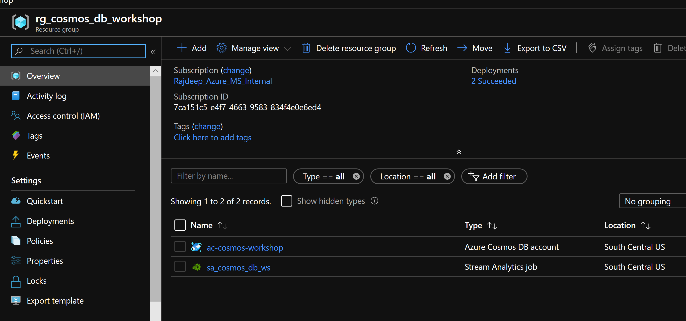

1. Click on Data Explorer 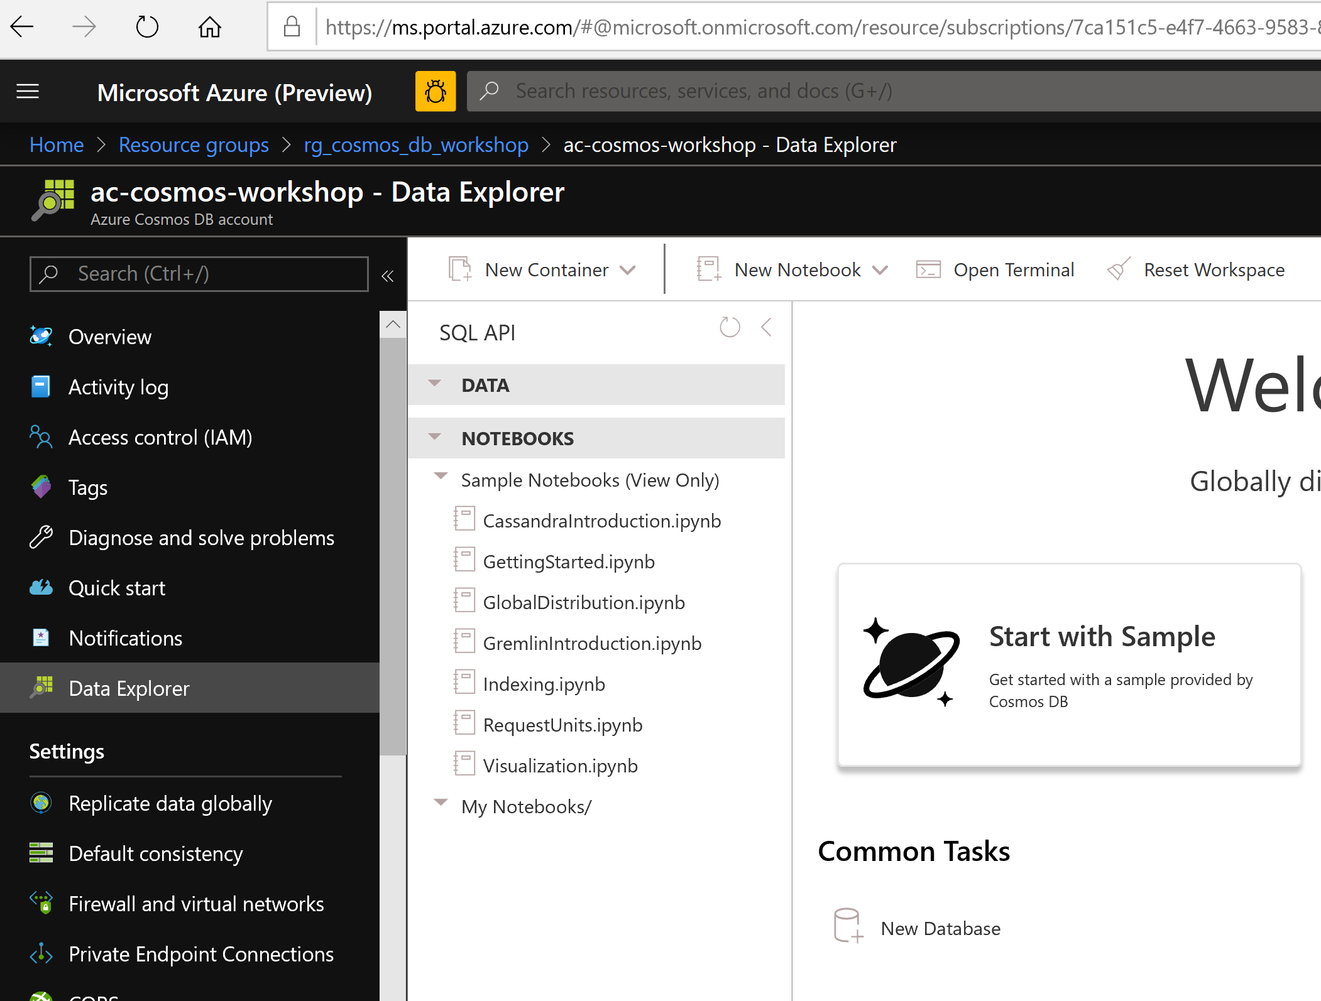
2. Create new database clicking on the dropdown beside new container 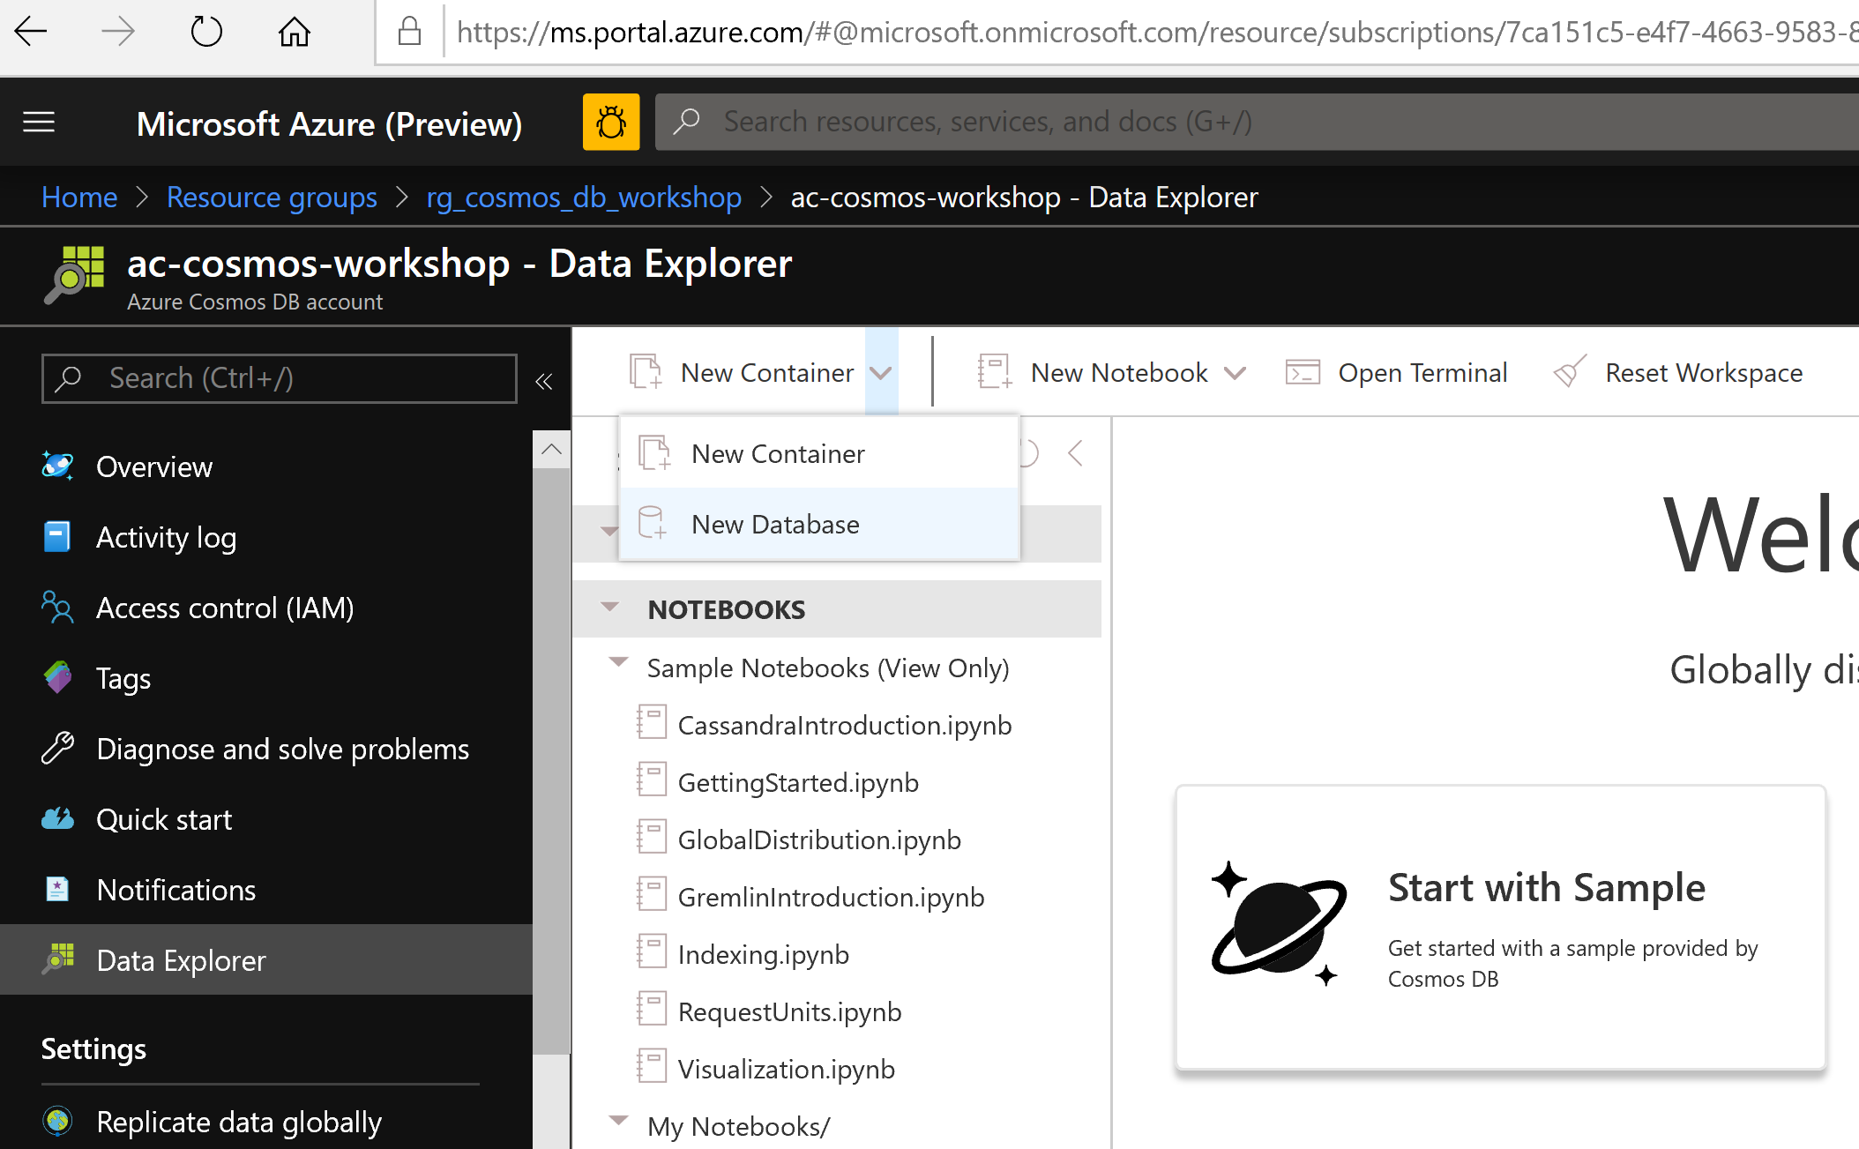
3. Create new database as db-cosmos-workshop-<alias> and leave the RU as 400. We will show the calculation separately from the worskhop. 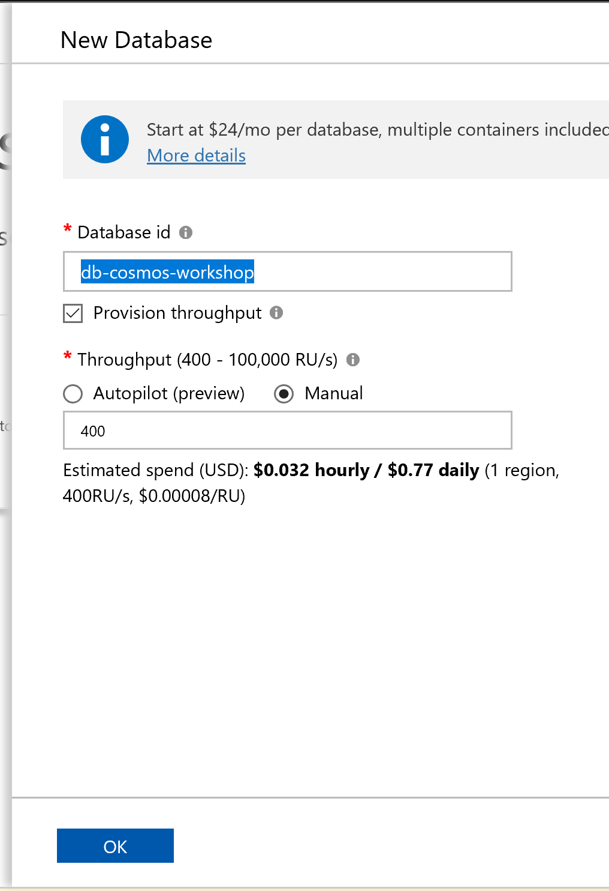
4. Create new container (wich we will refer as collection for the rest of the workshop) 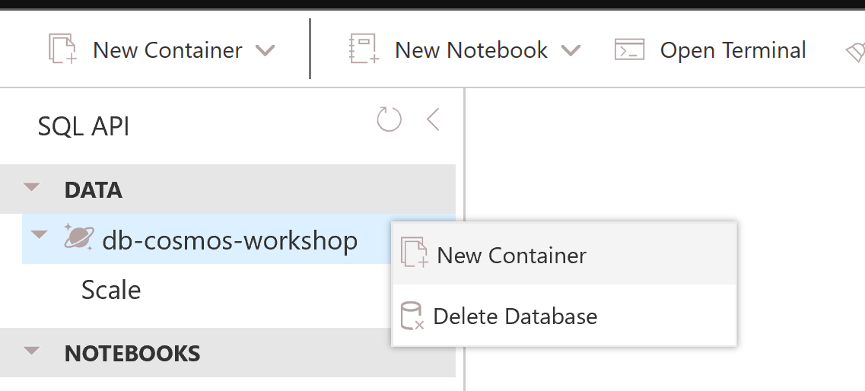
5. Name the container as weather-utility and the partition key as /entitytype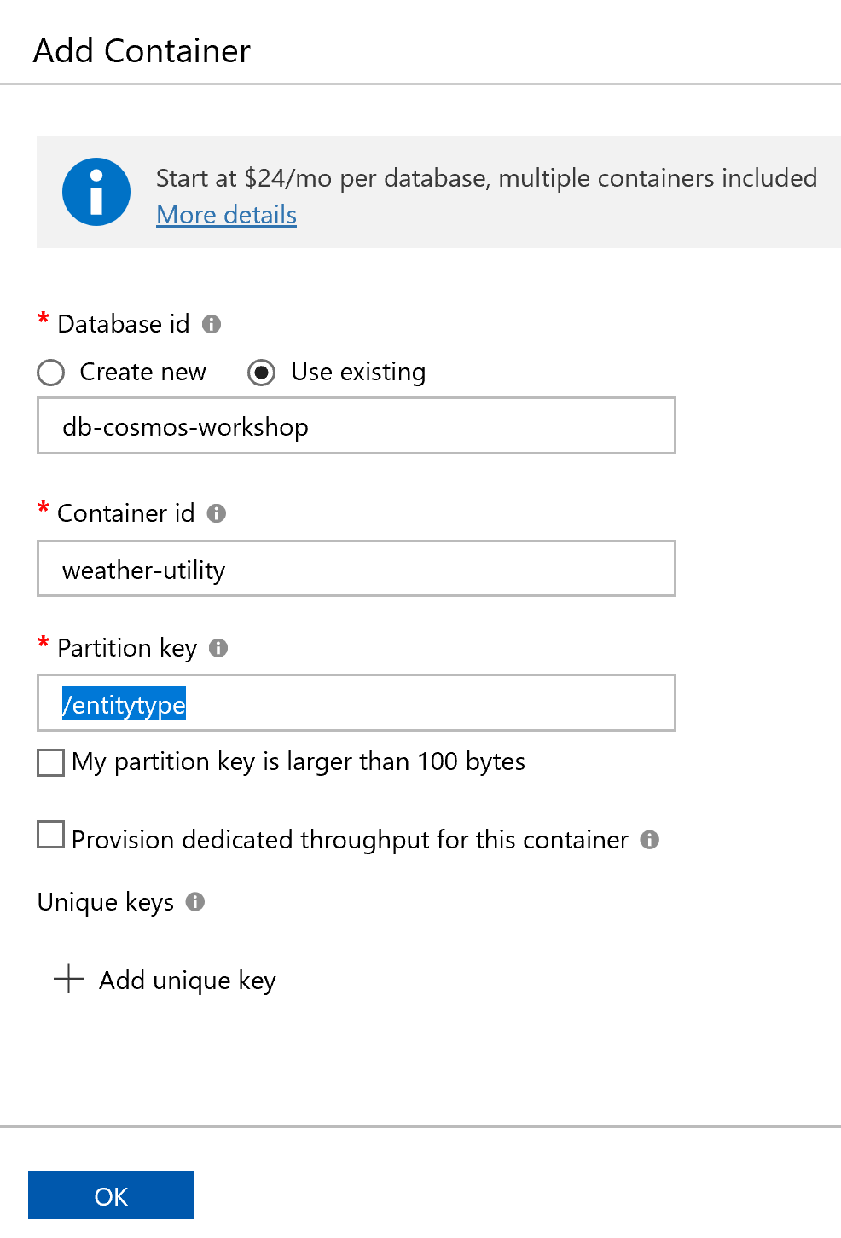
6. 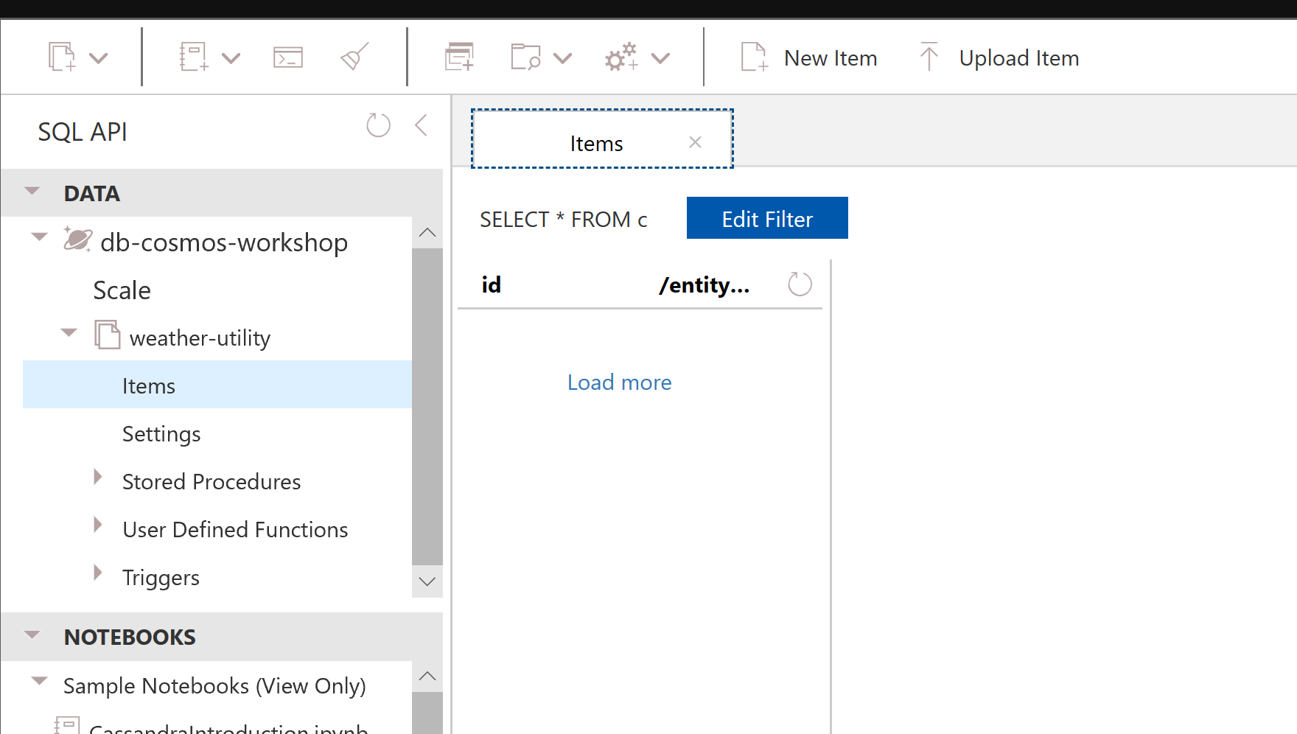
7. Click on Keys and store the URI and the primary key in a notepad for the stream analytics job to authenticate storing data in cosmos db 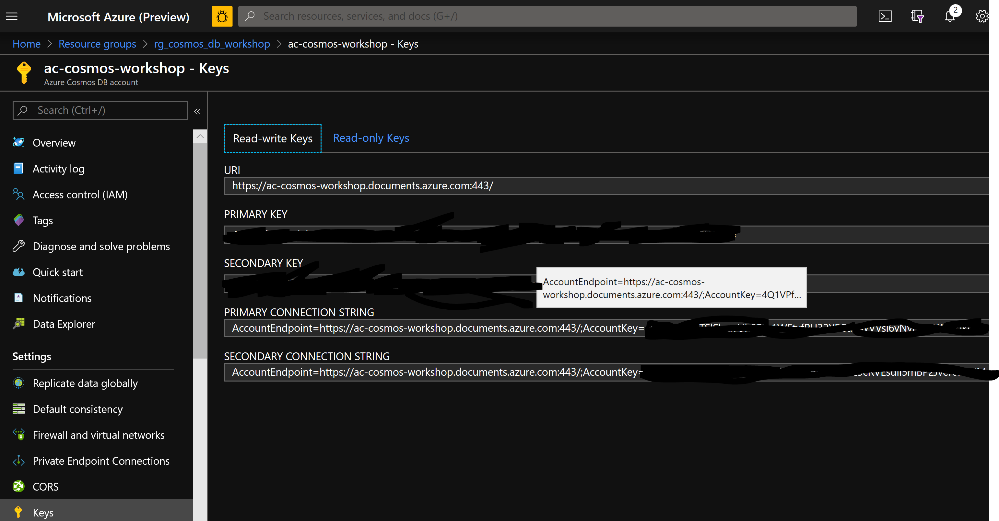

# Step4: Define Stream Analytics Job

1. Go back to the stream analytics job from the resource group

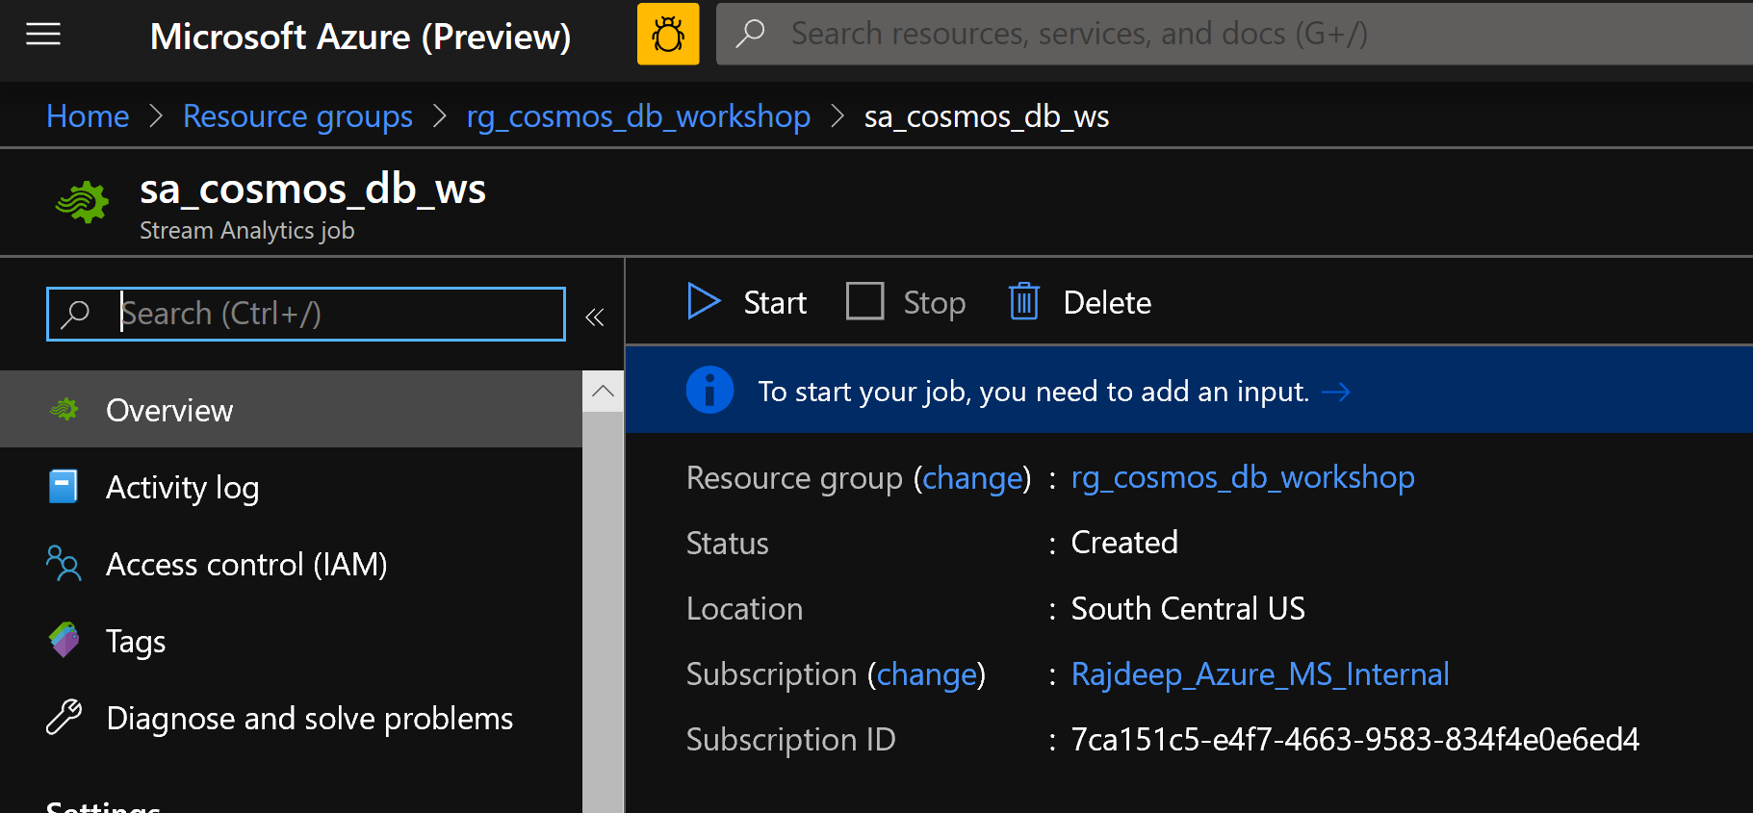

1. Click on input under job topology and define the input of the job. In this case it will be an event hub from which you will subscribe to the weather data and the utility data. 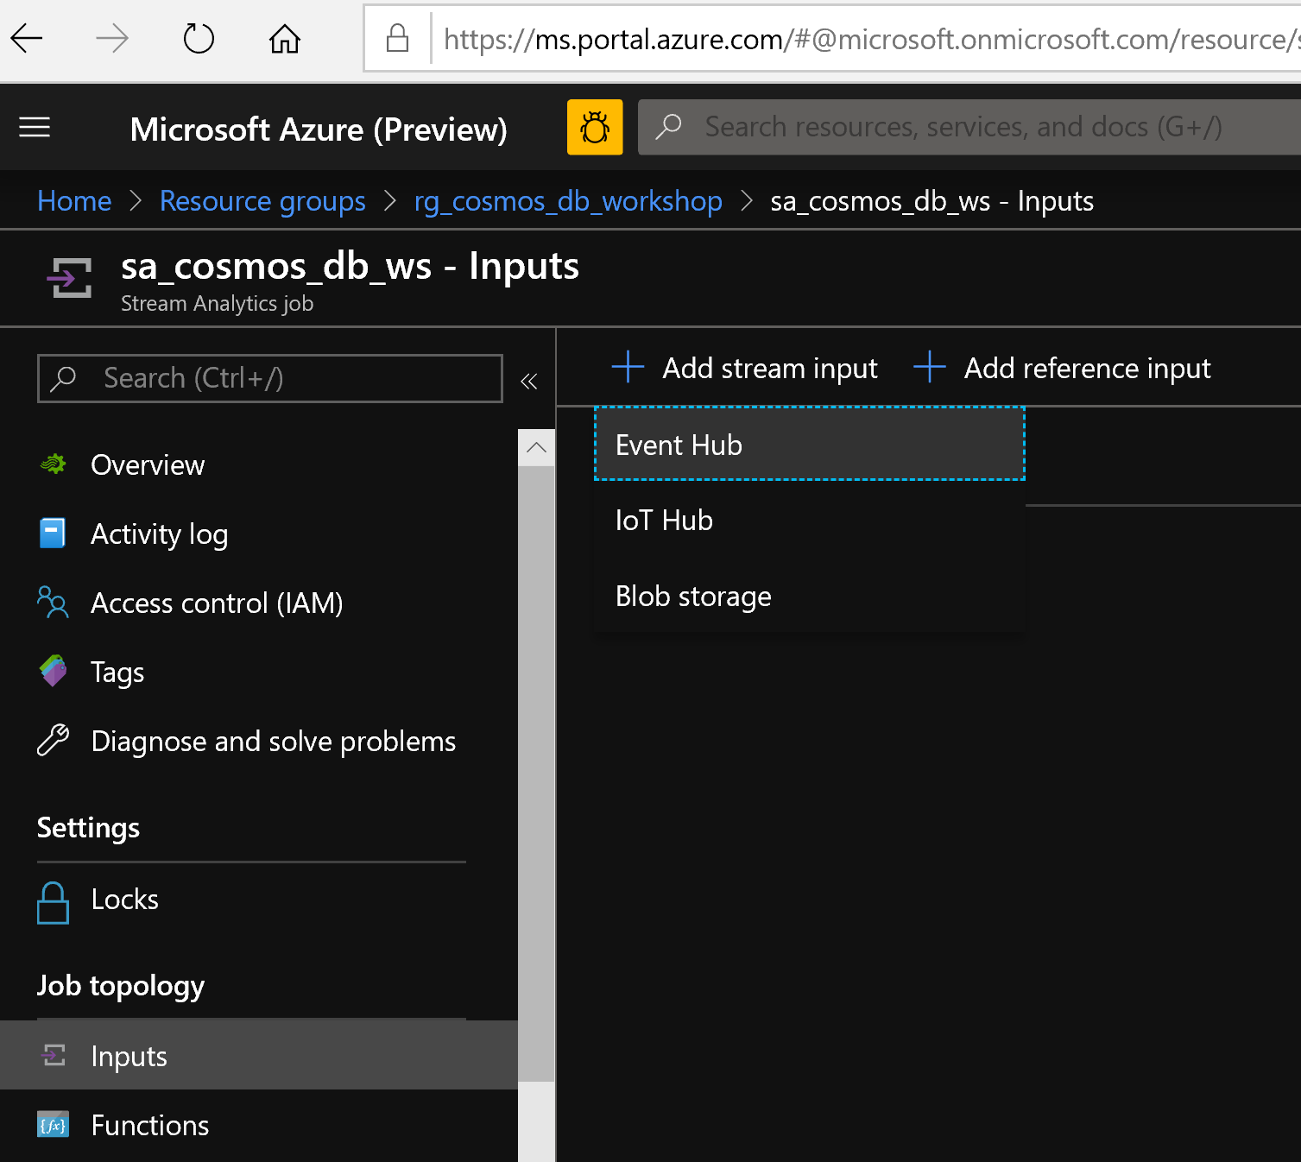
2. Create the input alias as event-hub-input and provide Event Hub settings manually and click Save

Value you need:

Service Bus namespace: eventhubstd

Event Hub Name: stdehp6

Event Hub policy name: RootManageSharedAccessKey

Event Hub policy key: OjoTMeyDnwc11JxRIYbmNFOXSlVDBoFnFFANRw2ojh4=

Event hub consumer group: cg<allotted_number> *

*we will provide you the allotted number

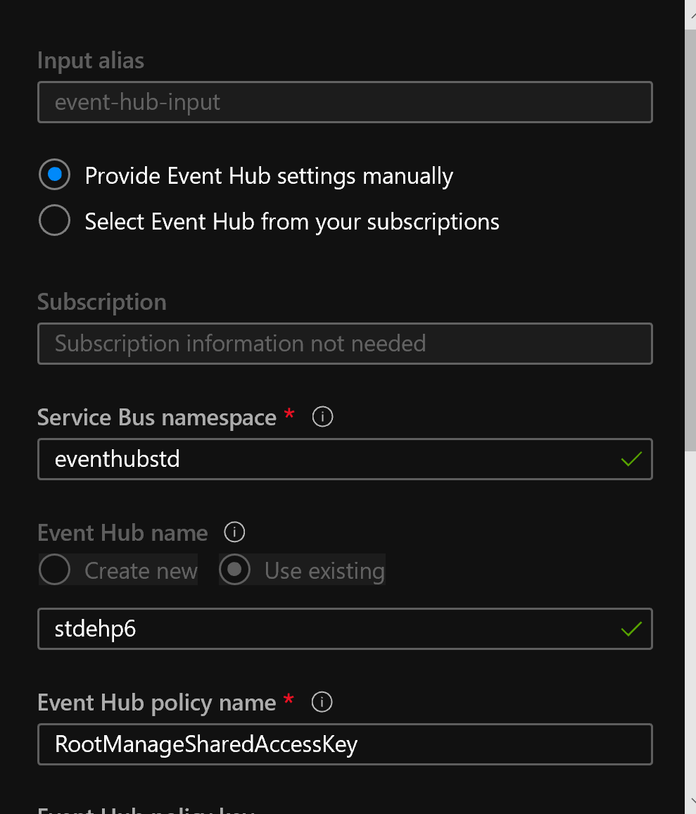

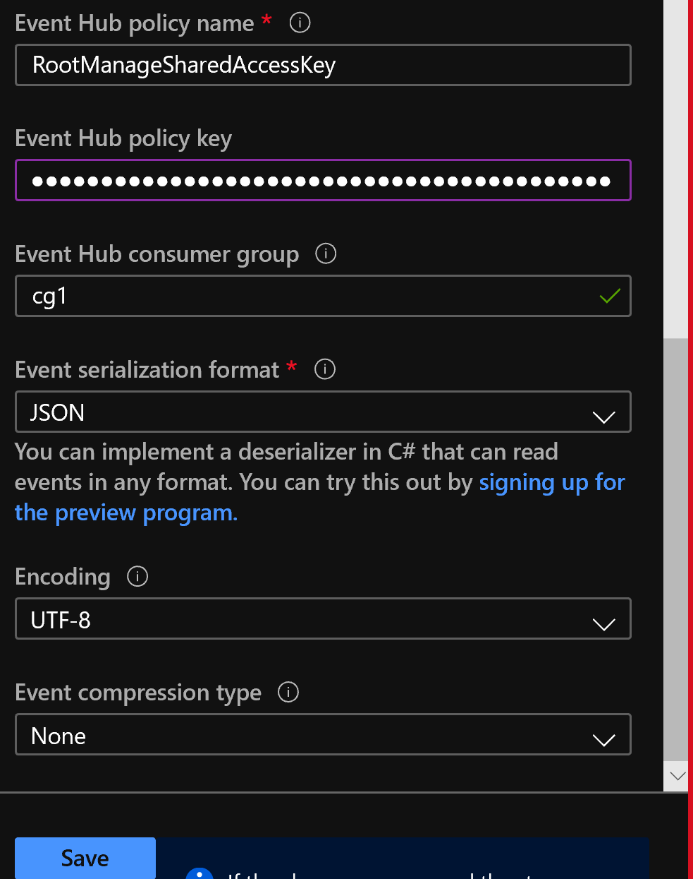

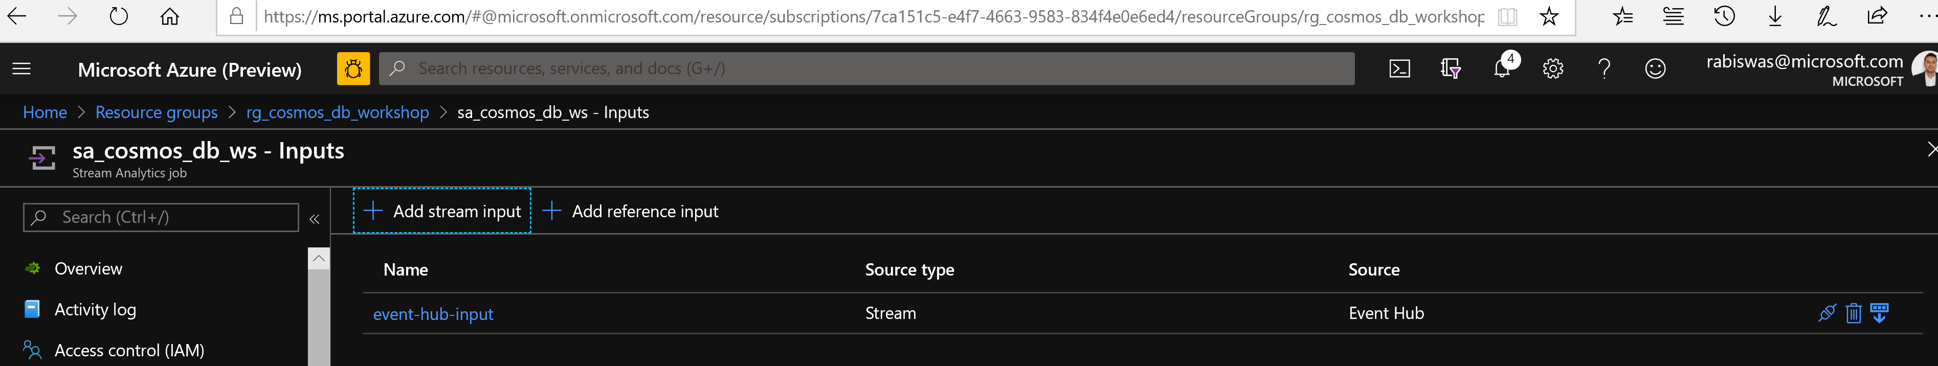

1. Go to the Outputs section and create the cosmos db output 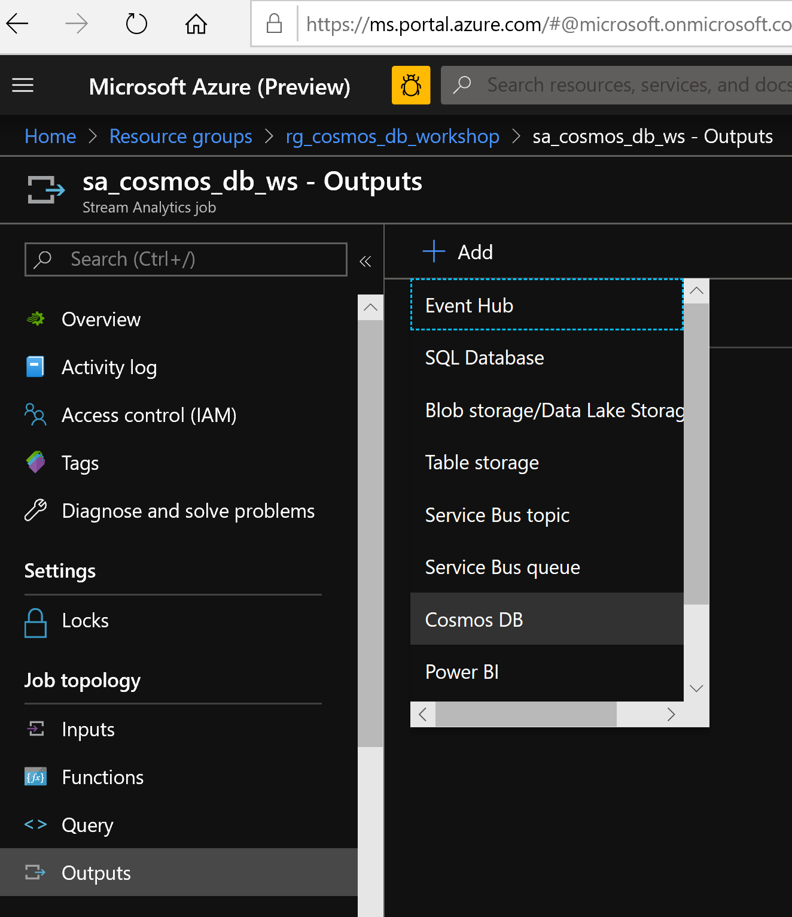
2. Name it as cosmos-db-output and choose it from your subscription, put the container name as weather-utility and hit save 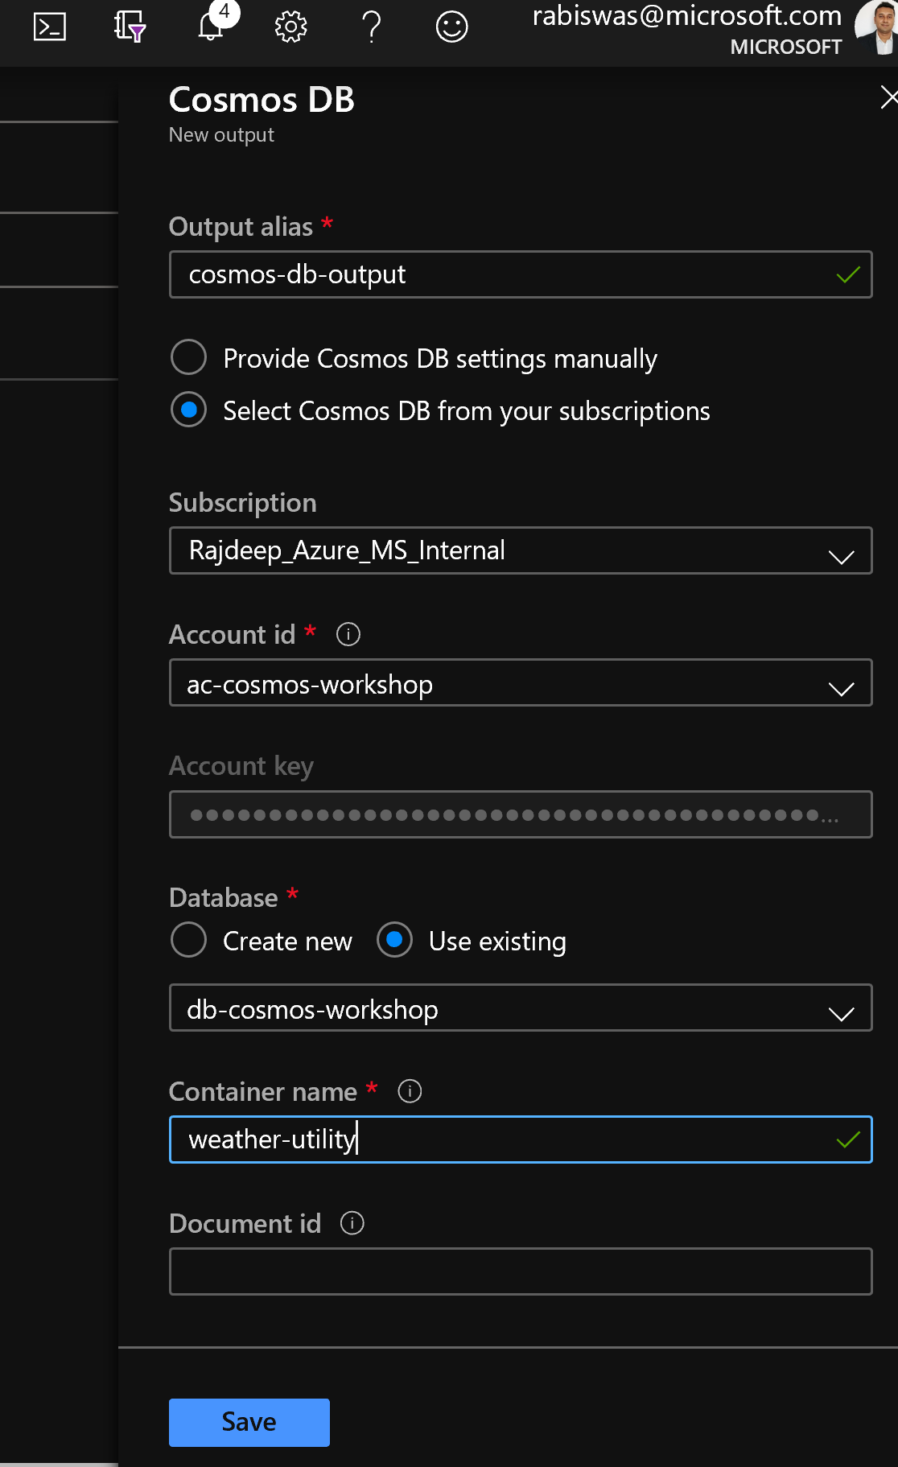 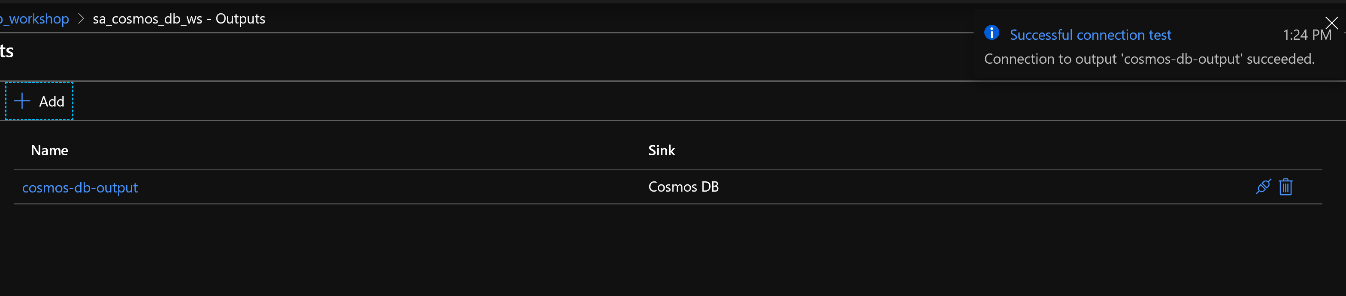
3. Go to the Query section under job topology and define the query aka the job definition for your stream analytics. Copy and paste the following lines.

SELECT

*,'stdehp6' AS datasource

INTO

[cosmos-db-output]

FROM

[event-hub-input]

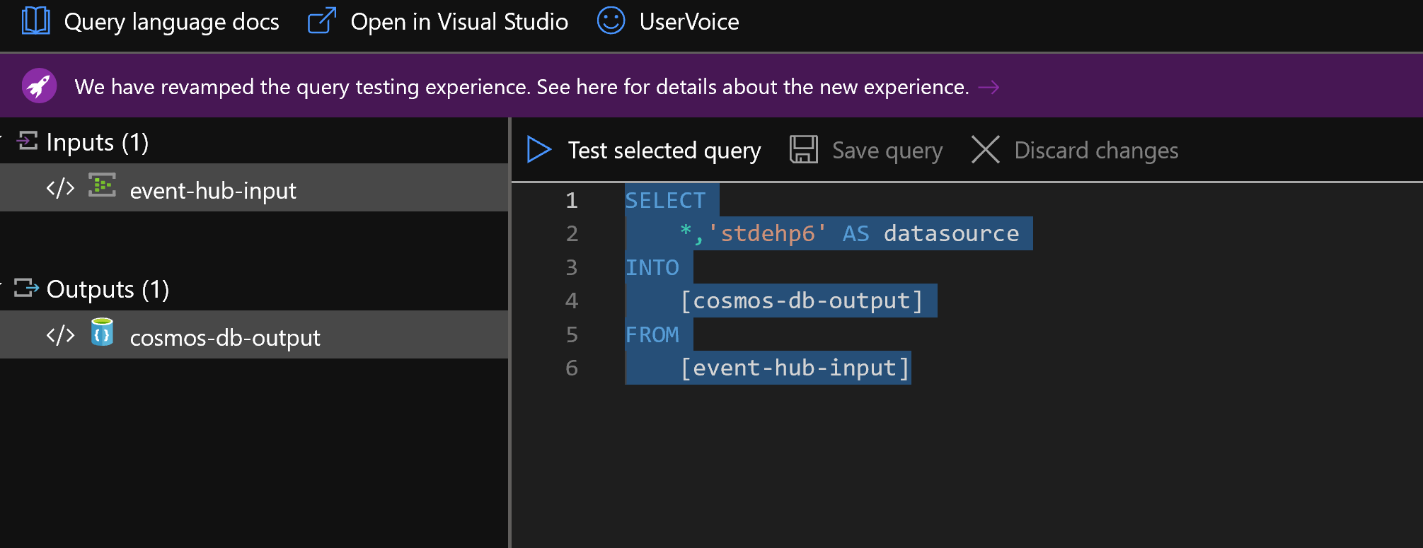

1. save the query.
2. Go back to overview section of the stream analytics job and hit Start

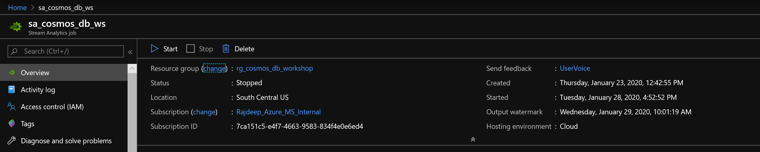

Click start with job output start time as now

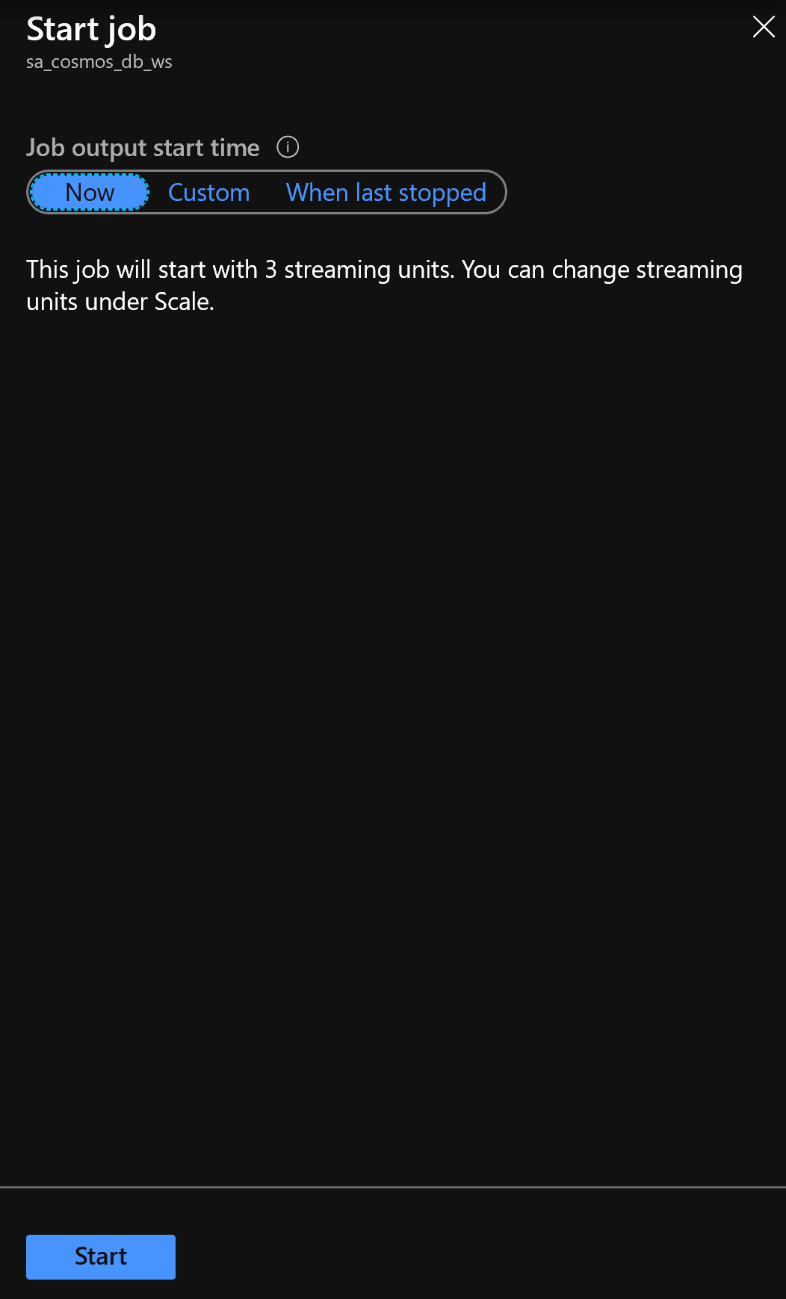

15. To test from cosmos db new data we need to create a new udf.

Go back to cosmos db Data explorer page

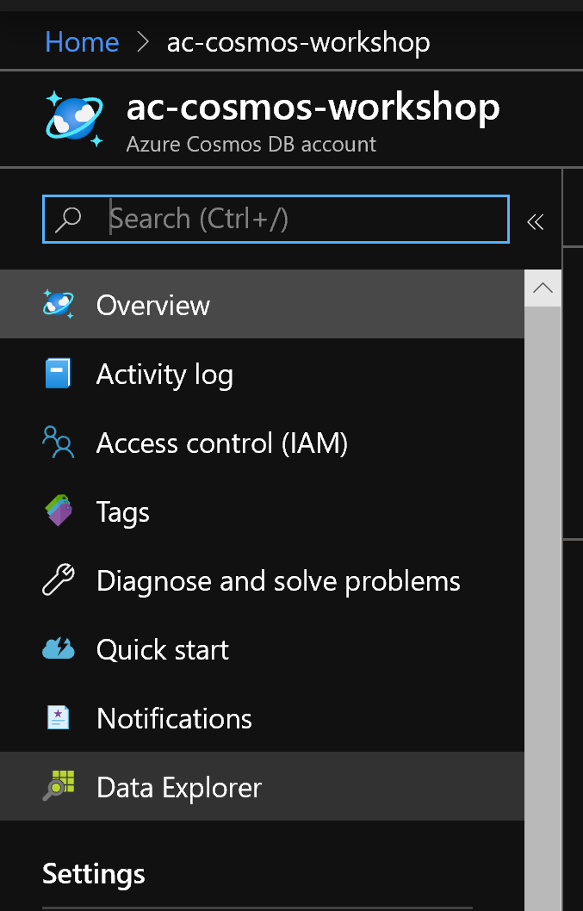

Click on the weather-utility container and select New UDF

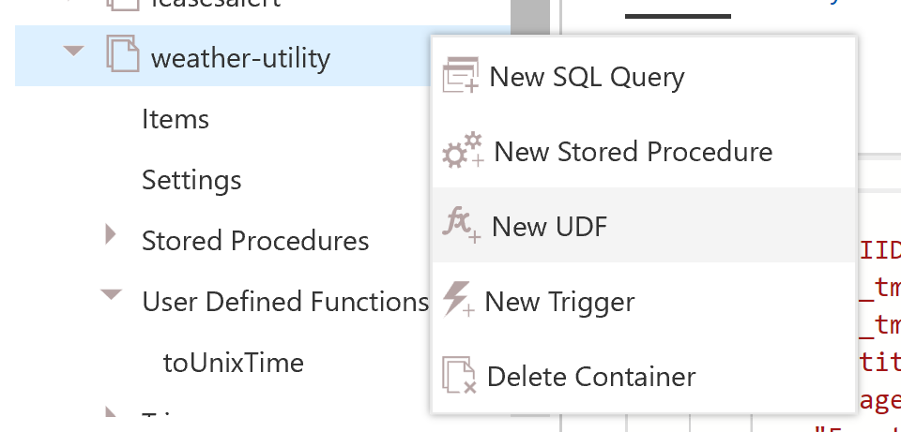

Copy Paste the following function definition and name the function ad toUnixTime

function toUnixTime(val1){

var newDate = new Date(val1);

var unixTimeStamp = Math.floor(newDate.getTime() / 1000);

return unixTimeStamp + 21600;

}

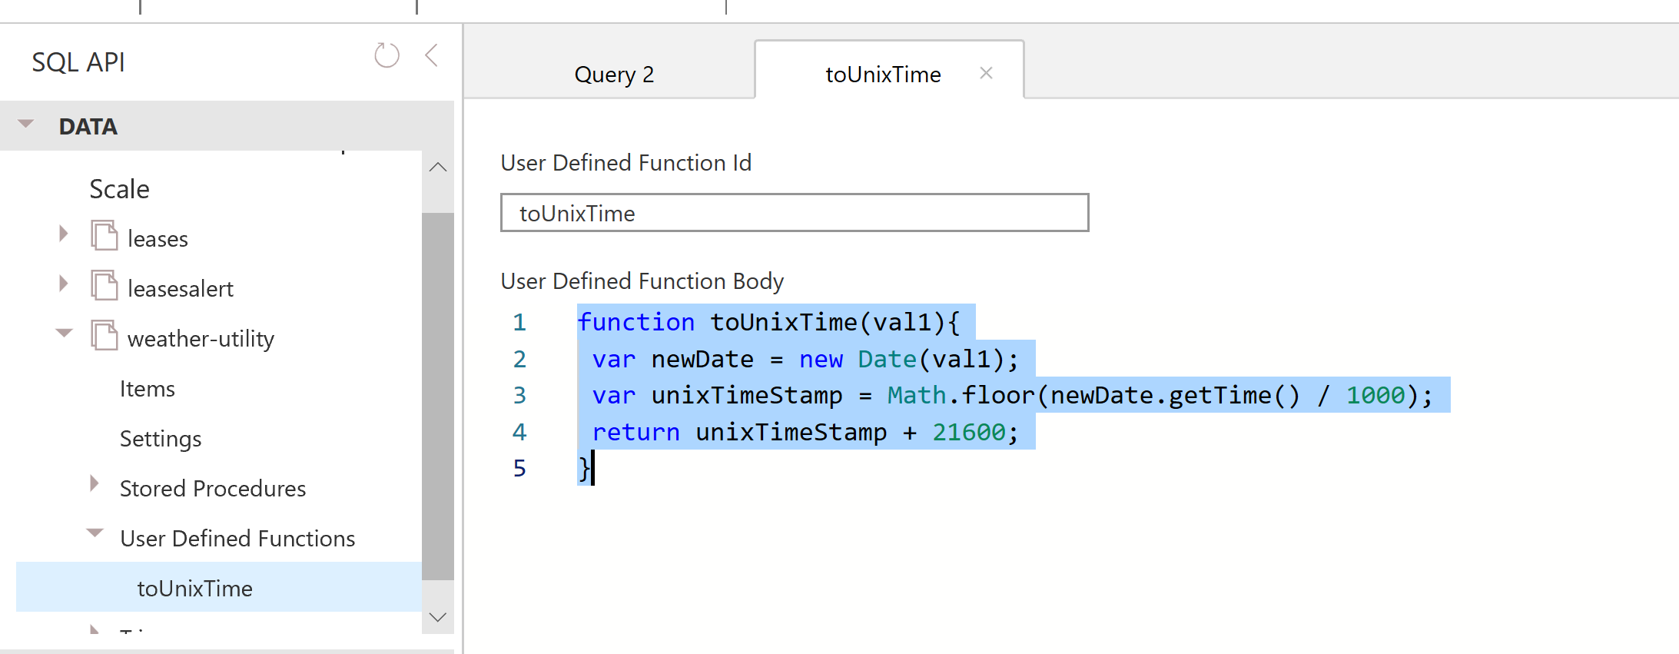

Hit Save

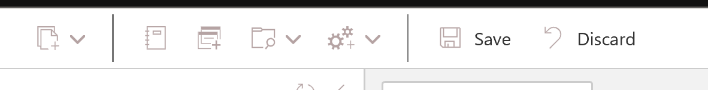

Create a new SQL query by clicking the the container

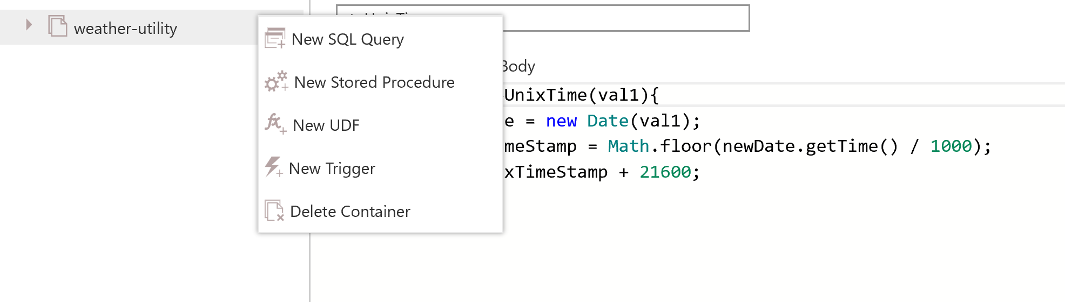

Copy the following query to test out new data and hit execute:

SELECT * FROM c where c.entitytype='kwh_raw' AND c._ts>=udf.toUnixTime('1/30/2020 1:00:00 PM')

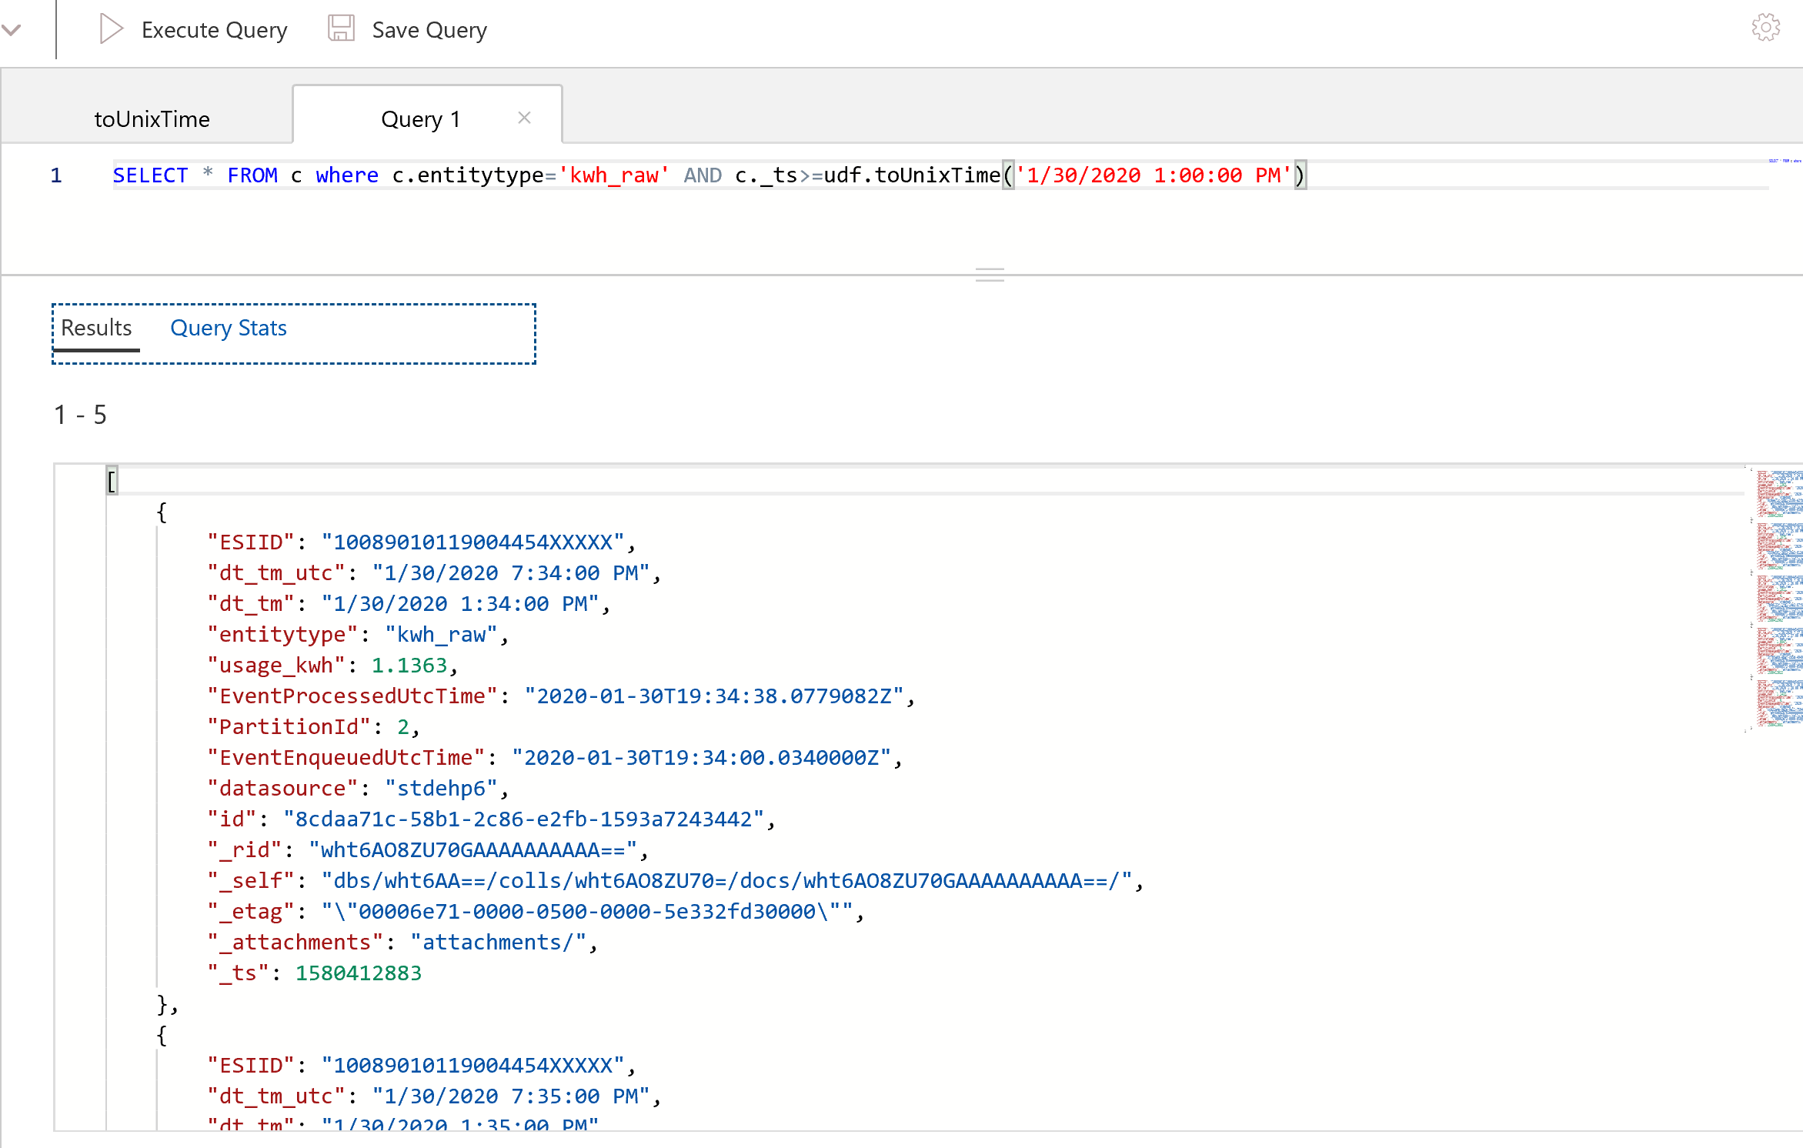

# Step5: Create Azure Function to set up alerts and aggregations

1. First create a Function App 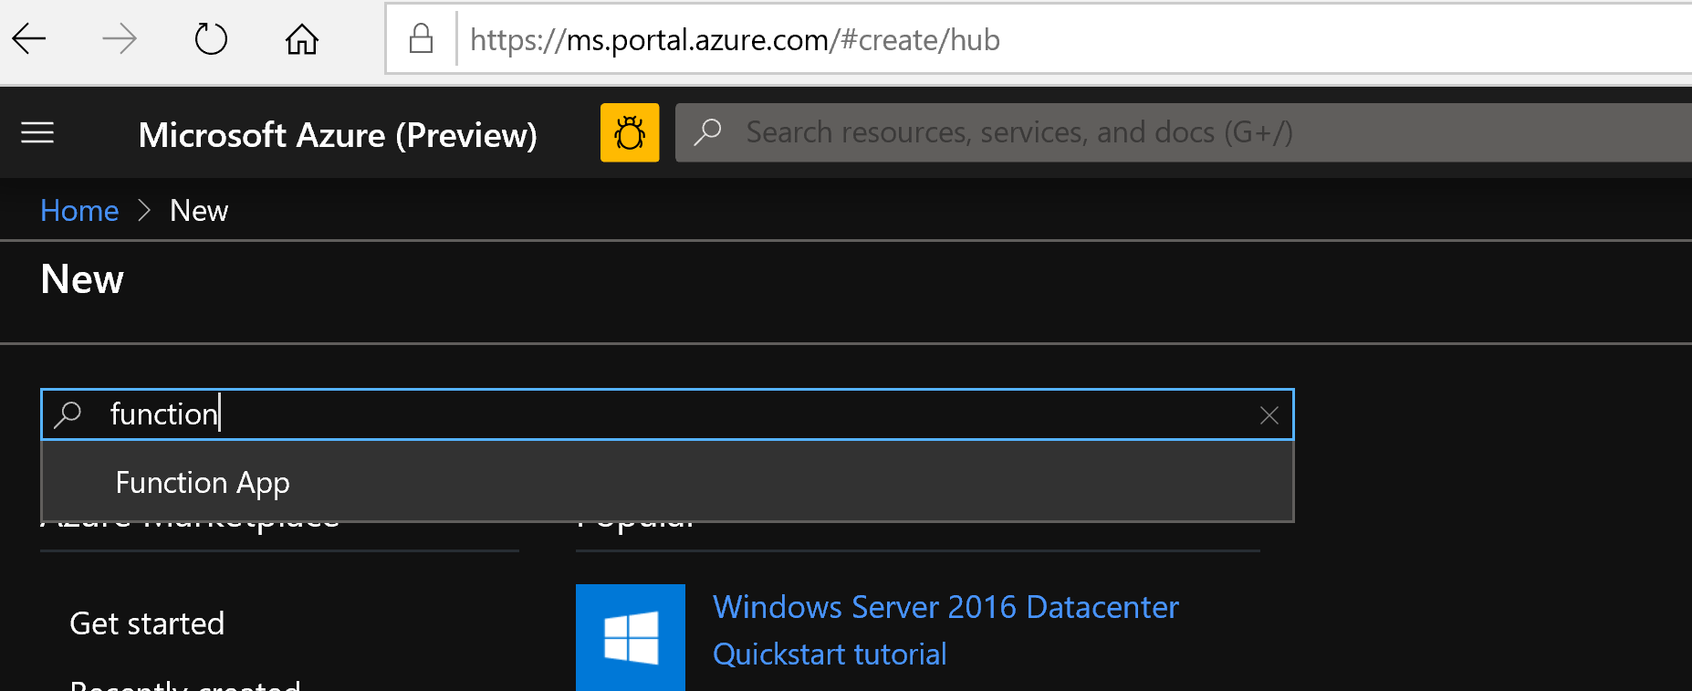
2. Name it function-app-cosmos-<alias> and put it in the resource group you are using

Select the Runtime stack as .Net Core and choose the region as South Central US

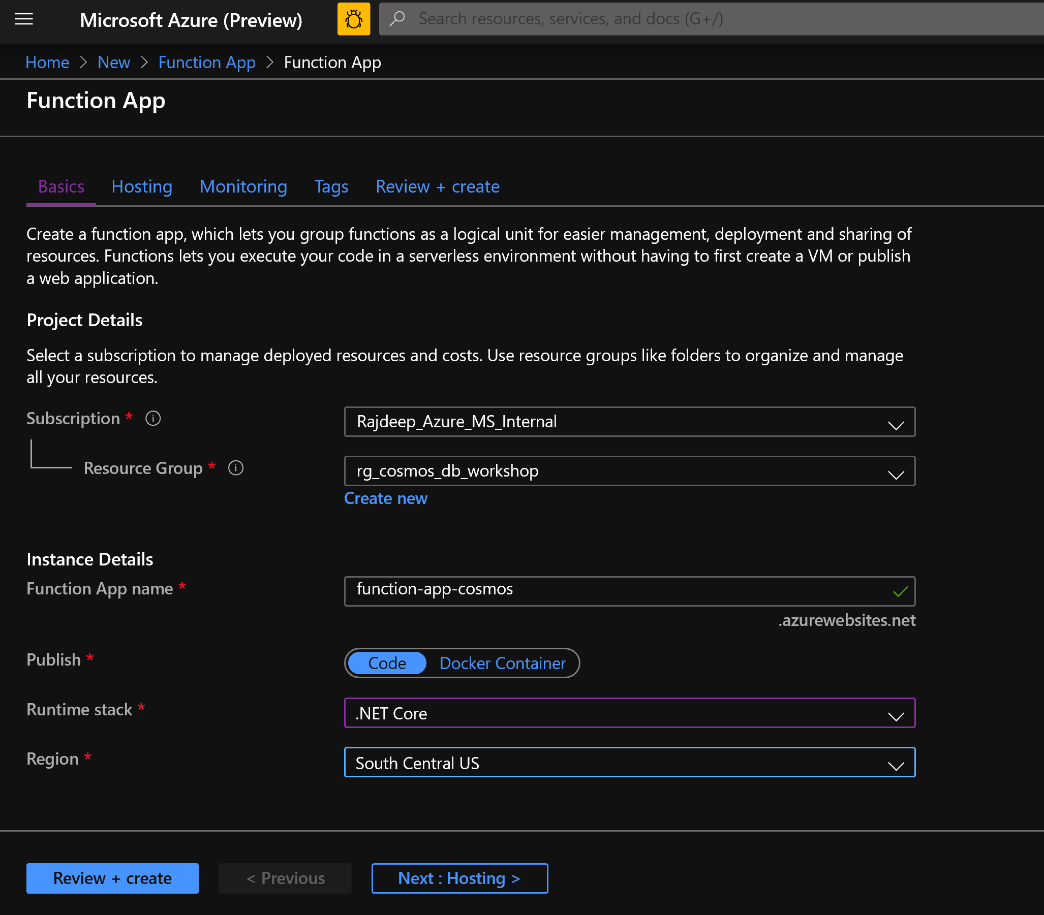

1. Hit Next: Hosting. Check the values Operating system should be Windows and Consumption plan is good.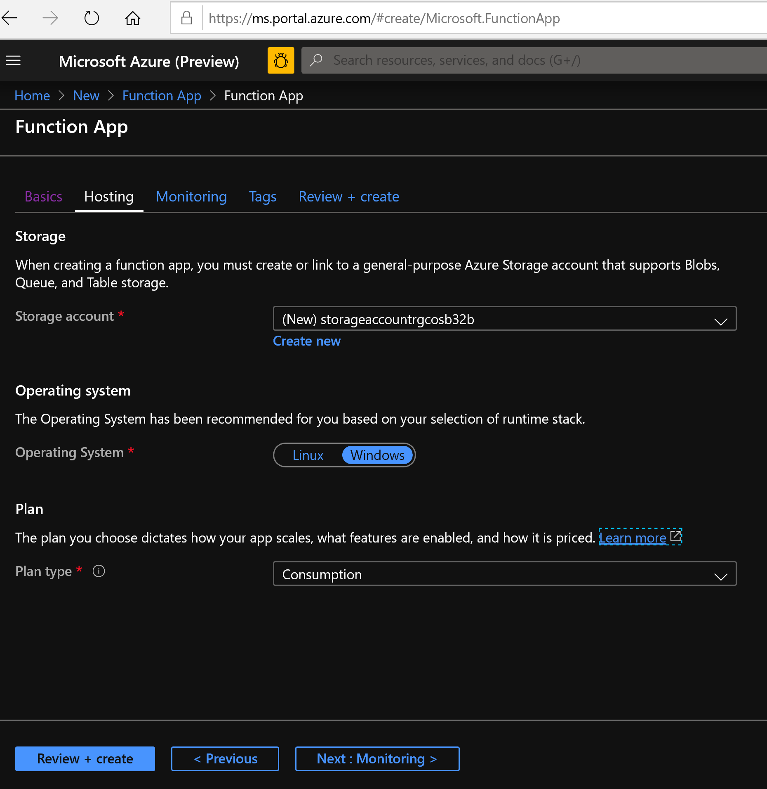
2. Review + create and then then hit Create after the validation is done.
3. Go to the newly created function app and we will add here some configuration settings

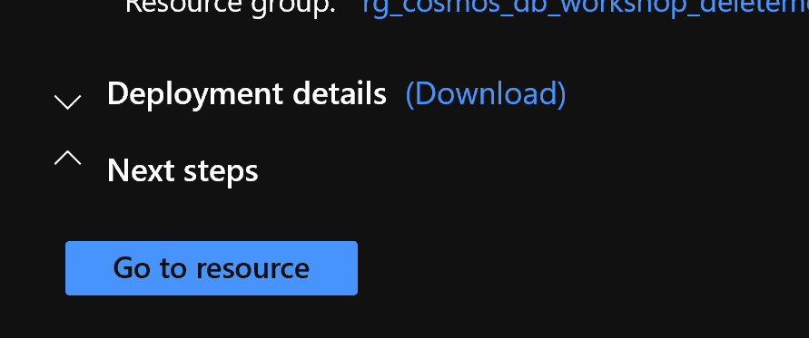

1. Click on Configuration under Configured features in function app 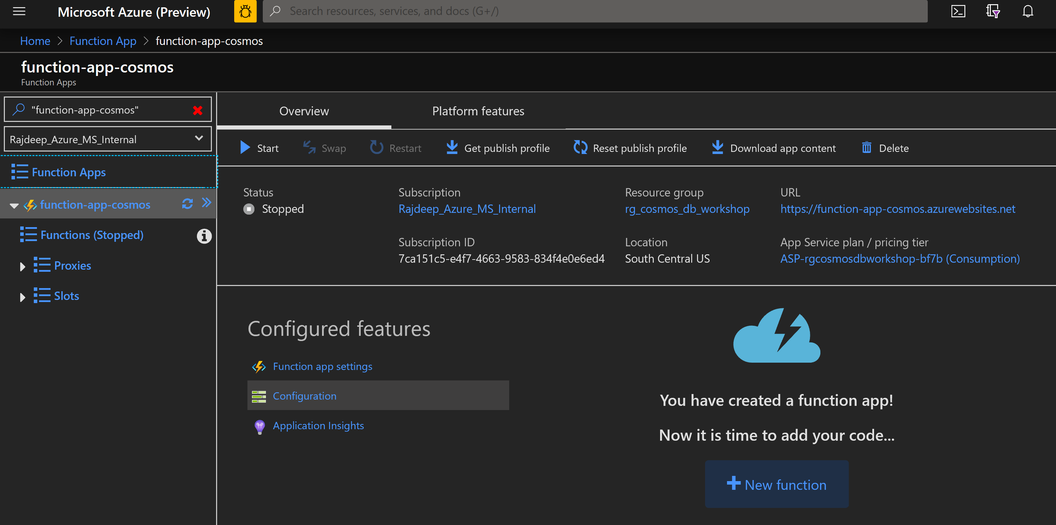
2. Click on new application setting 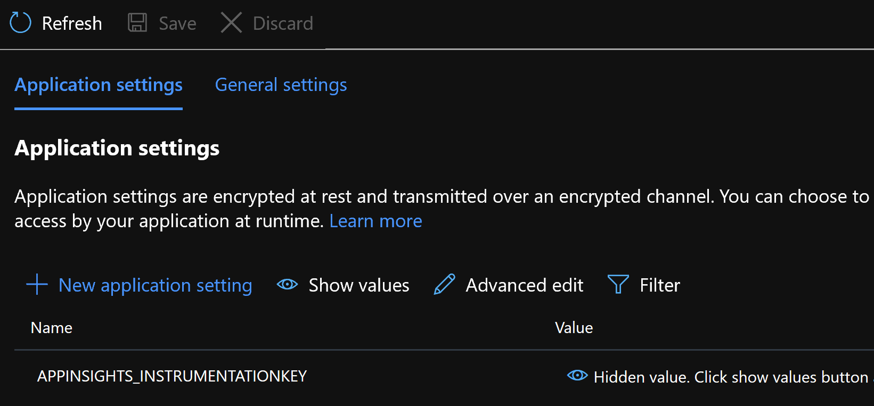 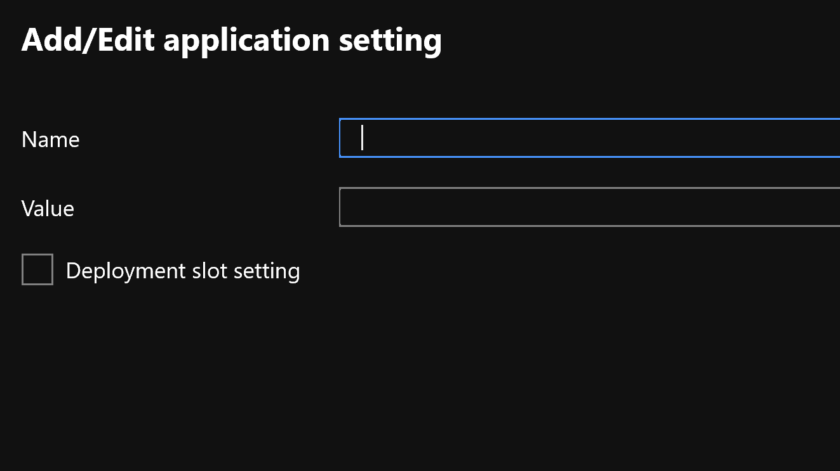
3. We will add the following configurations

|  |  |
| --- | --- |
| collectionname | weather-utility |
| databasename | db-cosmos-workshop-<alias> |
| endpoint | <CosmosDb URI that you copied from cosmos db keys section> |
| masterKey | <CosmosDb primary key that you copied from cosmos db keys section > |
| weather-utility-changefeed-kw_ConnectionString | <CosmosDb PRIMARY CONNECTION STRINGfrom cosmos db keys section > |

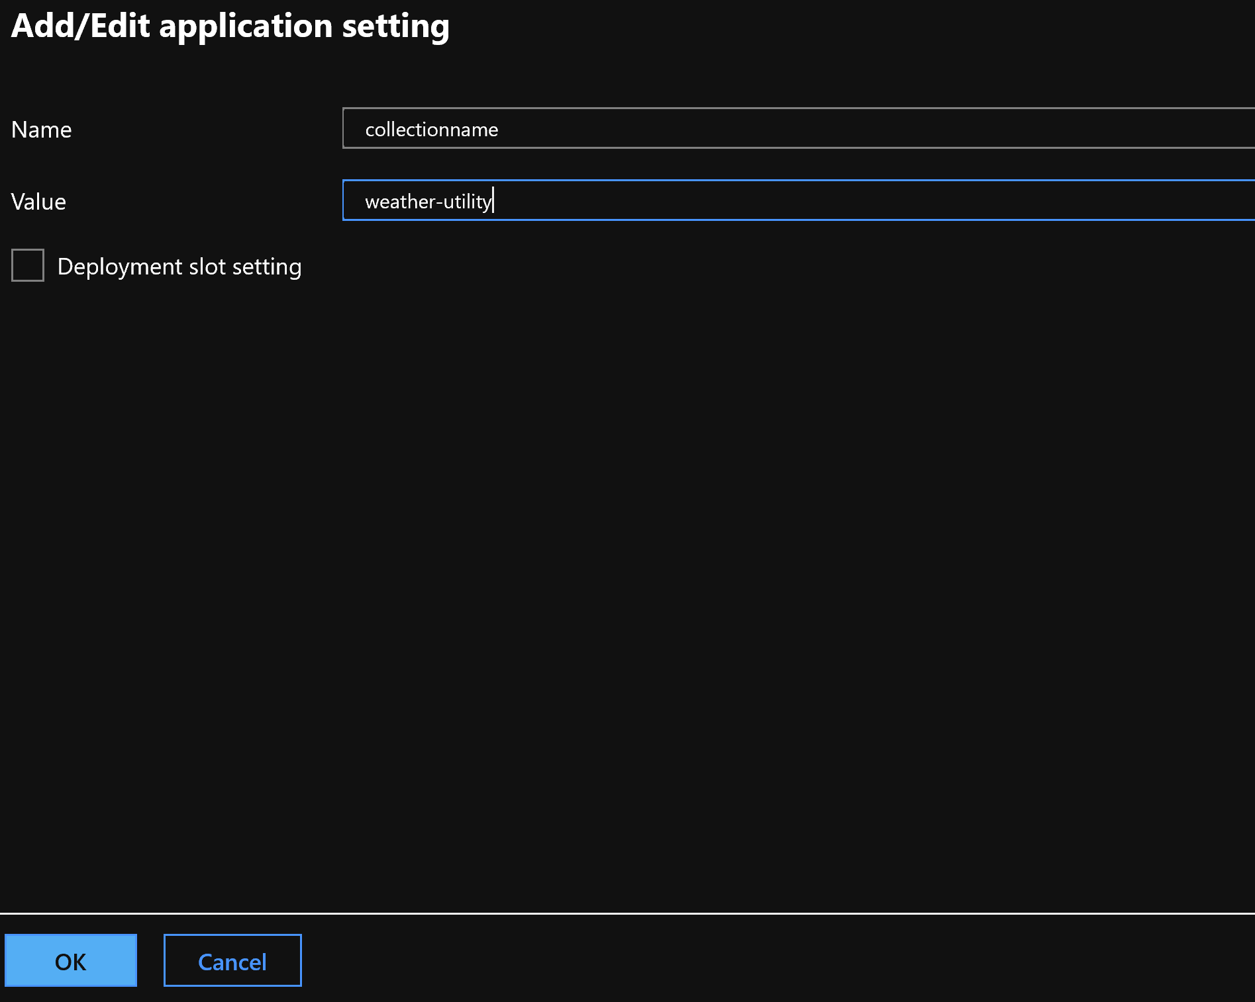

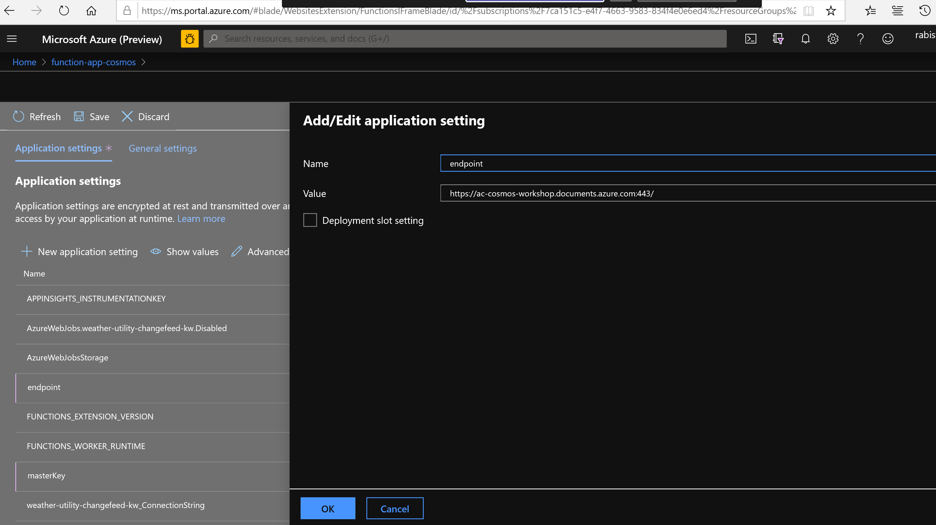

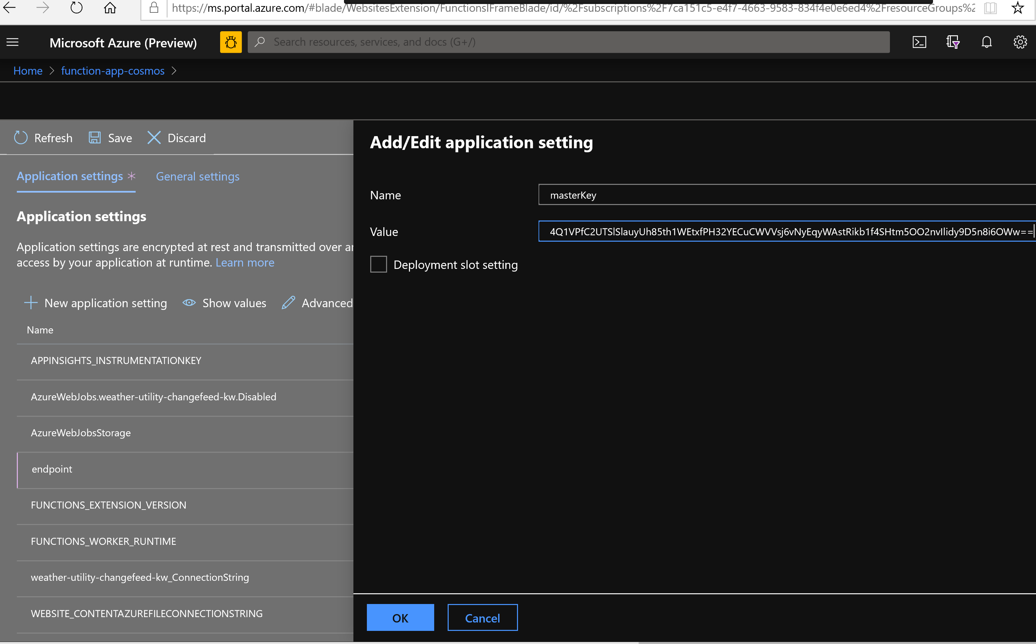

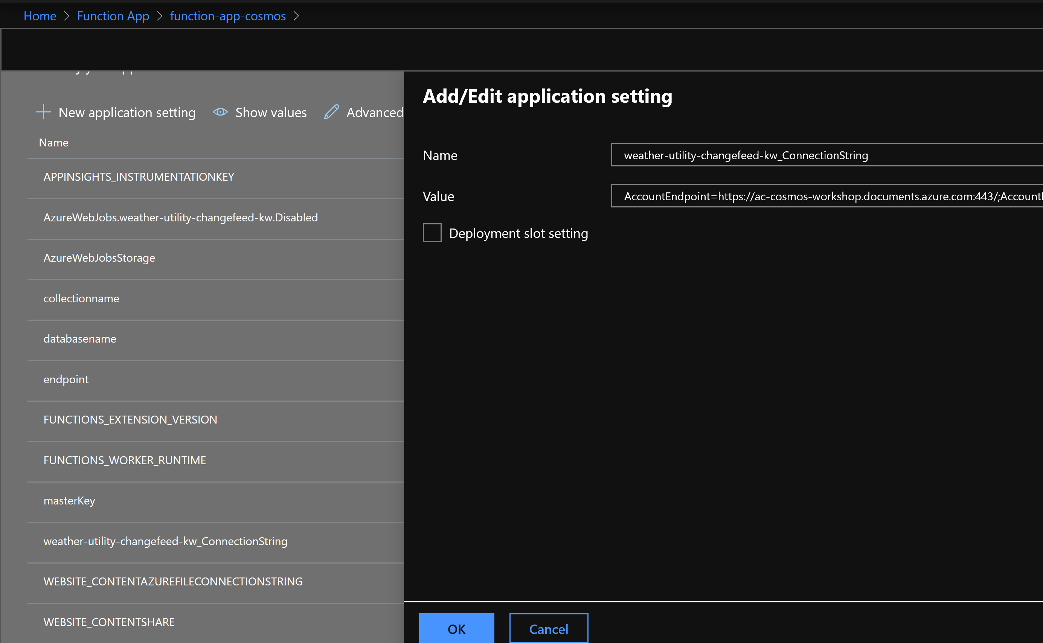

After adding all of them click save

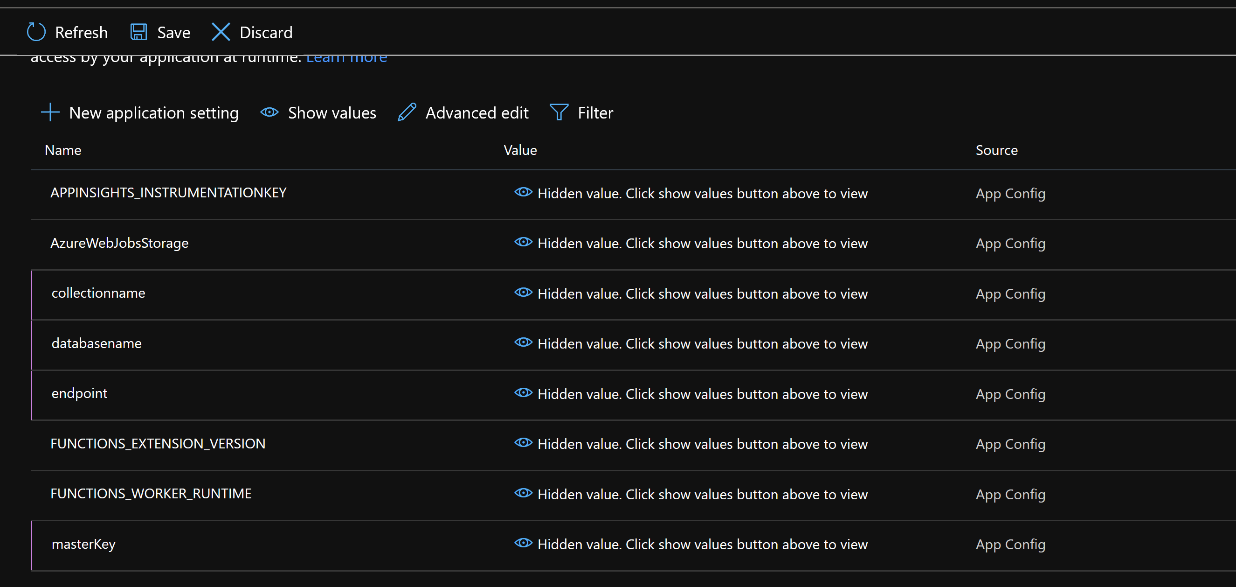

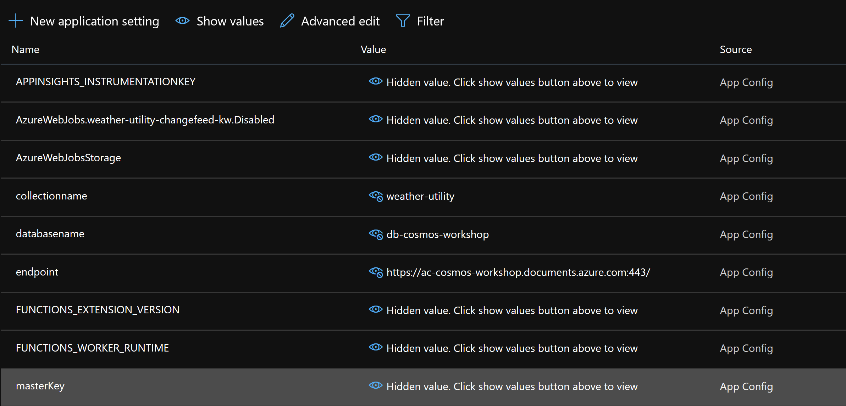

We will add 3 functions for this workshop each demonstrating different capabilities.

1. The first function we will add is called aggregate-kwh-timer-trigger

From the function apps page click the + sign to create a new function

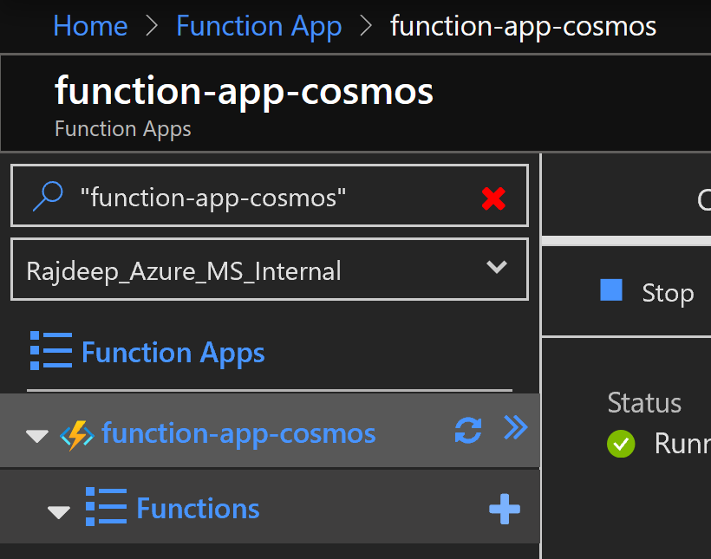

Next click on In-portal option on the quick start page and hit continue

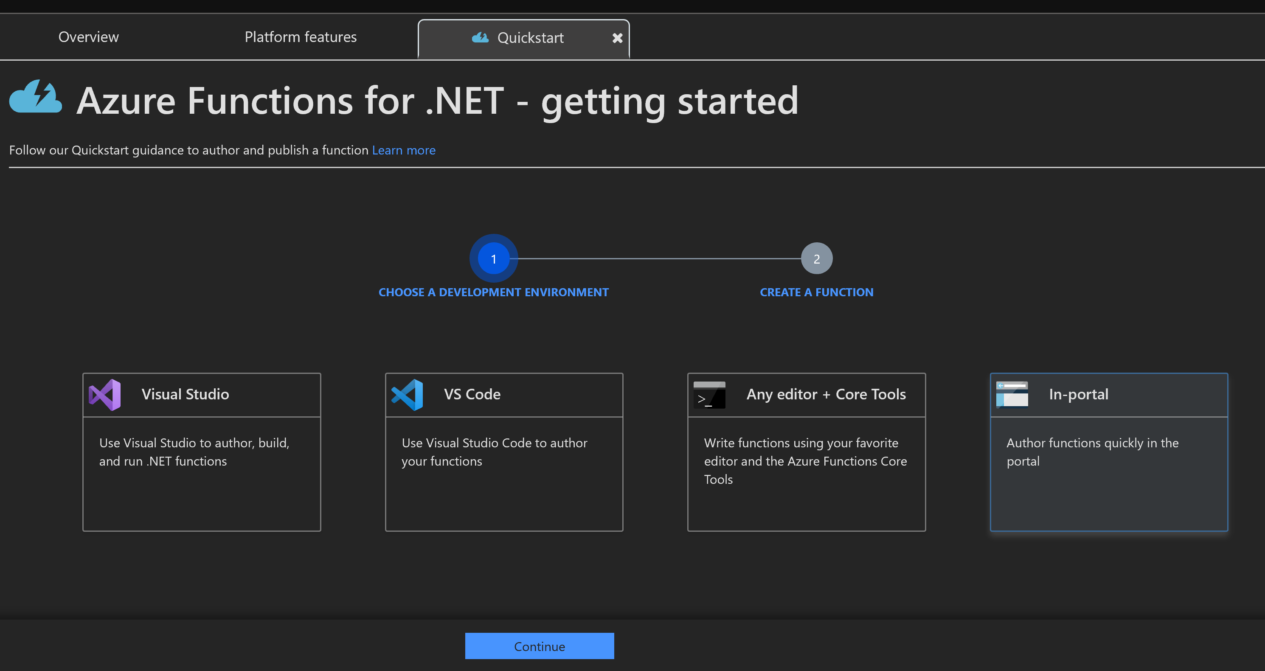

Click on More templates and then Finish and view templates

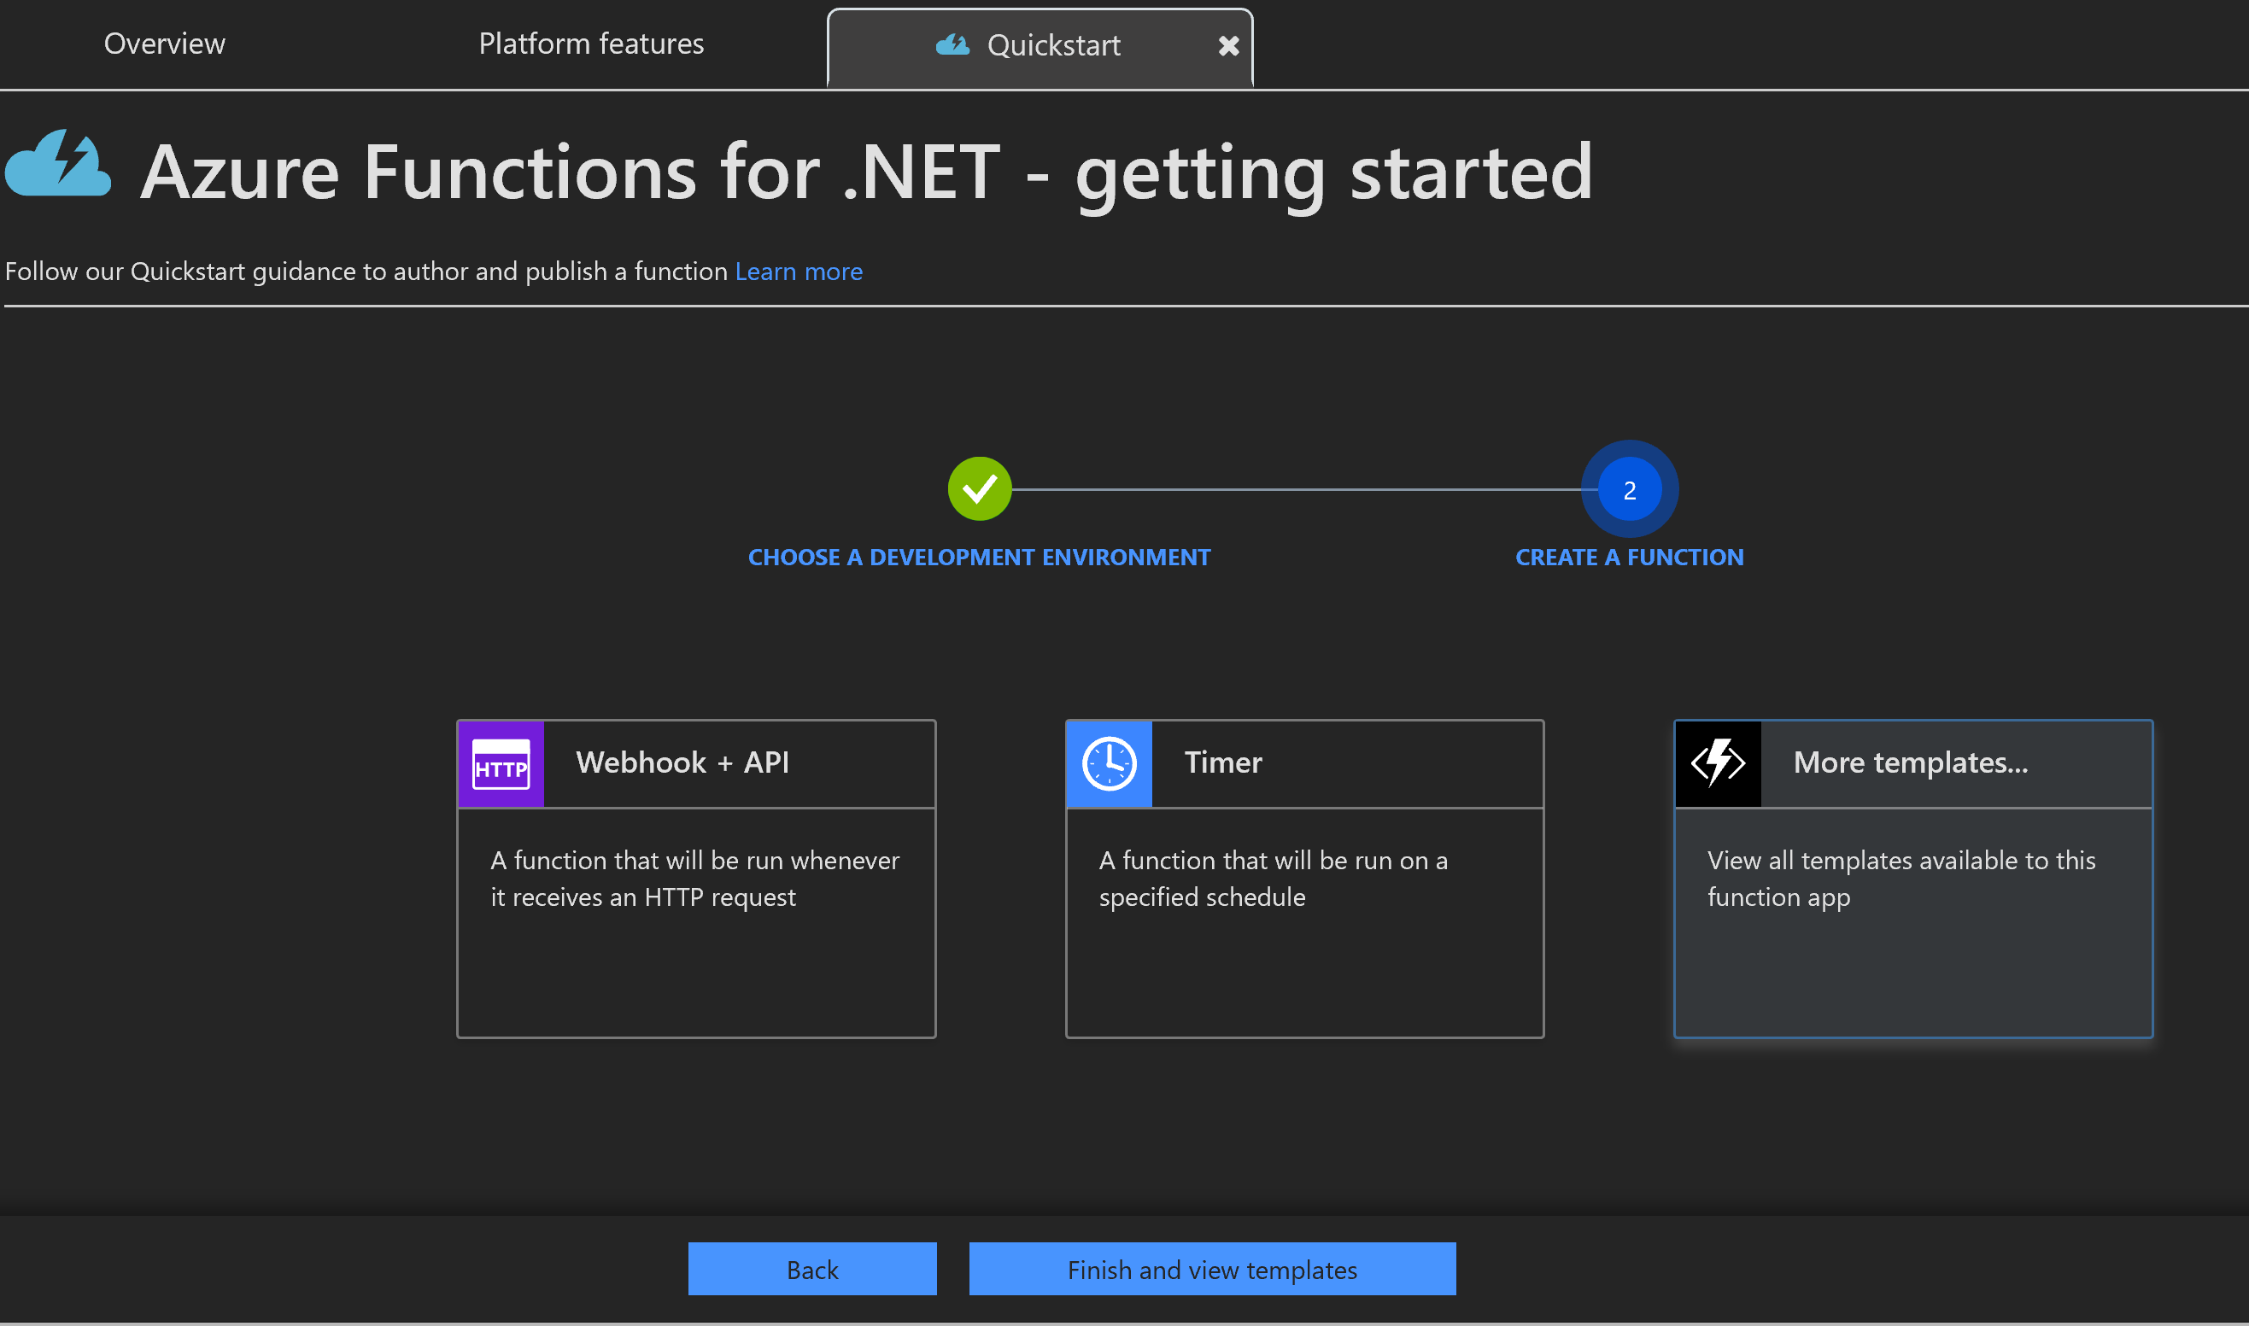

Choose timer trigger name it as aggregate-kwh-timer-trigger, change the schedule as 0 */3 * * * * and hit create

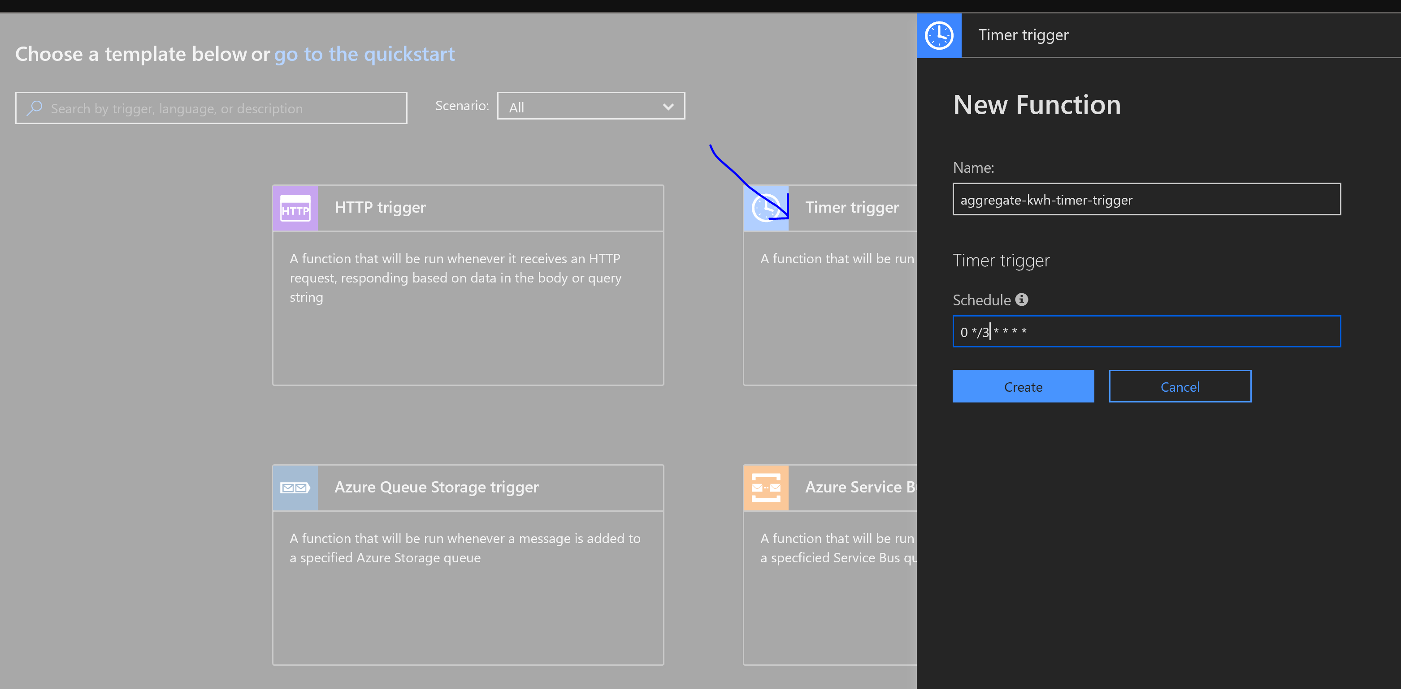

Click on integrate

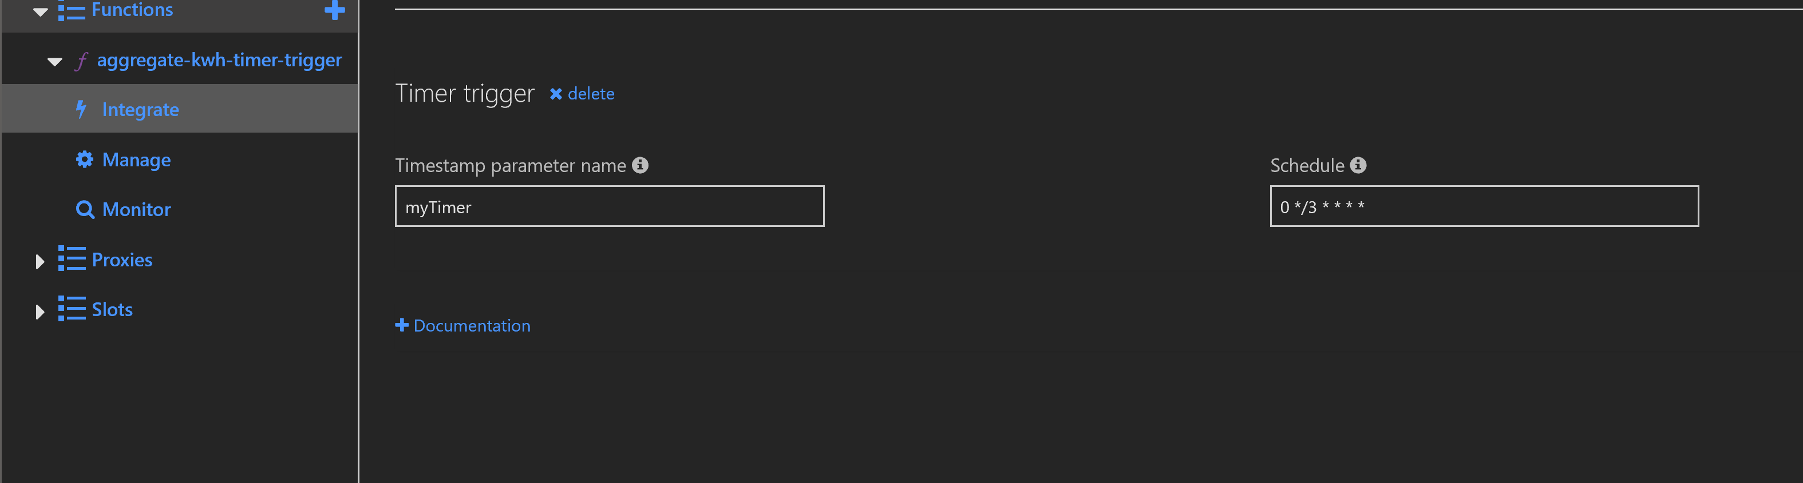

And then click on new Output. Choose cosmos db

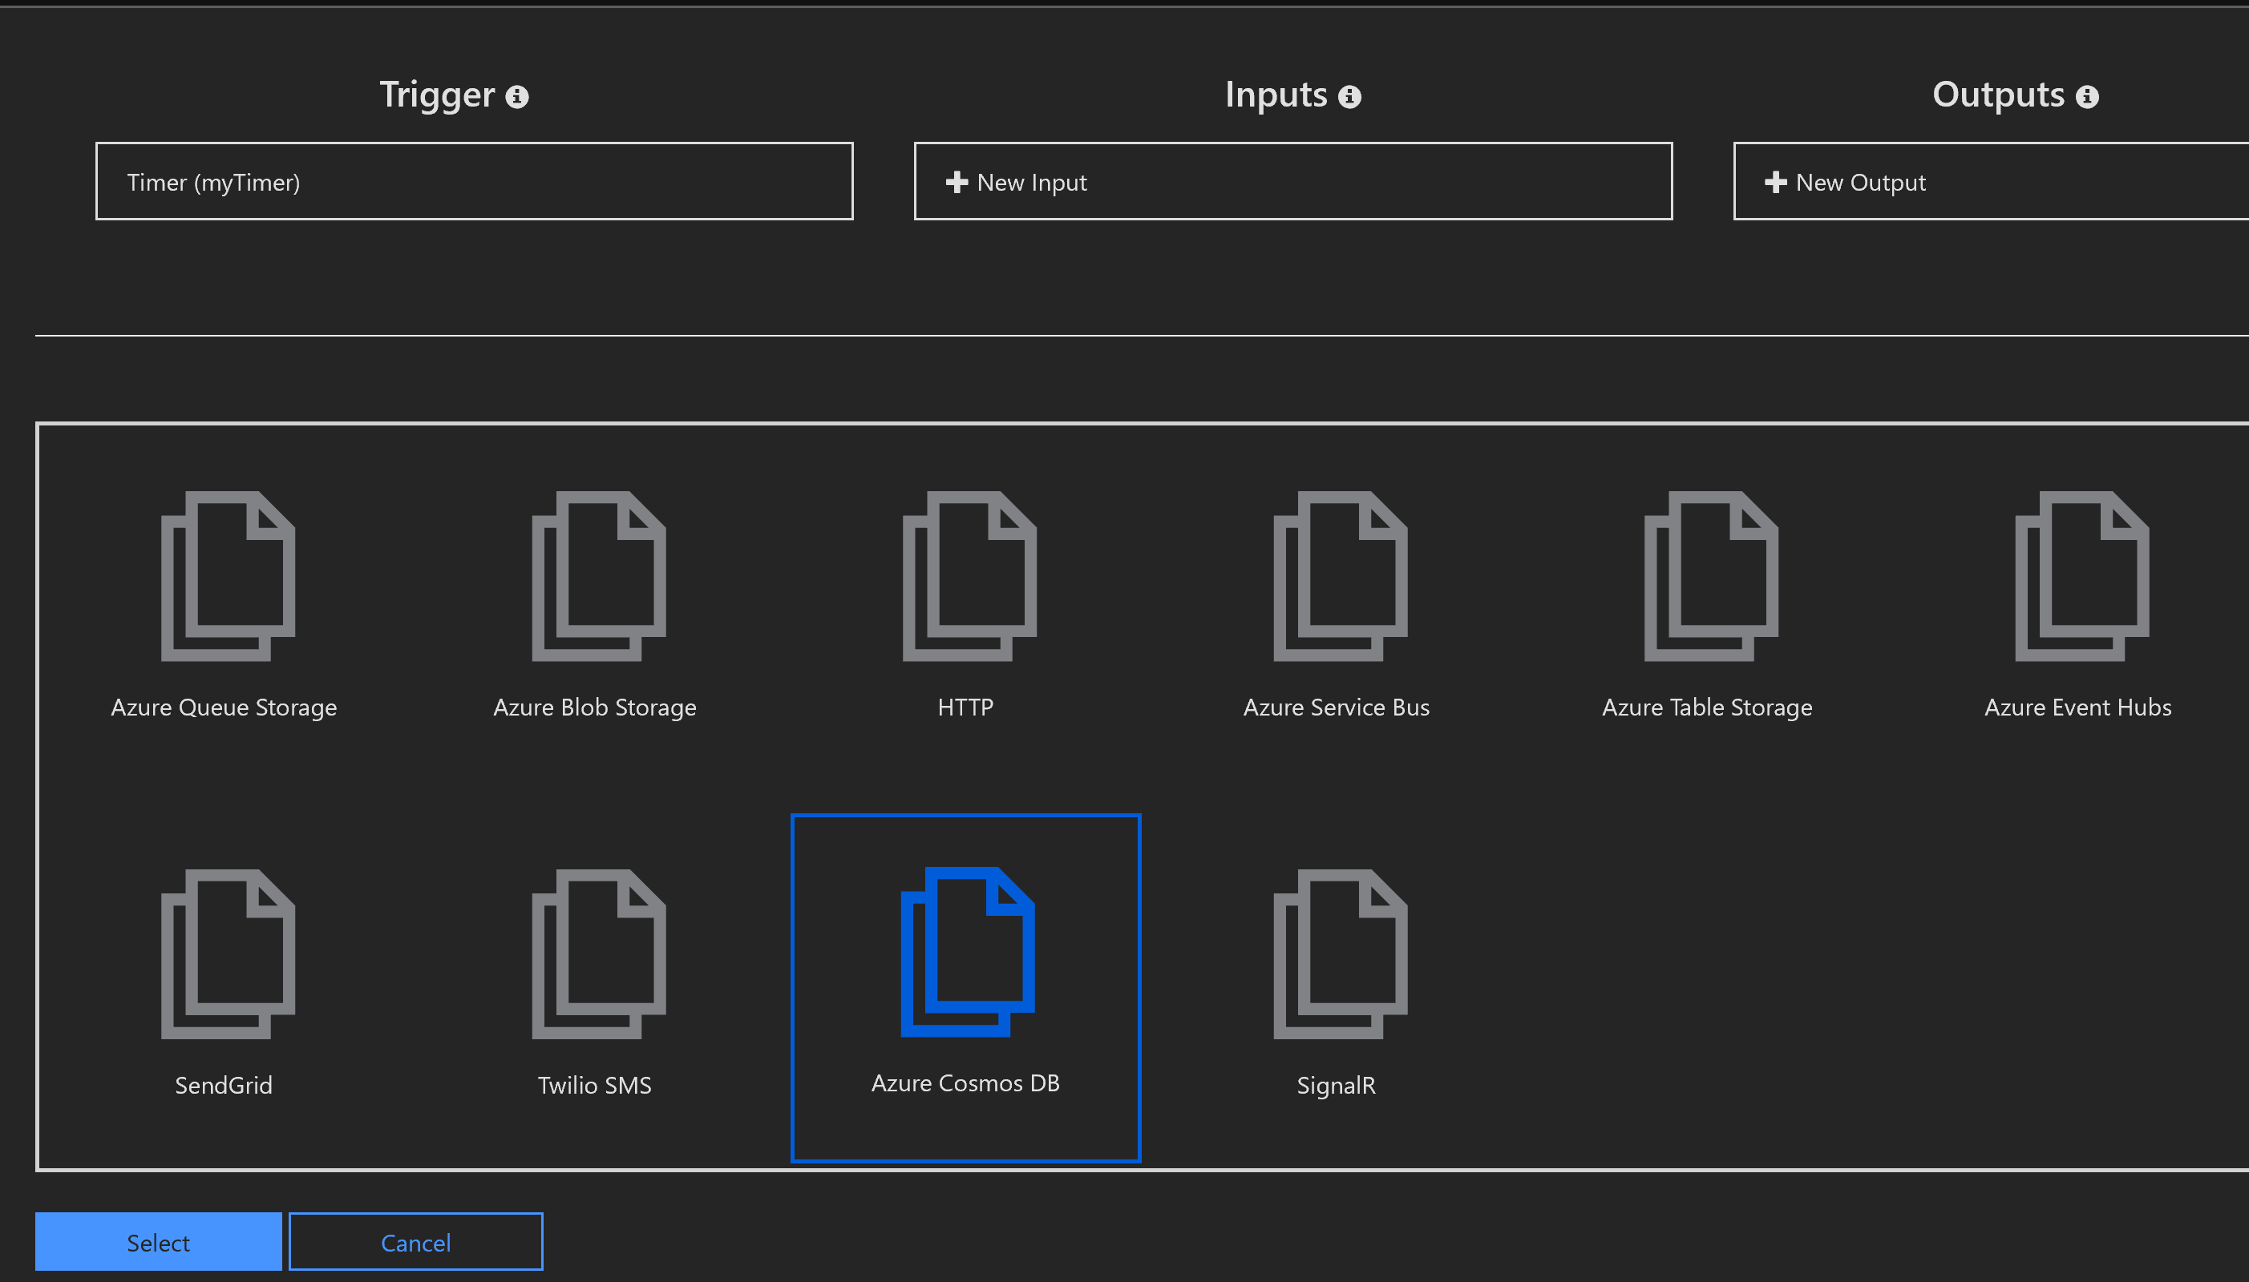

Change the following values and click save

|  |  |
| --- | --- |
| Collection Name | weather-utility |
| Database name | db-cosmos-workshop-<alias> |

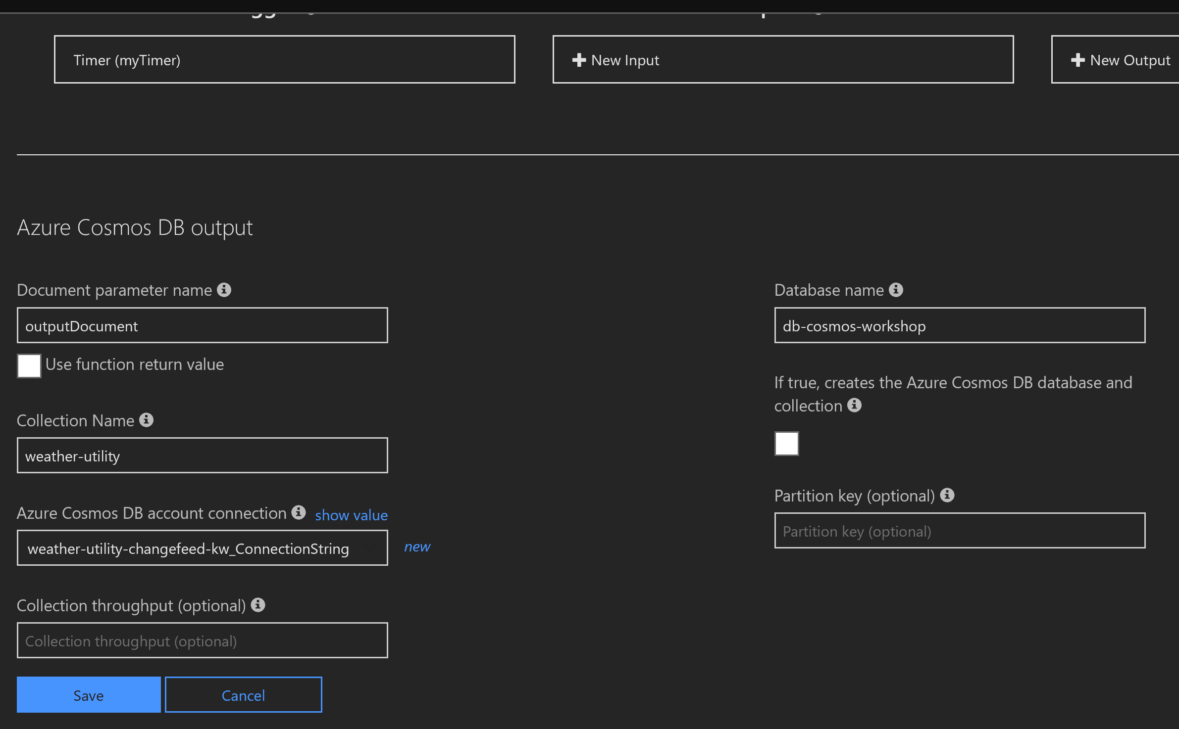

Copy paste the contents of the function from <https://github.com/RajdeepBiswas/cosmosdbworkshop/blob/master/AzureFunctions/aggregate-kwh-timer-trigger.cs> in the function body and hit save.

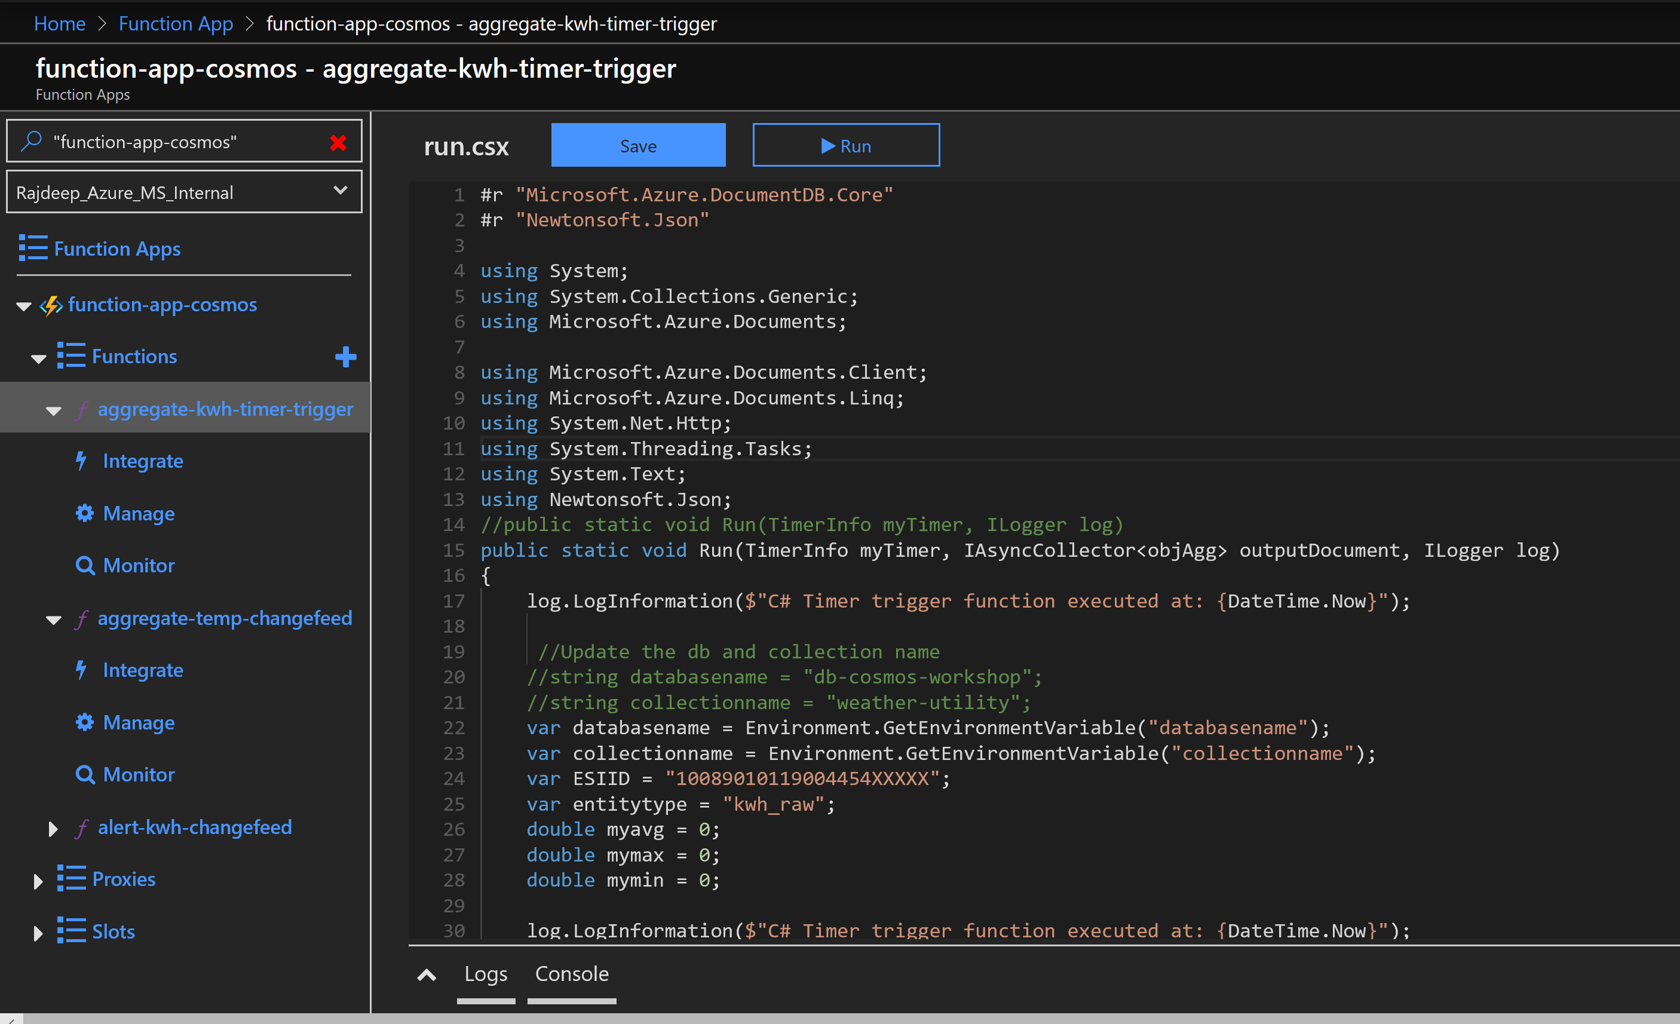

Click on the Logs at the bottom to see how the function is running

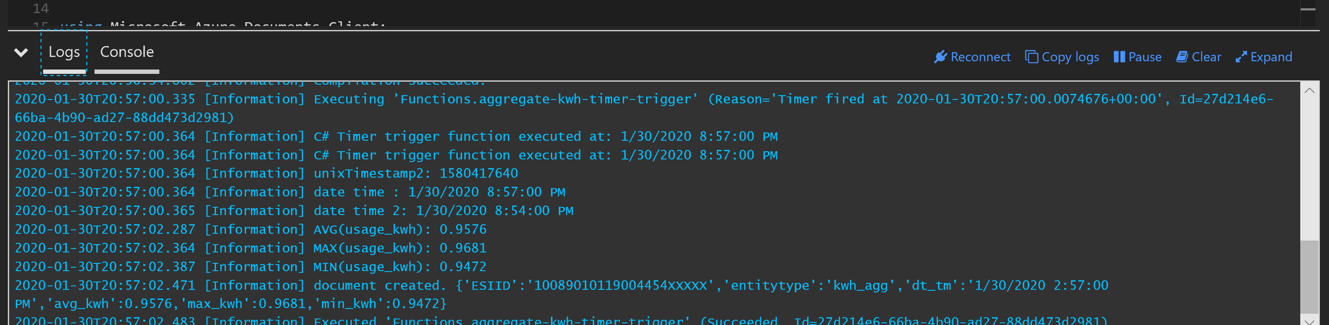

You can also validate the function from the cosmos db data explorer.

Query to validate:

SELECT * FROM c where c.entitytype = 'kwh_agg'

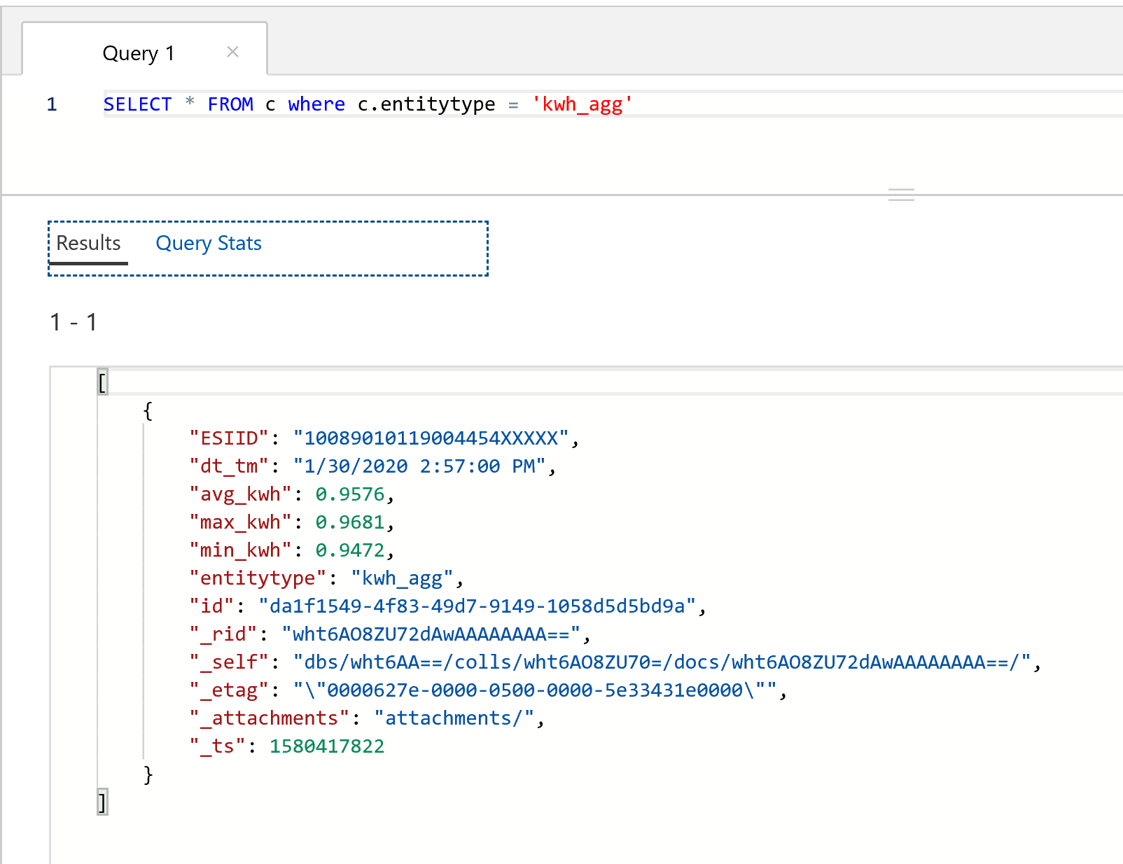

1. The next function we will add is called aggregate-temp-changefeed

This function is a cosmos db trigger and captures the avg of tmp in F from the weather change feed

Click the + sign for new function and from the template search and select Azure Cosmos DB trigger

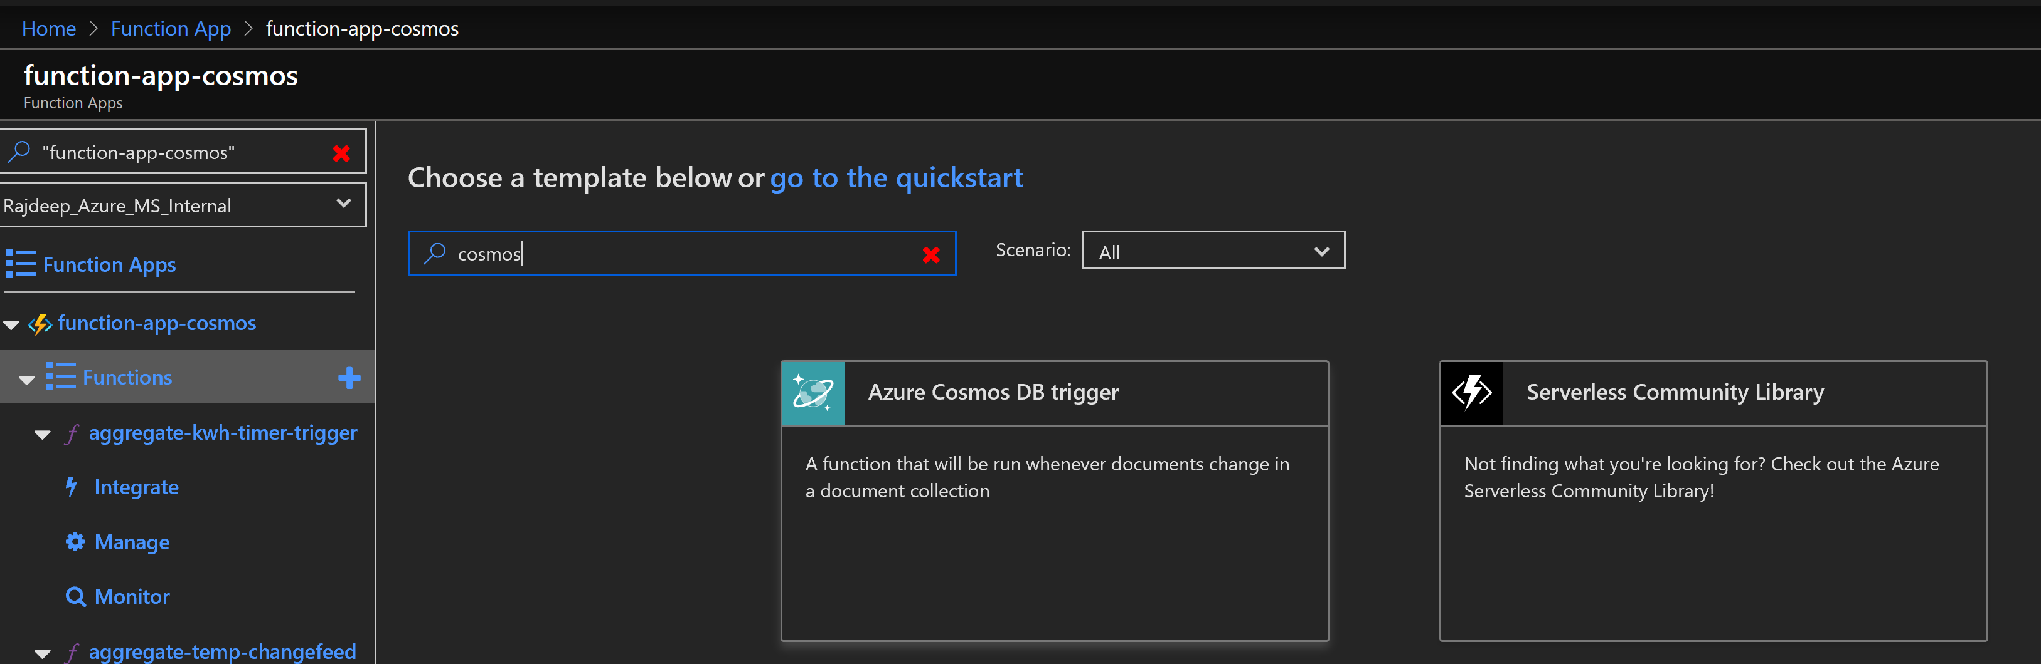

Change the following values and click Create

|  |  |
| --- | --- |
| Name | aggregate-temp-changefeed |
| Collection Name | weather-utility |
| Database name | db-cosmos-workshop-<alias> |

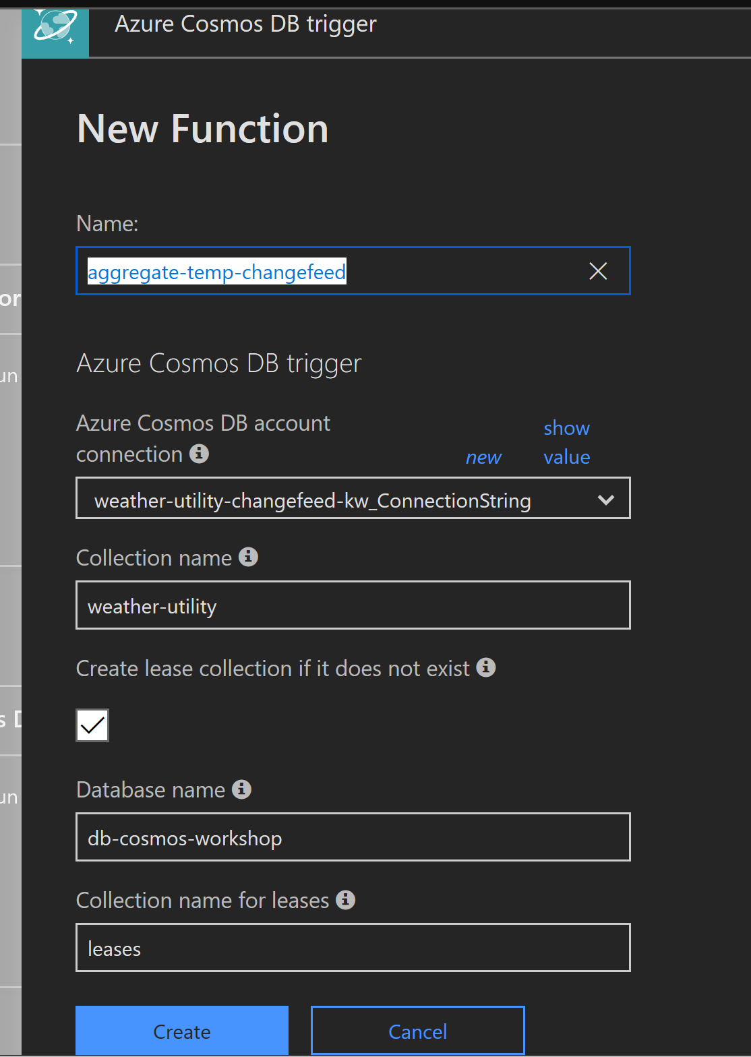

Go to the Integrate section of the function and click on new Output. Select Cosmos DB.

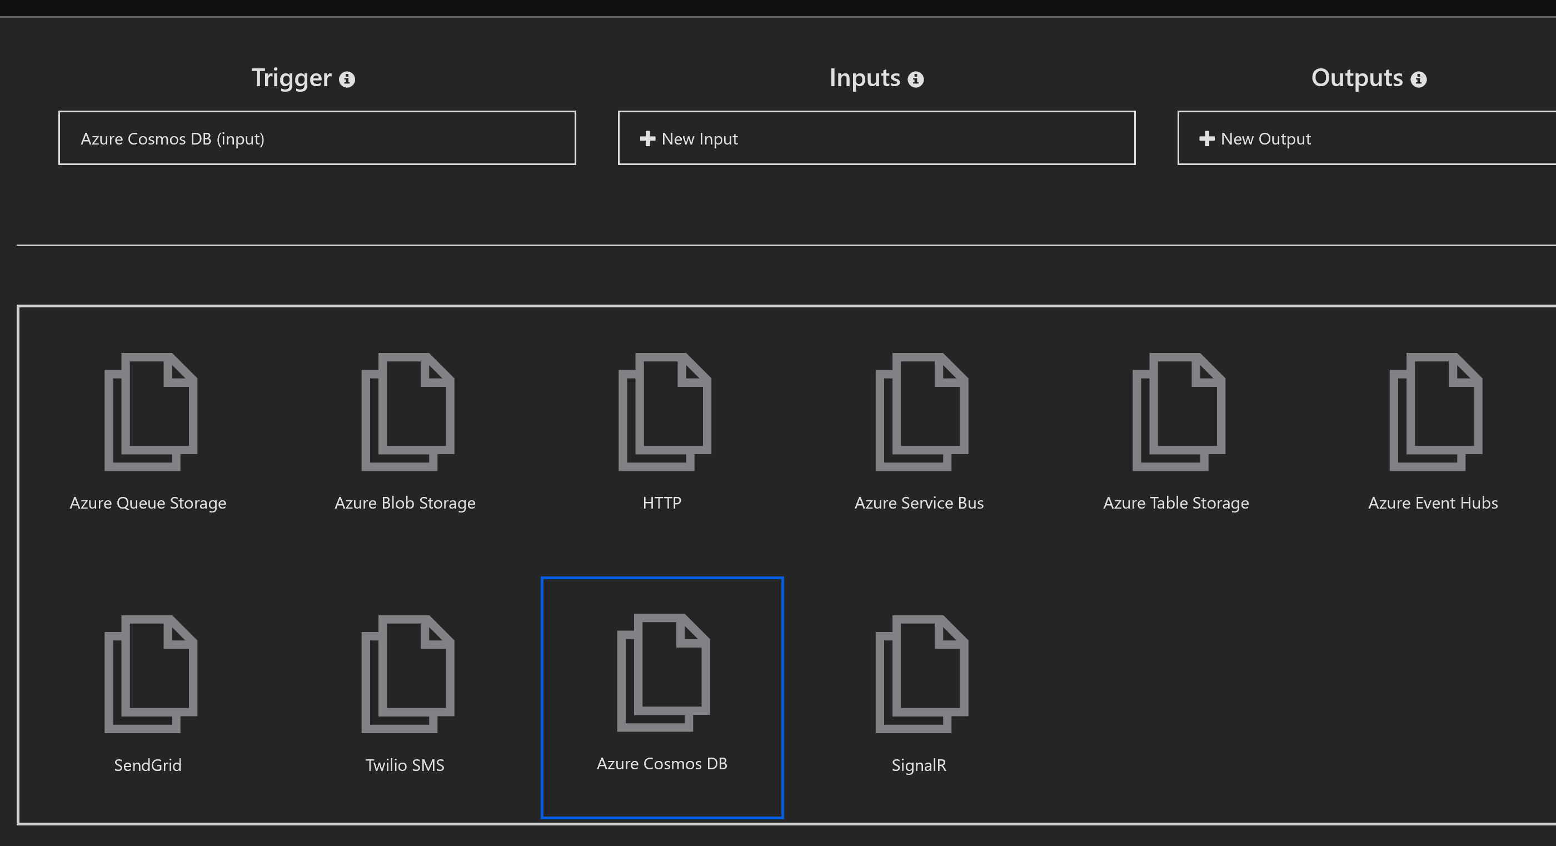

Change the following values and click Save

|  |  |
| --- | --- |
| Collection Name | weather-utility |
| Database name | db-cosmos-workshop-<alias> |

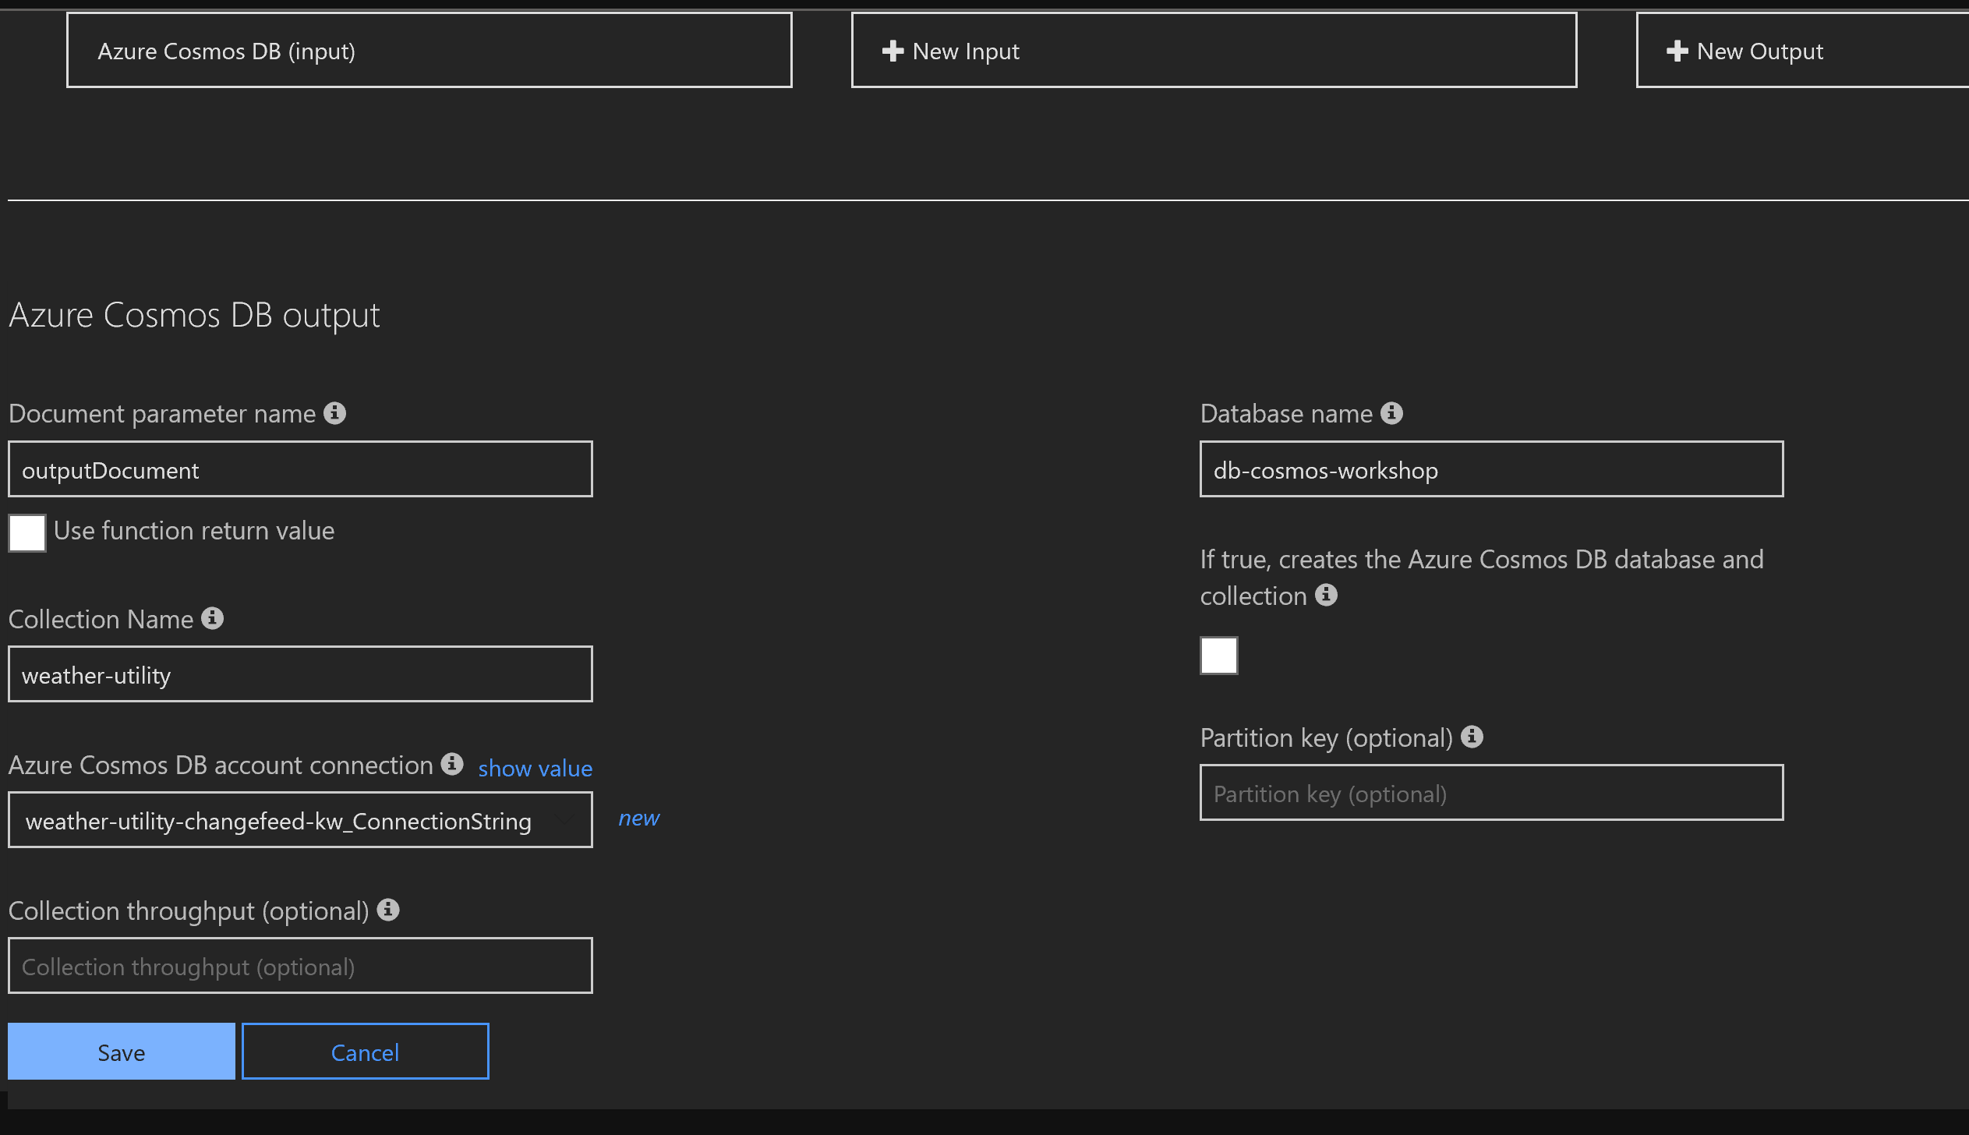

Copy paste the contents of the function from <https://github.com/RajdeepBiswas/cosmosdbworkshop/blob/master/AzureFunctions/aggregate-temp-changefeed.cs> in the function body and hit save.

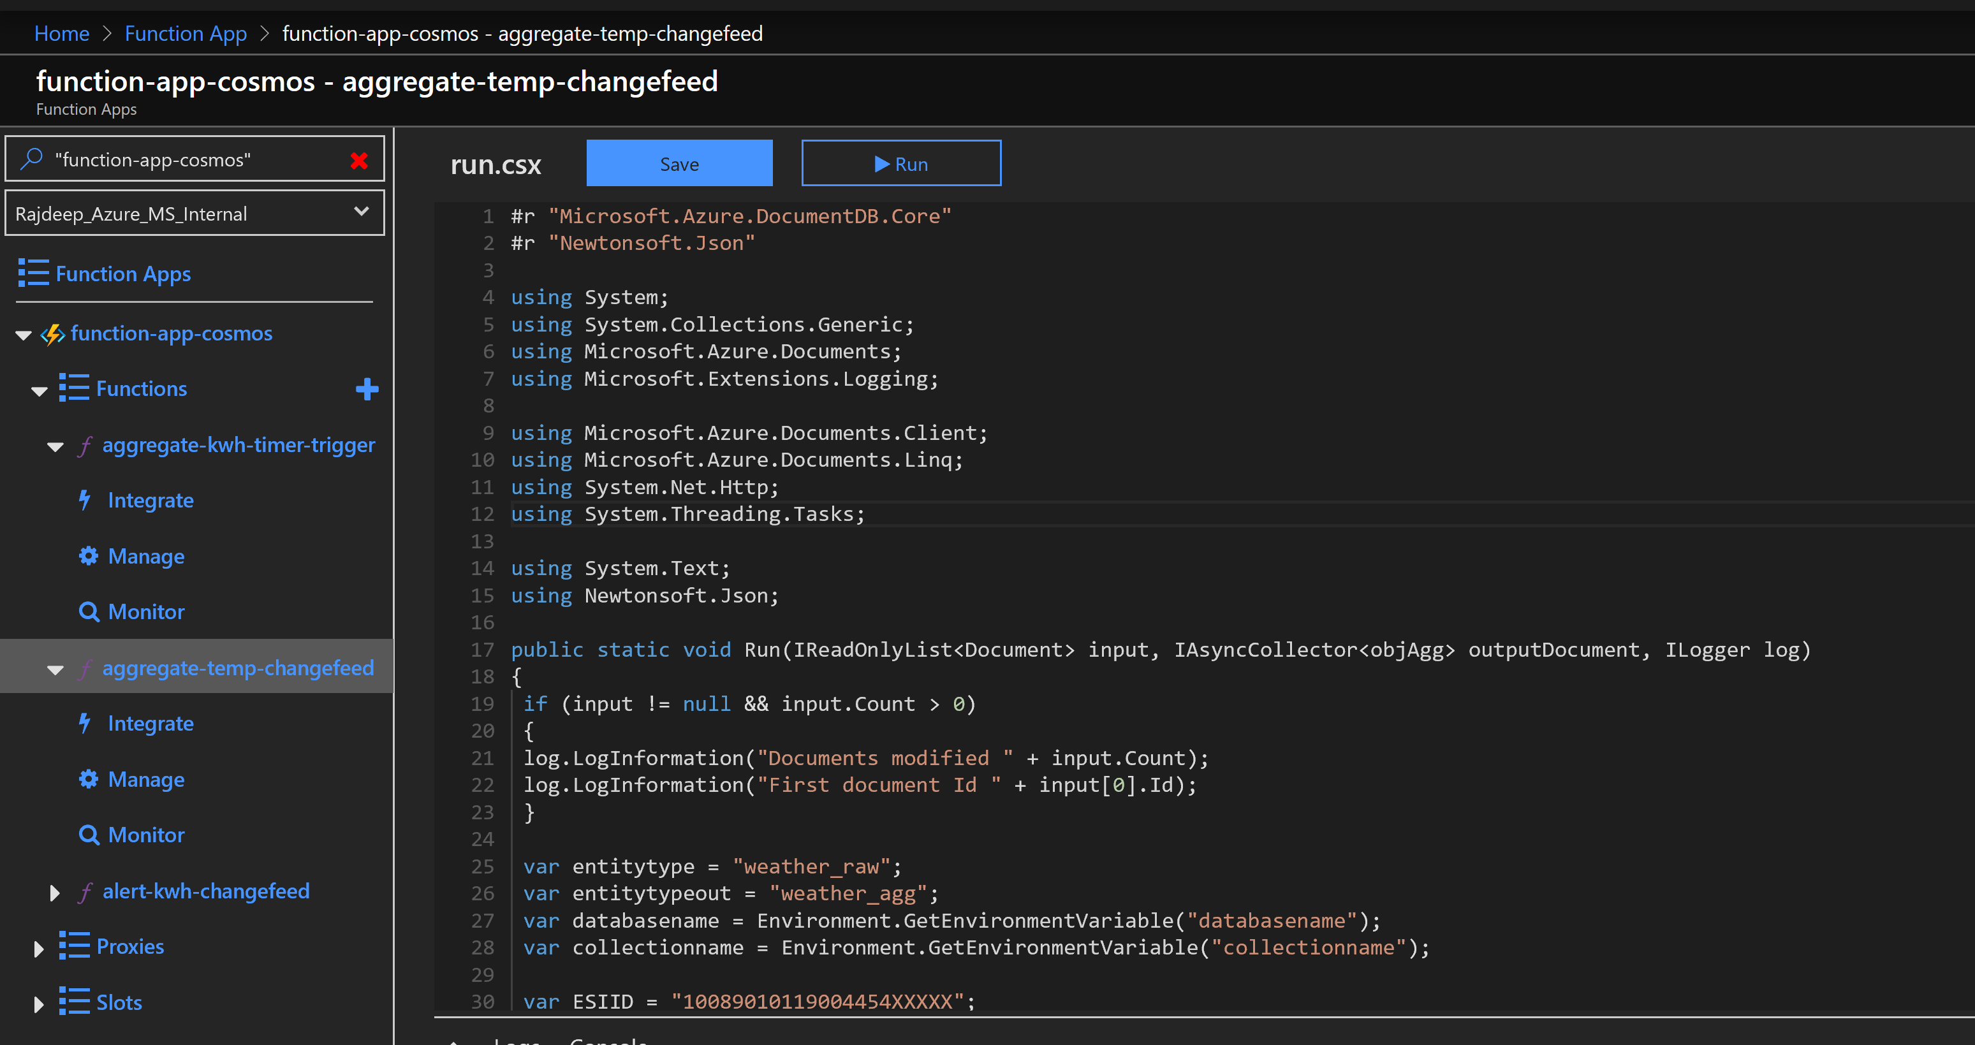

Observe the logs

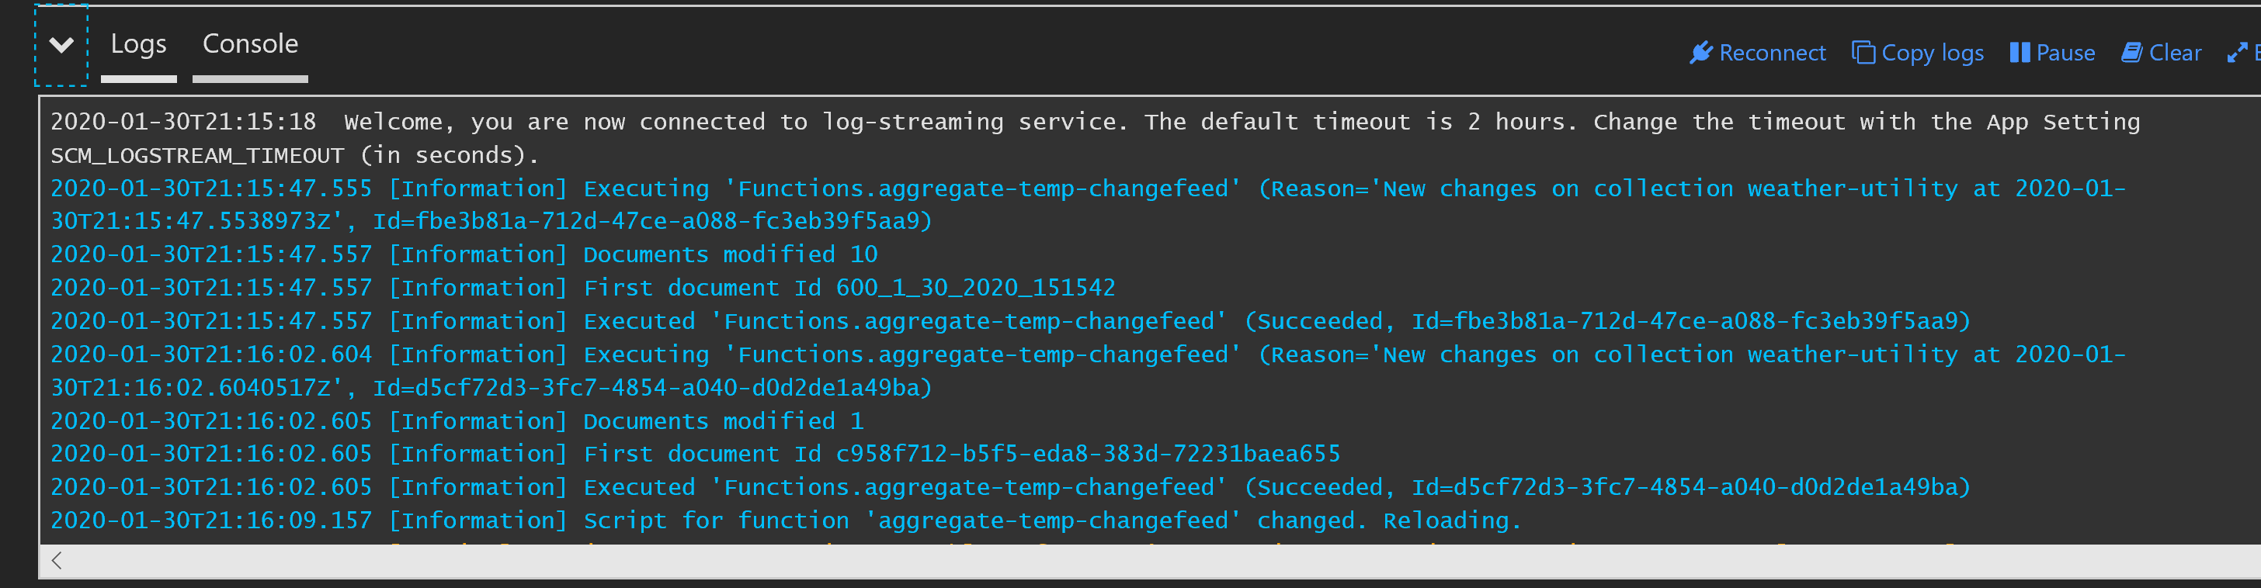

Query to test from the cosmos db terminal

SELECT * FROM c where c.entitytype = 'weather_agg'

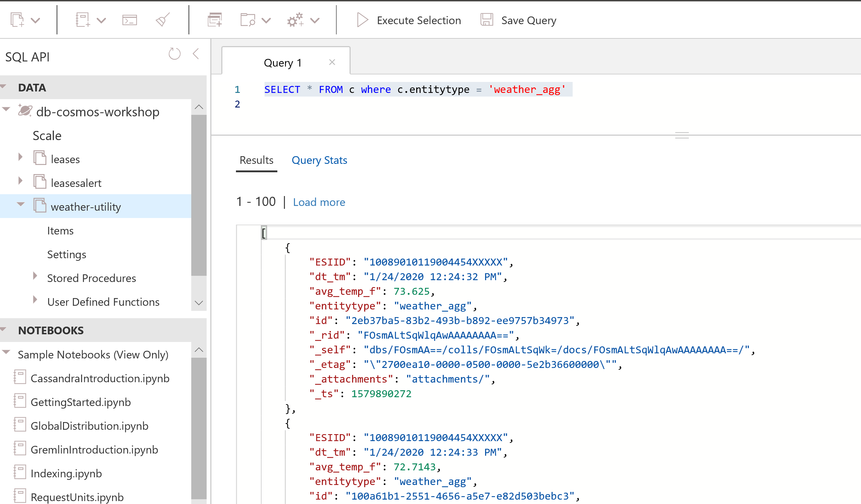

1. Alerting function with cosmos db trigger. This function will generate an alert document if more than upperbound kwh is getting consumed. The upperbound threshold is configured through a document in cosmos db.

From the cosmos DB data explorer create a new document

Create new doc (new item) from the json below

{

"id": "1",

"ESIID": "10089010119004454XXXXX",

"kwh_upperbound": 0.3,

"entitytype": "kwh_upperbound"

}

Click on new item and replace

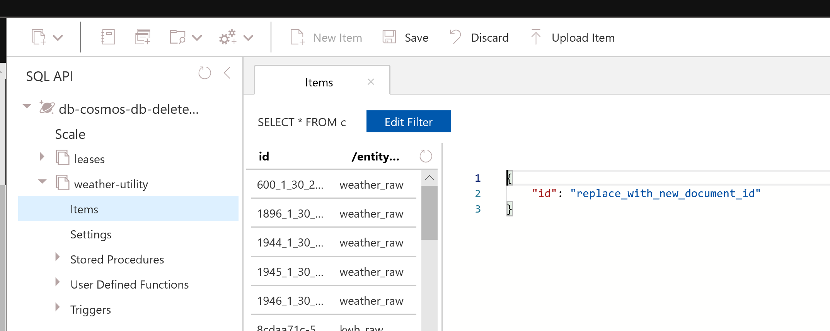

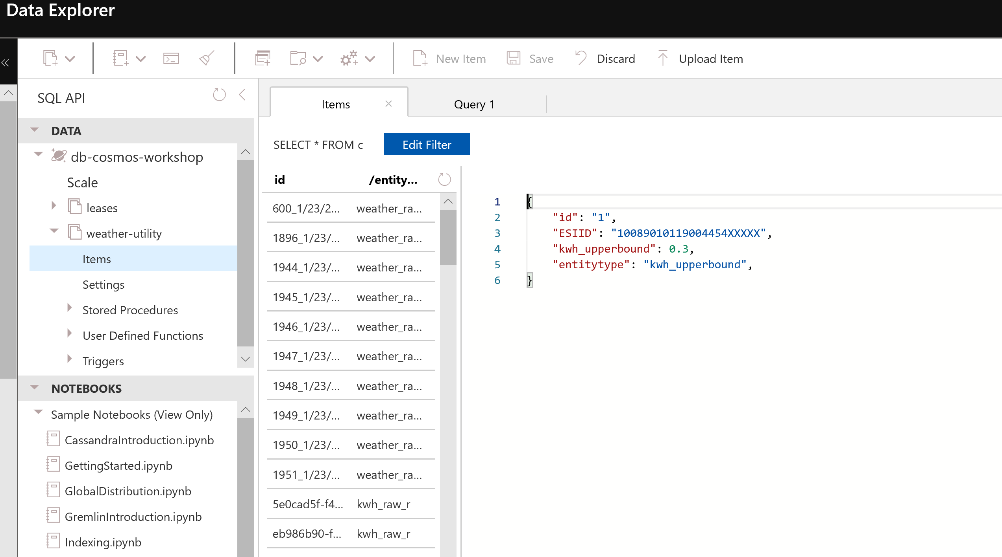

Hit Save.

You can also edit the upper threshold:

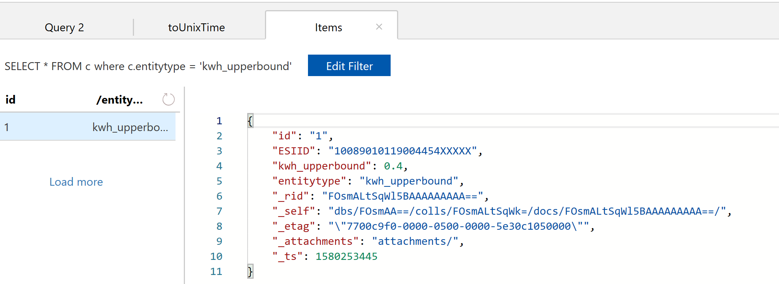

Click the + sign for new function and from the template search and select Azure Cosmos DB trigger



Change the following values and click Create

|  |  |
| --- | --- |
| Name | alert-kwh-changefeed |
| Collection Name | weather-utility |
| Database name | db-cosmos-workshop-<alias> |
| Collection Name for leases | leases1 |

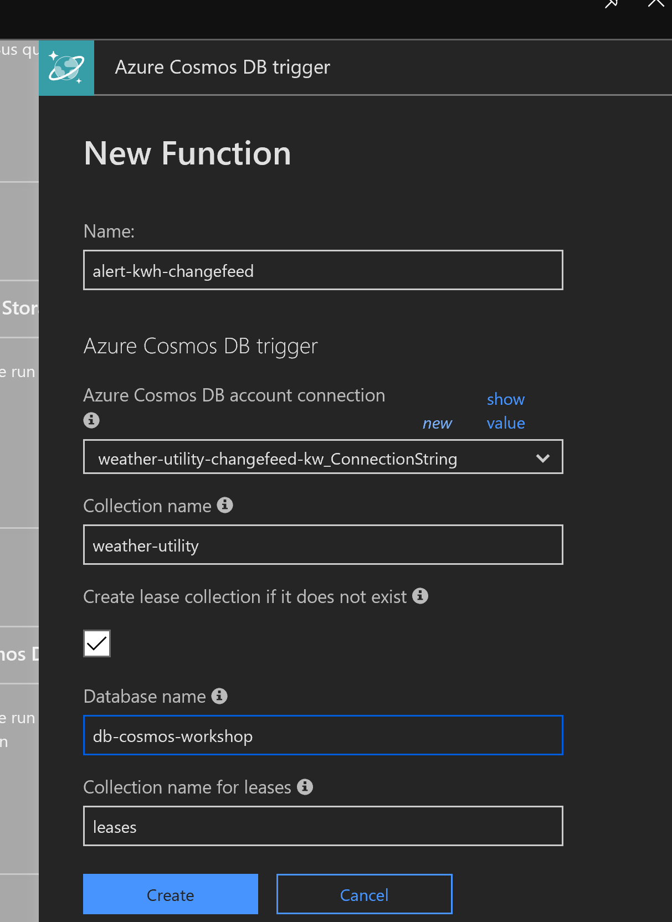

Click on new output from the integrate section.

Change the leases to leases1

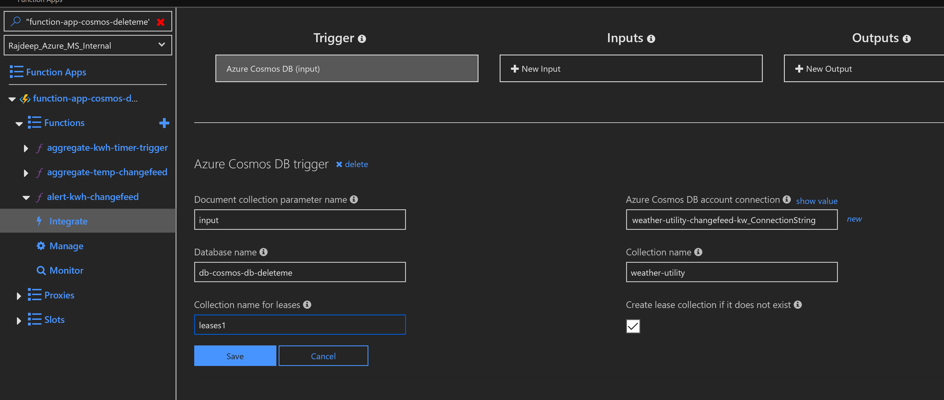

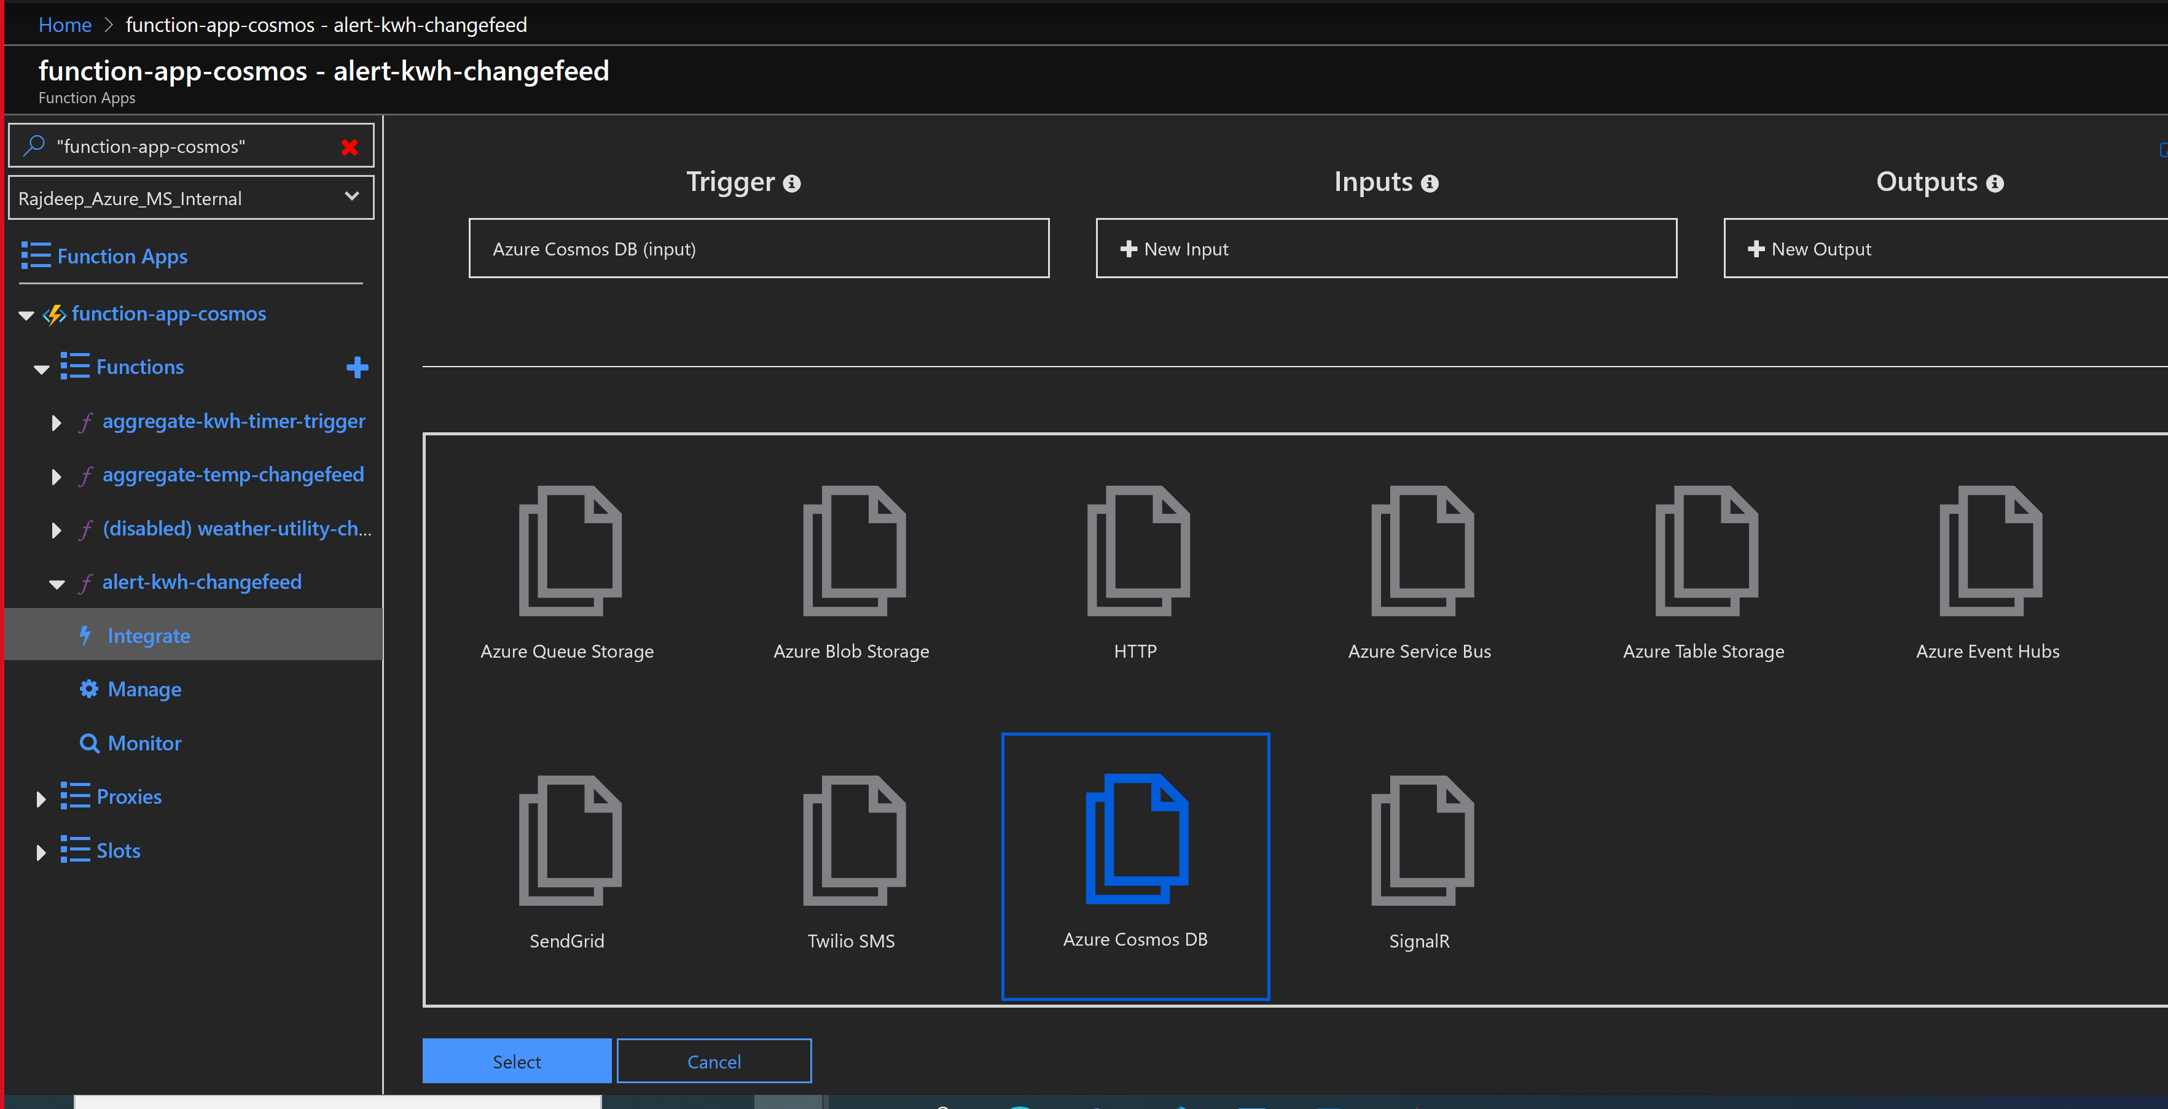

Change the following values and click Save

|  |  |
| --- | --- |
| Collection Name | weather-utility |
| Database name | db-cosmos-workshop-<alias> |

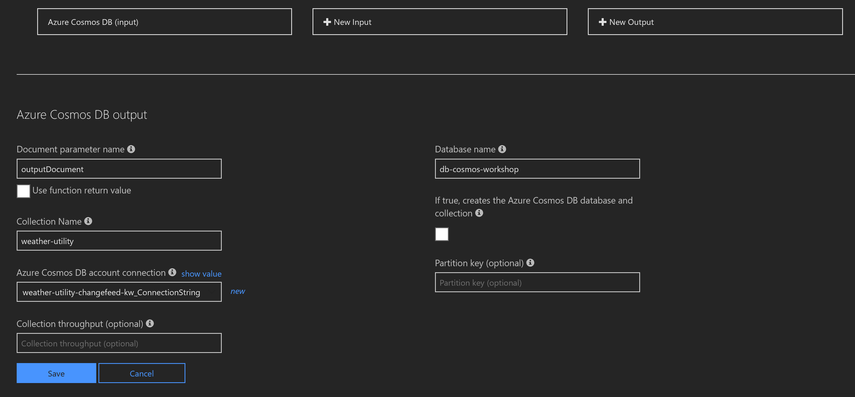

Click Save.

Copy paste the contents of the function from <https://github.com/RajdeepBiswas/cosmosdbworkshop/blob/master/AzureFunctions/alert-kwh-changefeed.cs> in the function body and hit save.

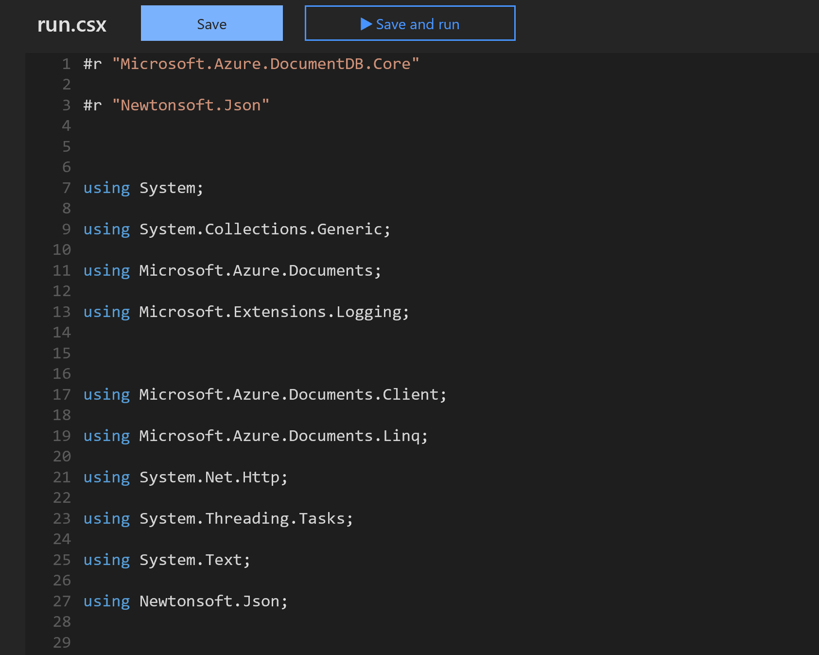

Observe the logs

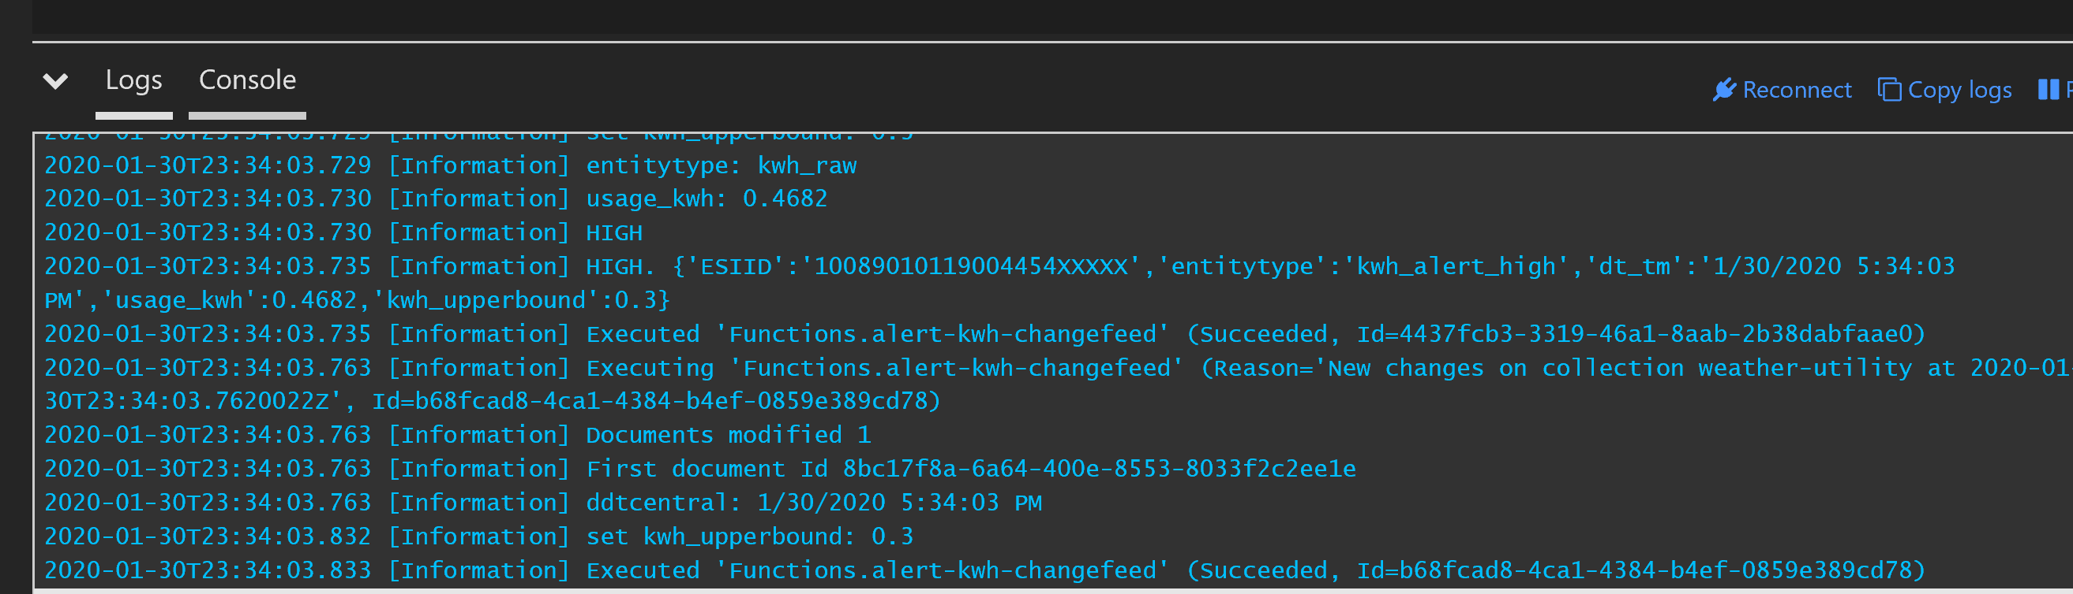

Query to test from the cosmos db terminal

SELECT * FROM c where c.entitytype = 'kwh_alert_high' AND c._ts>=udf.toUnixTime('1/30/2020 1:00:00 PM')

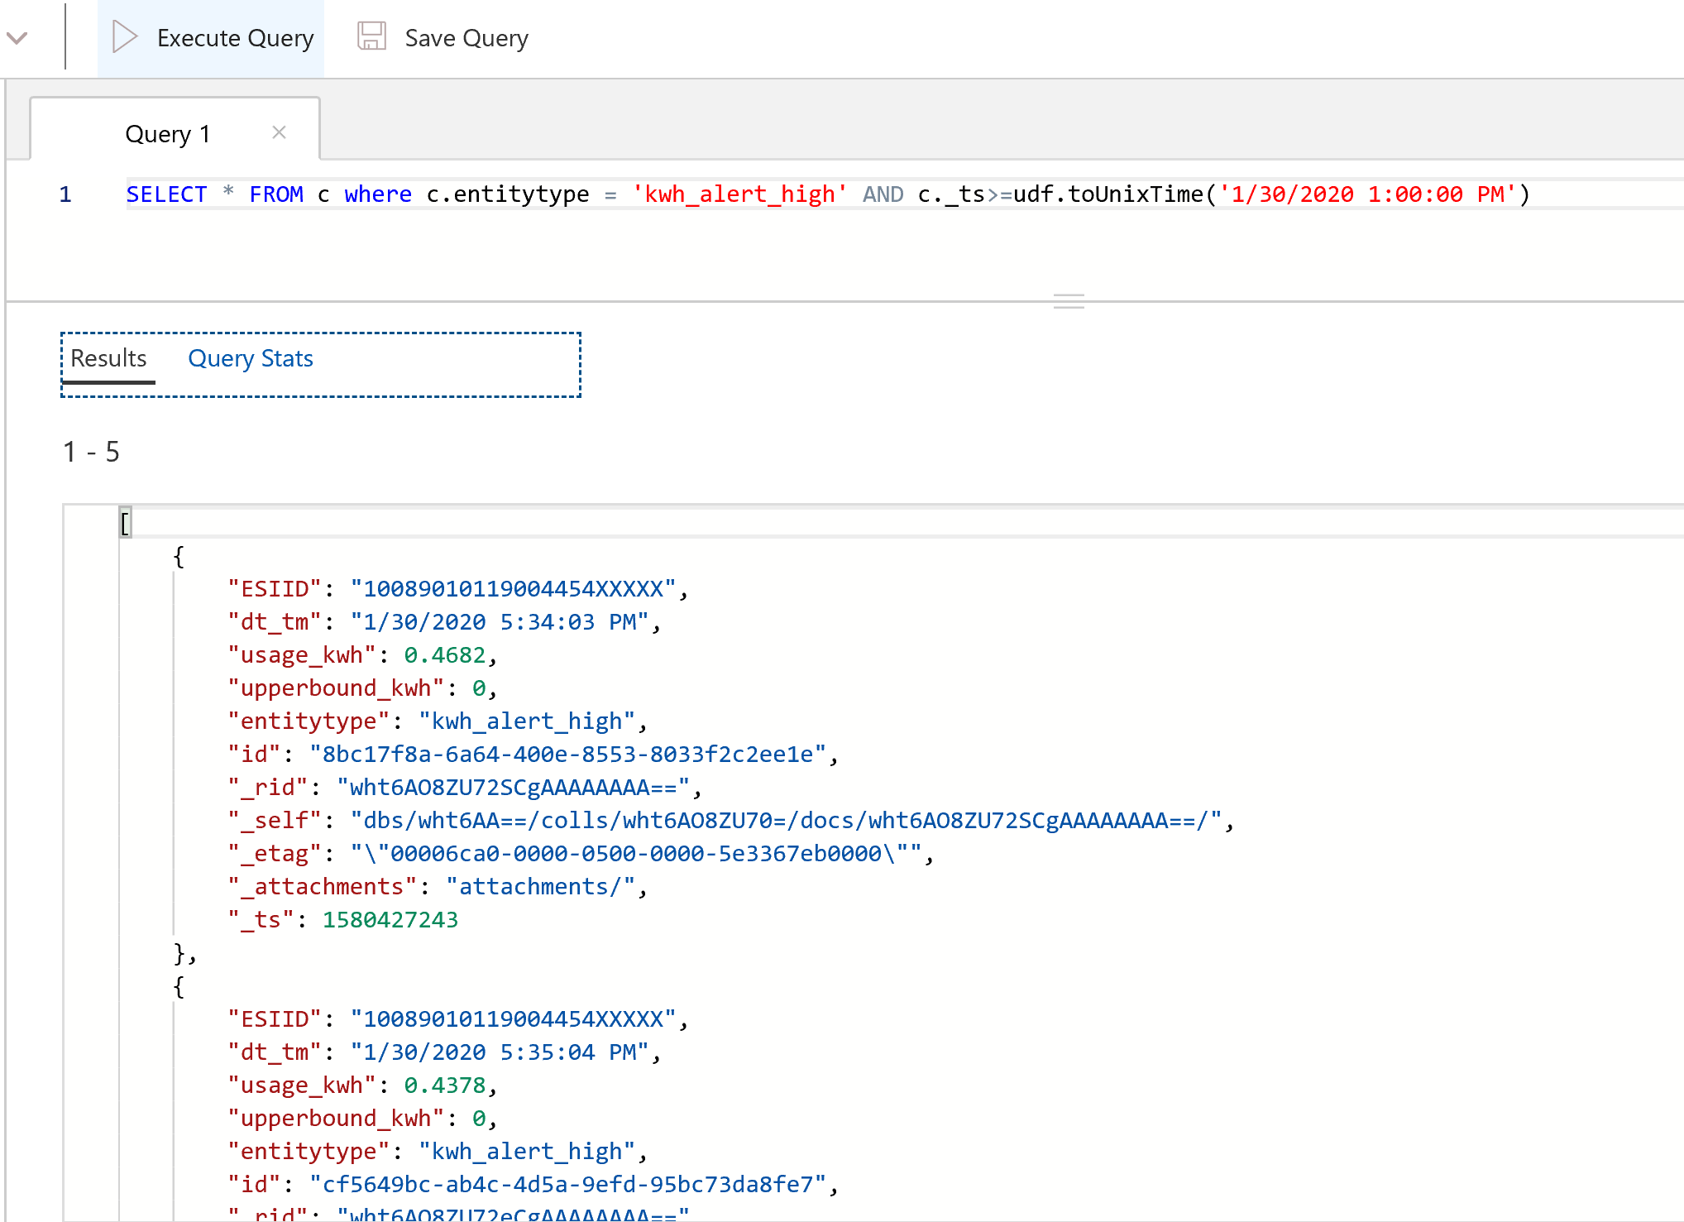

## Congratulations you have finished the workshop. Think how you can apply the concepts in a practical used case.